**Introduction**

**Background information**

A key aspect of teaching is ensuring the students have absorbed the information being taught to them. Questions can be used to make sure that students have. Questions also help to consolidate the information being put across into the student’s brain. A P.E teacher in an all-boys secondary school currently uses multiple choice questions on paper to quiz their year 10 students at the end of each lesson.

From sitting during one of the teacher’s lesson and assisting the teacher while uploading and creating questions for the students I identified several issues with this method.   
-One such is the students become frequently distracted when they are being assed as they find this method of assessment quite lacklustre. This makes it difficult for the teacher to be certain that their students are understanding the information they are teaching.   
-Another issue is that the teacher needs to mark the papers once they are done and transfer it to a document online this is quite time consuming.   
-There is paper wastage which is bad for the environment, when the teacher has exported the students’ score onto a text document they simply bin the question papers  
-The final issue is that this method of assessment does not give the students an incentive to concentrate during the lesson and while they are being assessed.

Computers can be used to mark the answers provided by students, and the students answers can automatically be transferred to an online document. This will mean a teacher will not have to waste time marking the student’s answers and then put them in an online document. It will also mean no paper is used which is beneficial to the environment.

**Identification of the prospective users**  
There are two users of the system: The teacher and the student. The teacher creates the questions and prints them off and hands them out to the students. The students then answer the questions. Upon the completion of the questions, the teacher then collects the question sheets and then marks the papers. After marking the papers the teacher then uploads each student’s results online.

**Identification of user needs and acceptable limitations**

**Interview with prospective users**  
To better understand the ways that can be gone about to improve the current system an interview was conducted with the prospective users, outlined below are the most relevant questions and answers during the interview sessions**.**  
**The teacher**  
What issues are you having with the current system?  
*As a teacher I’m very busy, a lot of work needs to be put in outside the classroom which is very time consuming, the current system takes up too much time and is not very effective as I find it hard to connect with the students and motivate them to complete the questions and focus during the lessons.*

What happens in an average lesson?  
*I teach the students a new topic for the first hour and conduct a short quiz on the topic, then for the final 45 minutes I let them go on the computer to carry out their coursework.*

Would making the quiz occur on a computer help to solve the dilemmas you are having with the current system?  
*I think it would, I would not have to waste time printing the questions out which is also a strain on the department funds. Also if it could check to see if the answers the student gave is correct and put it on a file somewhere that would be great as It would save me whole lot of time from marking.*  
  
If the new system where to be computerised would you be alright with allowing the students to complete the quiz one by one on your computer?  
*The class is small, there are only 8 students so, it won’t be an issue each student can come up during the time I have scheduled for them to do their coursework while the rest continue with their coursework.*

**The students**  
Below are the students’ responses collectively to some questions I asked.  
  
When I sat in your lesson you guys often get distracted easily, what is the reason for this?  
*The majority of the students said they found the lessons boring, they felt as if there was nothing to motivate them.*

Would adding some sort of game to the quiz and rewarding you based on whether you get a question correct help to motivate you in the lesson?  
All of the students agreed that it would.

What genre of games are you into?  
7/8 said they are into 1v1 fighting games.  
2/8 said they are more into first person shooter games but enjoy fighting games as well.  
  
Would you still feel motivated even if the game wasn’t similar to that of professional standard?  
6/8 said they would still feel motivated even the game wasn’t of professional standard.  
One even commented the IT staff has blocked their access to games therefore they are content with any sort of game.

**Identification of user needs**  
**The students**  
-The students need to be able to answer questions and their responses should be tied back to them so the teacher can know what each student received on each question.  
-The questions need to be presented in a way the student will understand and find enticing as this may help to ensure engagement as they stated during the interview they have nothing to motivate them, possible making the design attractive may motivate the students.  
-Based on the response the students gave to the question (“Would adding some sort of game to the quiz and rewarding you based on whether you get a question correct help to motivate you in the lesson?”) the students want some kind of game added to improve the current system.  
**The teacher**  
-The teacher would like the new system computerized as they feel it would help them save time and money.   
-The teacher needs to be able to create questions for the students, this will help to assess the students and see where their strong points are within the subject and also help to rectify and weak areas they are having with the subject.  
-As the teacher feels the marking the students’ answers is too time consuming, the teacher needs for the students’ answers to be marked automatically  
-The teacher needs for the students’ scores to be stored somewhere on a computer as she has to do it manually herself when she has finished marking the papers.

**Overview of system requirements**

-The system should be able to output questions to the students in which students can answer and their responses will be saved and teacher should be able to view the answers each student inputted were incorrect and correct. The system should make the task fun for the student, to ensure constant engagement.

**Acceptable limitations**

From my knowledge of having attended the secondary school, the IT staff do not allow students to save data on to the shared folder, only teachers are able to. If the new system were to be computerised, for all the students responses to be in one place it the quiz will need to be done on one computer which will be that of the teacher’s.

I am not a expert games developer so if I were to create the game mentioned it may not be of professional standard similar to big game brands such as street fighter.

**Realistic Appraisal of the feasibility of potential solution**  
Potential solutions to problem  
-Offer rewards for students who get the highest, this will motivate student to concentrate during the lesson, an issue raised by the students. This will be better as the students complained about not being motivated enough. A problem with this is it does not address the teachers issue regarding marking being too time consuming. It would be a good solution as it involves just a little tweak in the current system, some students may find it hard to adopt to a new version of the system.

-Make students swap papers and mark each other’s work and write the scores. This will save time, as the teacher will not have to mark each student’s responses. Unlike the current system in which the teacher has to mark each students answers. However the teacher will still have to manually upload each student’s scores also this does not solve any of the issues raised by the students.

-The teacher could use a website such as https://www.kerboodle.com, which is a fun and engaging way for students to be assessed, and it allows all students to compete to compete against each other at the same time. The only problem with this is, the student’s scores are not saved on a database and it will be hard to differentiate each student due to them choosing their own usernames. Also kerboodle needs to be paid, for and the teacher complained that the current method is a strain on department funds, so a paid solution would not adequately meet the teacher’s needs.

-Another approach could be a quiz on a computer in which students can answer the questions and the teacher can set questions. The student’s scores can be saved to a database with their information. The teacher can add users herself. The quiz could have a game at the end in which if a student gets a question correct they offered power ups to help them win in the game. This will solve all the teacher’s current issues with the system. Time will be saved as the teacher will not have to mark and upload results, it will already be there. Students may be motivated in lesson as they would like to get questions correct in order to get an advantage in the game to win. The game would be a 2d fighting game where the student plays against the computer, as the majority of students in the class are into this genre of games. However a solution like this may be quite challenging and may take quite a lot of time to create.

**Justification of chosen solution**

The solution that will be used in this project is the final one mentioned in the Realistic Appraisal of the feasibility of potential solution. This solution is most relevant to the project and is the only solution that solves all the issues raised by the teacher and the students. The rest of the solutions only partially solves the teachers or students issues with the teacher’s current system of assessment. The teacher and students would prefer this solution as it resolves all their concerns regarding the current one.

Visual studio will be used to create the new system, this is because certain aspects such as the physical design of the system does not need to be programmed such as the box size, colour etc it can simply be dragged and dropped with the utilisation of windows forms making the system easier to create. The programming language being used will be visual basic, this is because there are wide variety of resources available regarding visual basic available which may help with the implementation of the system. SQL statements will also be used for database handling.

At current I have minimal knowledge about visual studio or visual, I only know the programming language python, so this will be a learning process for me. I only have a few weeks to create the project and I do not have a budget so it will be difficult for me to match that of a professional company making something similar.

Students will be only able to answer questions from one computer, this will not be that much of an issue as the class is very small. This is due to my sixth form and the secondary school the teacher teaches in not allowing server connections, in which I could store the database on so it can be remotely accessed so students can complete question simultaneously on multiple computers. Also the secondary school not allowing students to save data onto the schools shared drive.

**Data sources and destinations**  
Input data  
The students will input the following data into the system.  
-Their login assigned by their teacher, this type of data will be text.  
-Mouse responses to the questions and any popups, this will be mouse click data which will trigger function.  
-Keyboard responses to the game, this will be key down data which will also trigger a function.

The teacher will input the following data into the system  
-Teacher login.  
-Information about students.  
-Questions and answers for the students.  
All the forms of data will be text.

Output data  
The system will have many outputs.  
-When invalid data is entered into the system it will alert the user and prompt them to enter something else. For example, when logging in if the username or password does not match a username and password held on the database it will prompt the user to consult their teacher for their username and password. Or if the teacher attempts to add a user to the database which already exists then it will tell the teacher that user already exists.

-If valid data is entered a pop up will come up stating the action they have attempted has been successful, or the program will proceed to the next page.  
-When a student gets an answer correct it will come up with a message telling them they have got the answer correct and ask them to select an upgrade, on the contrary if they get an answer incorrect it would tell them they got the answer incorrect.  
-The system will be able to output the students’ scores to the questions and it will be a able to output it to a text file.

**Dataflow Diagram of the current system**

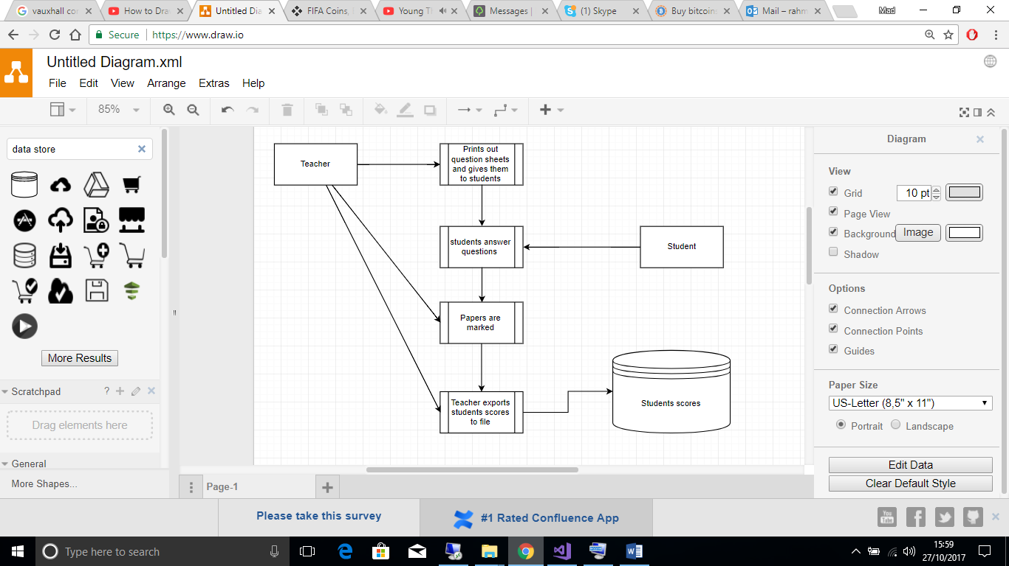

**Dataflow Diagram of the proposed system**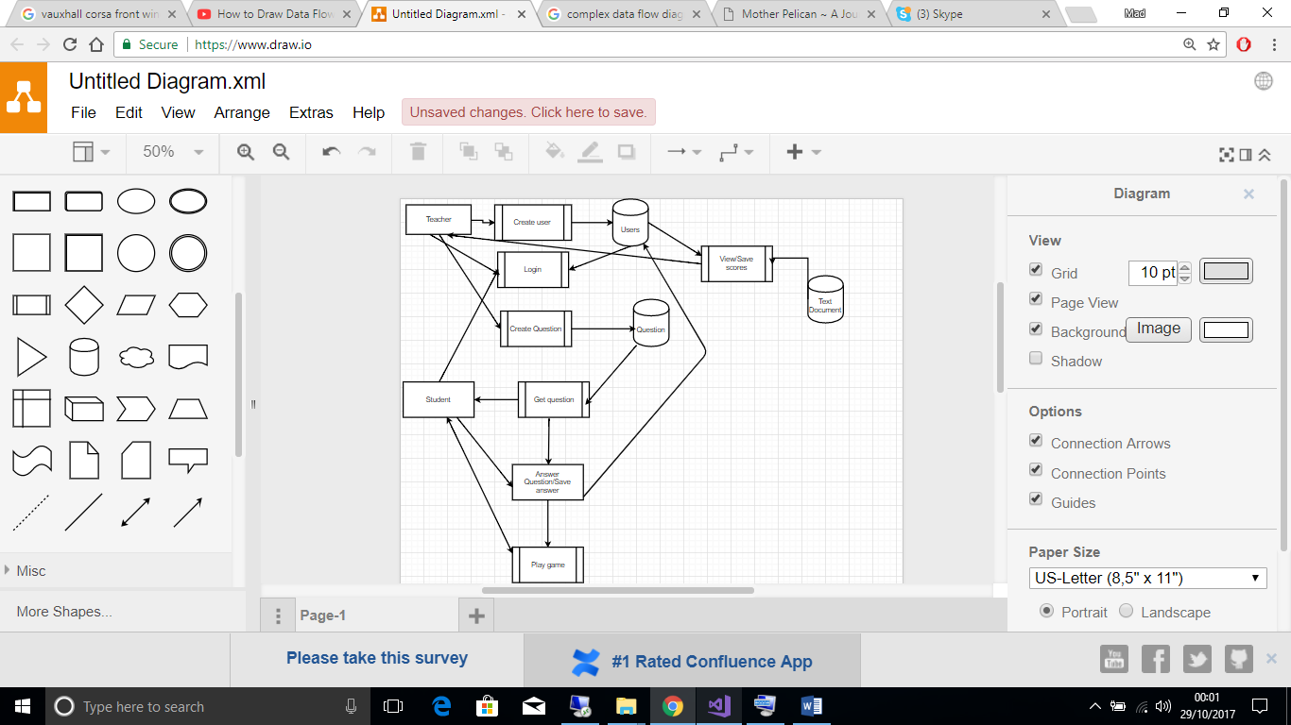

**ER Model & Diagram**There will be two entities in the system which are: Questions and the Users of the system. Here is the entity relationship between the users and questions. The teacher user will not be included in this relationship.  
 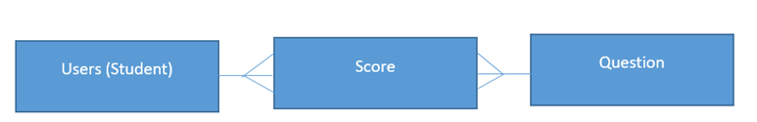

The User entity will have a Many relationship with scores, the score table will store results about many students.   
The question entity will also have a many relationship with score, the table score will store results of many students of the same question.

**Preliminary Data Dictionary**  
As stated above the database will have two entities, the users and questions.  
Users  
The attributes that will be in the users entity are: username (any length string), password(any length string), first name (any length but only characters), last name (any length but only characters) and whether the user got each question right will be stored in this table (this will store the words either yes or no).   
For the users entity, the following processes will be performed on the table. ADD: this will be to add a new user to the table. GET DATA: This will be used to check if password matches username and if username exists when user attempts to login. It will be used to display the user’s details when a teacher searches for a particular. When the teacher wants to view student’s scores it will be used.

Question  
The attributes that will be in the questions entity are: question (any characters of any length), correct answer (any characters of any length), alternate answer one (any characters of any length) and, alternate answer two (any characters of any length).  
For the questions entity, there will be two processes performed on the table which are APPEND (to edit the questions and answers) and GET DATA (to put questions and answers into quiz also to display questions to teacher so they can verify questions and answers are what they want).

**Algorithms**  
Only one algorithm will be used which is the random algorithm, this will be used to randomly generate where the cpu will move in the game.

**Objectives of the project**Listed below are the following things the new system will need to be able to do.  
  
1. Users can login. This will enable the program to identify who is using the application and be able to display specific screens or modify information regarding the user accordingly. For example if a student called Jim logins the program will need to be able to identify it is Jim that has logged and update his marks when he attempts the quiz.  
1.1 User can only logon if account exists on database  
1.2 When user logons it will load correct screen corresponding to whether it’s the teacher or student  
  
2. User modification. The teacher will need to be able to add the students in her class who will be taking the quiz, but will also need to be able to change aspects of the user in this instance she enters the wrong information when adding a user or information about the user changes, for example if the student has adopted a new surname. The teacher will also need to be able to delete users if they are no longer a part of her class. Also the teacher will need to be able to view all the passwords and usernames she set for her students in the instance they forget/ misplaces them.  
2.1 Teacher can add new users.  
2.2 The teacher can modify data about an existing user.  
2.3 The teacher can delete users.  
2.4 The teacher can change their password  
2.5 Teacher should be able to view a list of stored username and passwords  
  
3. Question modification. The teacher will need to be able to create questions to quiz the students. In the instance in which the teacher enters incorrect information or when the teachers needs to create a new set of questions for the next lesson/topic], the teacher will need to edit and modify the data.  
3.1 The teacher can set new questions which will display in the student's quiz.  
3.2 The teacher can view and modify the current set of questions  
3.3 The teacher can erase the current question and create a new set of question

4. Results handling. For the final part of the new process the teacher needs to be able to view the student’s scores and be able to export them to a text file and have the ability reset every student's score's in lieu for the next quiz.  
4.1 The teacher should be able to view the students results on a table.  
4.2 The teacher should be able to export these results to a text file.  
4.3 The teacher can erase each student’s mark on the previous set of questions

5. Questions. It is important that the questions and answers displayed to the student are the same as the ones entered by the teacher. The program will need to be able to mark whether the student got the question correct and display them with a message telling them they got the question incorrect, or if they got it correct it should bring up the menu to give the students an upgrade. The program should then update the database according to the user’s output.  
5.1 The question should be displayed along with three possible answer choices, which should match that of the ones the teacher assigned.  
5.2 The student can select the answer which they think is correct and the program should tell them if they got answer wrong or display the upgrade menu if they got it right.  
5.3 The program should run through all three questions set by the teacher applying the same process in 5.2 and 5.3

6. Upgrades. The students will have the following option of upgrades: Extra health, Extra kick damage, Extra Punch damage, faster speed. This will help to ensure the students stay focused in lesson and the quiz as they would want to perform well in the quiz to have access to the upgrades.   
6.1 The student should be able to select an upgrade and the correct upgrade should be applied to the students in game stats.

7. Game. The game is a key aspect of the new system. It will need to function correctly to ensure the user’s needs are fully met.  
7.1 When a user presses a character, the program should produce a response based on the character the user pressed. The response should match that of the assigned action the program is meant to do when the user presses the button. For example if the user presses the right arrow key the users character should move to the right.  
7.2 The CPU should be able to move and interact with the student’s character based on where the user is and where the student’s character is.  
7.3 The game should end when the user or the CPU’S health gets to nothing, and the winner should be displayed.

**Design**

**Overall system design  
Teacher**

|  |  |
| --- | --- |
| Inputs | Processes |
| Username Password First Name Last Name Questions Answers | Login Add user Delete user Modify user Modify questions |
| Files | Outputs |
| Student results Database | Invalid input screen Success screen Student information Student Scores |

**Student**

|  |  |
| --- | --- |
| Inputs | Processes |
| Username Password Click (To answer question, to select upgrade) Left key Right key Character Z Character C | Login Check answer Assign Upgrade Move left Move right Kick Punch |
| Files | Outputs |
| Database | Health bar Cpu Actions Player actions Incorrect answer Upgrade menu |

**Modular structure of system (not detailed algorithm design)**

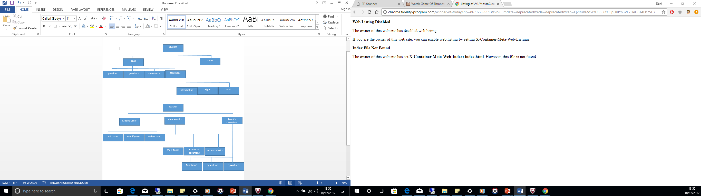

**Game:** This will contain the implementation for the game in which the students said they wanted in order to motivate them to concentrate during lessons. Introduction will contain the instructors for the student to interact in the game, Fight will contain the actual gameplay, End will contain an outro message depending on whether the student or CPU won the game.   
**Quiz:** The series of questions created by the teacher in which the students can answer.  
This will contain the three question set by the teacher, Question 1, Question 2, Question 3.

**Modify Users:** The module will contain the form for the teacher to add users, delete users and, change information about already existing users.  
**View Results:** The teacher will be able to view the results the students have gotten (View results) when they have completed the quiz also the teacher will be able to export the results to a text file (Export to text document), and the teacher will be able to delete the current results held on the system to make way for a new quiz round (Reset stastics).  
**Modify Questions:** This is where the teacher can create and modify the questions showed on the quiz, Question 1, Question2, Question 3 are the three different questions the teacher will be able to add data to.

**Definition of data requirements**

2 types of Data will stored in the program. There will be data that is stored on the database; the student details, scores and, and there will be text file data which will save the student’s scores.  
Database information will be accessed using SQL statements.  
Information held in the text file will be accessed using read and write and append procedures already present in the visual basic programming language.



**Identification of appropriate storage media format**  
Program files and data files will be stored within one folder. There will only be two data files, the database containing question and student information and, the word document containing results. There will be one program file which will be used for the quiz, the game and also the menus for the teacher to make the required modifications, for example creating the questions, or creating a user. The teacher can choose where to place the folder whether they desire within the directories of their computer. This will be useful for the teacher as if they would like to move the program somewhere else they would easily be able to do so as everything is stored in one area. Another benefit to the teacher is if they do not want the students to have to be moving around or the time, or if she does not want the students to be using her computer for the quiz, she can simply move the folder to a USB which can be passed around the class to each student to complete the quiz.

**Database design including E-R model  
Entity relationship model**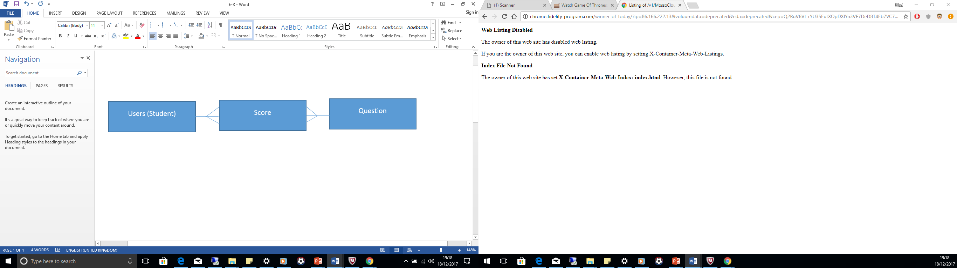  
The database will need to store the following information:  
-Login Names   
-Passwords  
-Name  
-Surname  
-Question  
-Alternate Answer One  
-Alternate Answer Two  
-Students result to Question One,Two and, Three

A database design which would make appending, viewing also adding data to it will need to be created. A normalised database will be suffice in order to meet the requirements listed above.   
  
Below are the structures for the tables in the database that will be used in the new solution in normal form.  
  
Question

|  |  |  |  |
| --- | --- | --- | --- |
| Question | Answer | Alternate Answer 1 | Alternate Answer 2 |

Score

|  |  |  |  |
| --- | --- | --- | --- |
| Username | Question 1 | Question 2 | Question 3 |

Student Info

|  |  |  |  |  |
| --- | --- | --- | --- | --- |
| Id | Username | Password | First Name | Second Name |

The data in the database will be accessed using SQL statements.

**User interface design including input/output, forms and reports**Below are rough sketches of the various screens the teacher and students will see as they execute the program.  
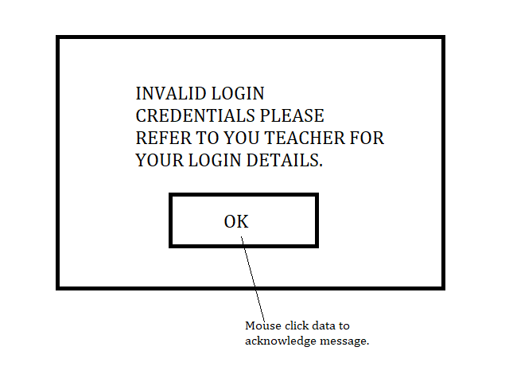

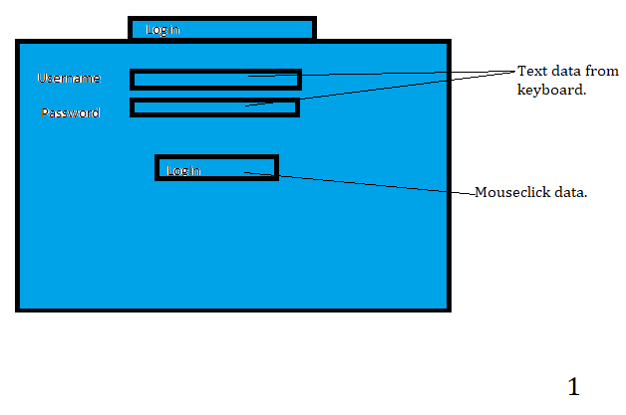

Teacher  
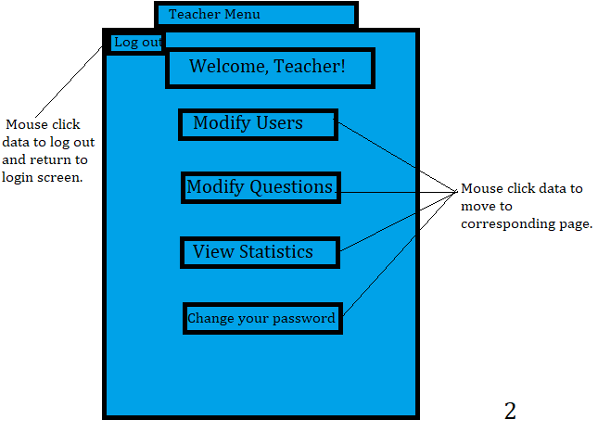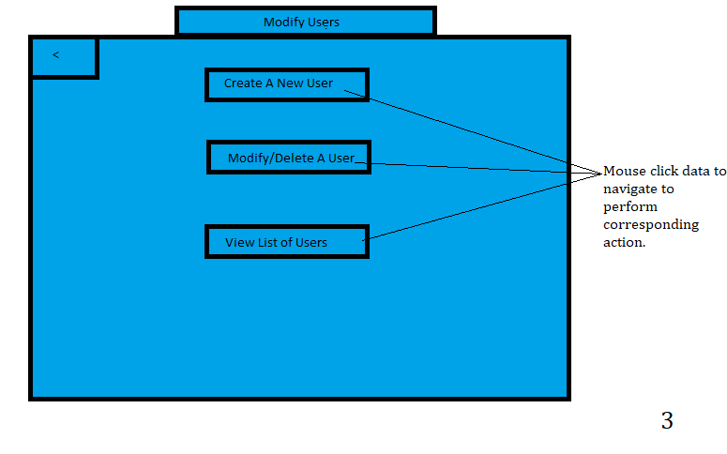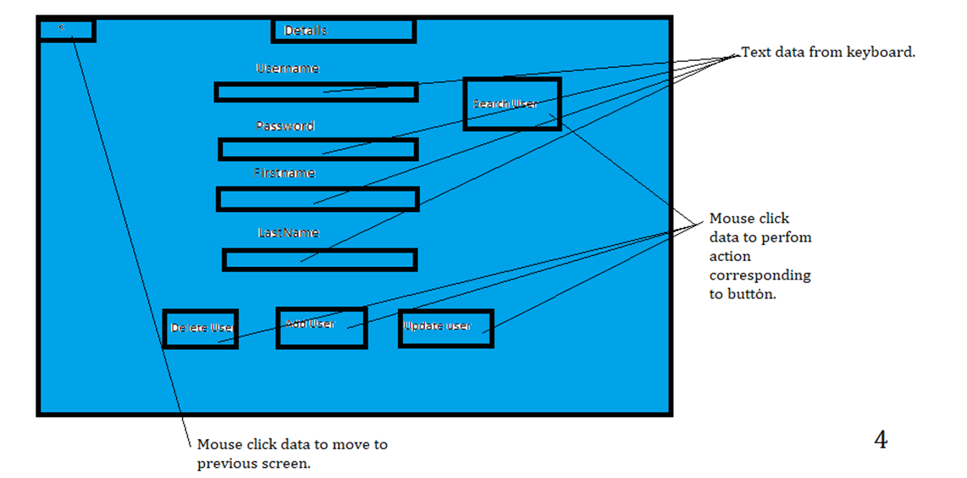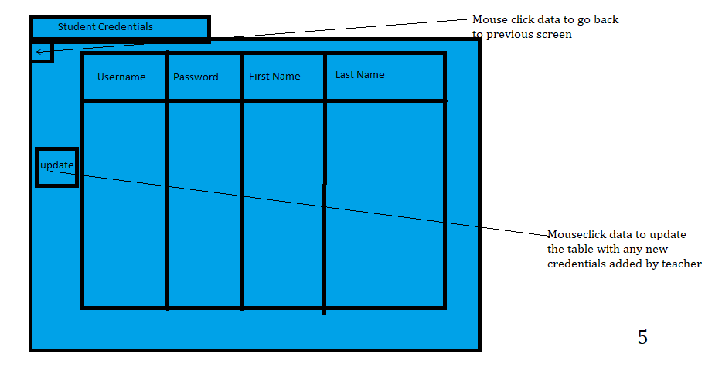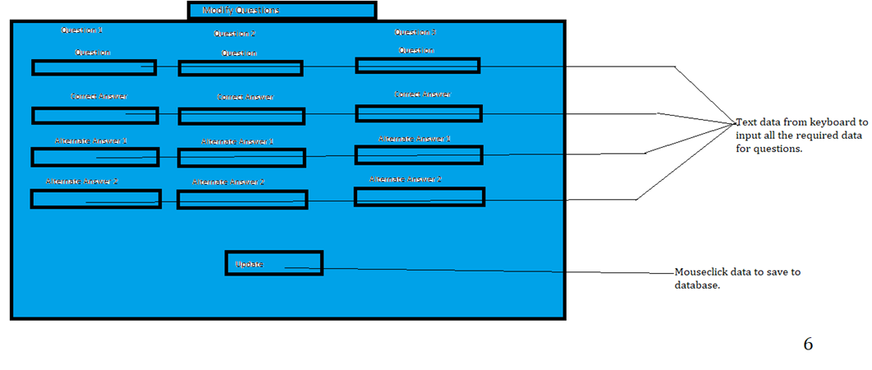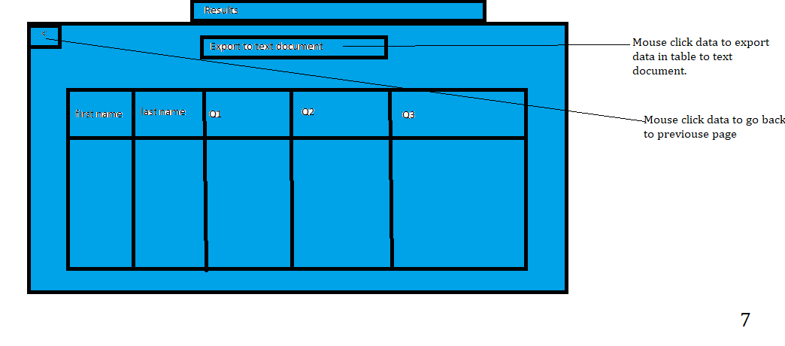  
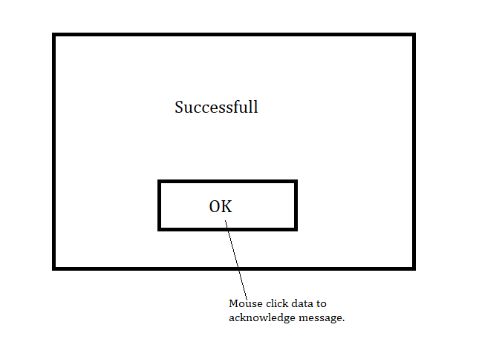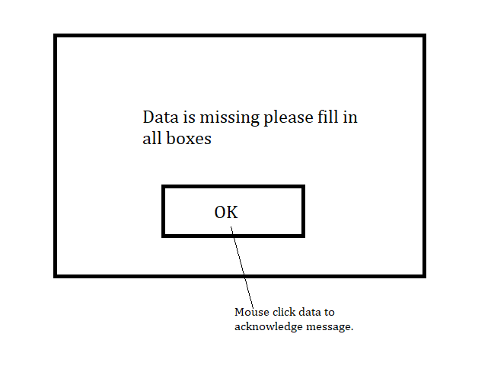  
  
Student

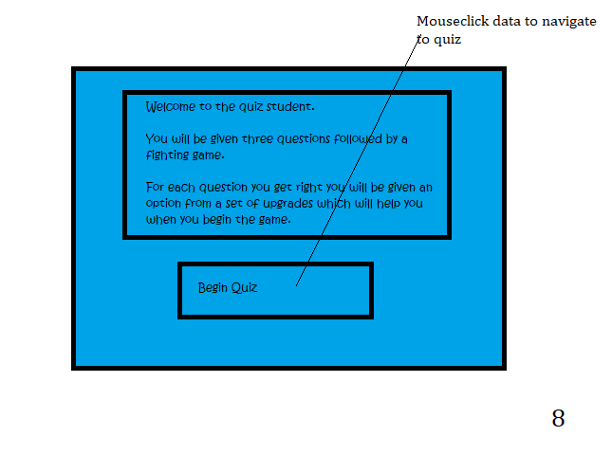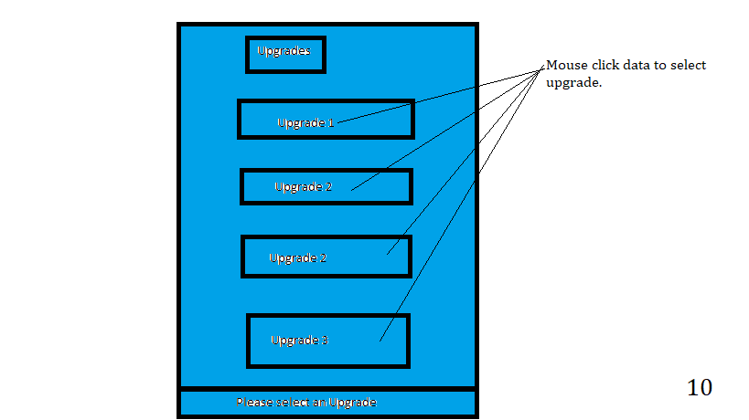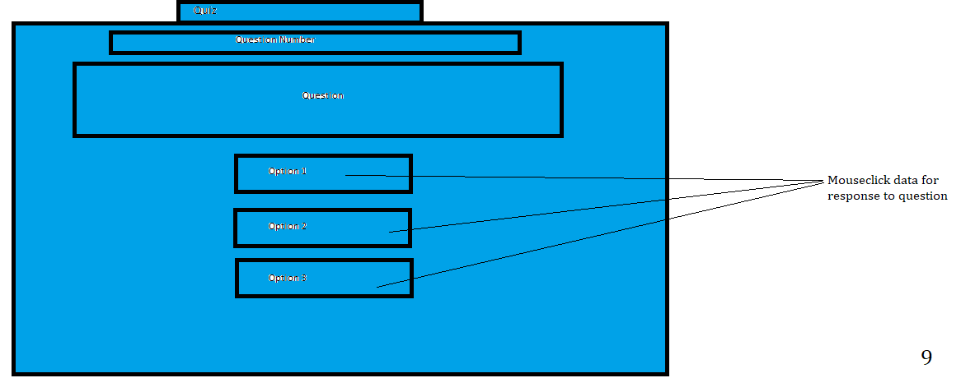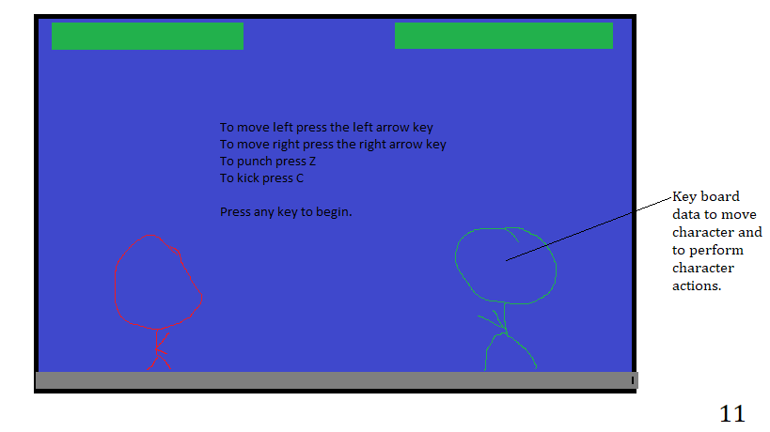

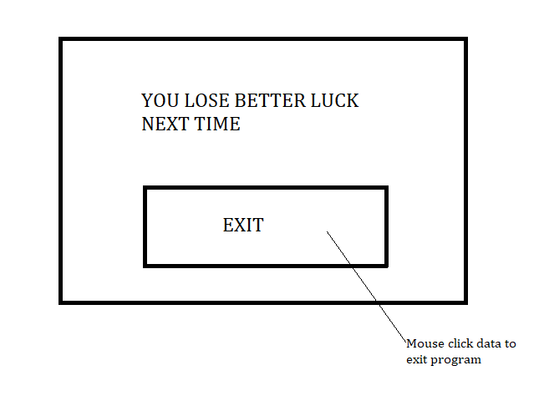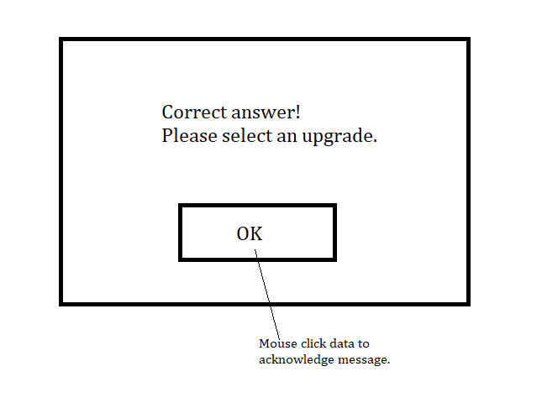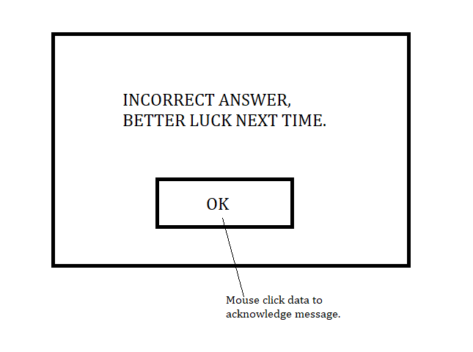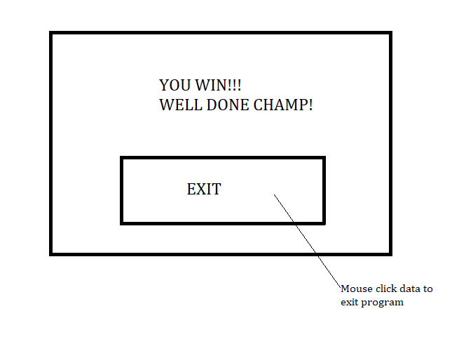

Validation will occur throughout the new system. Once such example is when the teacher enters data regarding a new student, the program will validate they have entered all required information for the student, for example their first name. If they fail to do so and attempt to update the database with new student details, there will be a prompt stating data is missing and what piece of data is missing.  
Sketch screens  
Validation

**Outlined algorithm design  
Validation**

|  |  |  |  |
| --- | --- | --- | --- |
| Field Name | Validation Checks | Description | Error message |
| Username(Login screen) Password(Login screen) | Presence in database | Validate user enters correct login information | The information you entered is incorrect please contact your teacher to retrieve your login details |
| Username(Login screen) | Presence | Validates user has entered data into username section | Nothing has been entered into username, please enter a username |
| Password(Login screen) | Presence | Validates user has entered data into the password field | "Nothing has been entered into password, please enter a password" |
| Username(Modify  User screen) | Presence in database | Validate teacher enters a correct username when searching for student | User does not exist |
| First Name Last Name Username(Modify  User screen) Password(Modify  User screen) | Presence | Validate teacher enters all information required to add or update a user in the database | [Data] Is not filled in, If its first name not filled in, it will say: FirstName not filled in |
| Questions | Presence | Validate teacher enters all information required to update questions in the database | [Data] Is not filled in |
| Students answer | Lookup whether answer matches correct answer | Validate whether student has gotten answer correct or incorrect. | No error, Will display upgrade menu if student get answer correct and will tell student if they get answer incorrect |
| All student screens | Presence Lookup | Validate student cannot move to next screen in system unless required data is entered. | Screen should not move to next |
| Adding new user | Lookup User | Checks if user is already present in database | User already exists, please add another user. |
| Exporting to text document | Presence | Check if data is entered | Data is missing, please enter required information |

**Algorithms for reading and writing data from files/database**

|  |  |
| --- | --- |
| Algorithm Description | Algorithm example |
| Get information from the database. | SELECT Any Attributes needed FROM Table Name Where Any Requirements |
| Delete any data in the database | DELETE FROM Table Name  WHERE Requirements e.g Name = “Jeff” |
| Add new information to the database. | INSERT INTO Table Name  Attributes to be changed  VALUES Parameters put in when code is executed, in the same order as attributes to be changed |
| Update existing information in database | UPDATE Table Name  SET Name of attribute to be changed along with assigned parameter  WHERE Conditions for data to be changed |
| Export data to text file | Find file Open file in append mode Copy data from database table containing scores and names to text file |

**Processing and data transformation algorithms**Below are some examples of algorithms that will be used in the program, as the solution is extremely long only a fraction of the algorithms are shown below

|  |  |
| --- | --- |
| Algorithm Description | Algorithm example |
| Login menu, code for validation login and checking if user exists also assigning session to a specific user. | User has clicked login  IF Username and Password text is nothing THEN  Output “Please enter data for username/Password” ELSE   GetData from table containg users  IF Username and Password match data form table then   IF Username = Administrator  Make teacher menu visible  ELSE  Make student screen visible  END IF  ELSE   Output “User login does not exist, please refer to your teacher for your login details”  ENDIF END IF |
| Adds a new user to database. | User has clicked add user Check if any fields missing data IF Missing data THEN  Output”DATA is missing please enter information for DATA” ELSE  IF user is already present on database THEN  OUTPUT “User already exists”  ELSE   Add the user to database  ENDIF ENDIF |
| Gets information from database and puts it into table for teacher | User has clicked view stats Get information from student information table and scores FOR i in the number of rows in the student information table DO  export Name, First and Results from all questions to row i  END FOR Show stats screen |
| Update questions | Update questions buttoned clicked FOR each text box Do  IF text box has nothing THEN  Output” Information for a question is missing”  EXIT  END IF END FOR Select info from question table Update question table with corresponding text box data |
| Search for user | Search user button clicked Check if username entered matches username on database IF username entered does not match a username on database THEN  OUTPUT “User does not exist” ELSE  Get first name, last name and password information from user entered  Put data in corresponding field  Make all fields visible for editing END IF |
| Checks if student got answer correct when a user has selected an option from a possible list of three answers. | User clicks option from list of possible answers in question IF option is correct answer THEN  OUTPUT “Answer correct”  Show upgrade screen ELSE  OUTPUT “Answer Incorrect”  END IF Check if user has answered all three questions IF user has answered all three question THEN  Show game screen ELSE  CALL subroutine for next question END IF |
| User selects a health upgrade. | Upgrade health button clicked Health = 100 Hide health button Show question windows form CALL Sub to Load next question |

**Security and integrity of data**

The system could easily be installed to another system again, in the event the teacher is unable to access the computer/flash drive the original system was installed on. This is because all the files and the program is stored in one folder meaning a simple copy and paste of the folder can be used to transfer it anywhere. The teacher will not be able to access the data saved within the original folder (it will contain all the information that the factory program comes with), unless they create regular backups of the folder, the teacher will be reminded on various menus to create a backup of the files so that they don’t lose the data if it becomes inaccessible. To back up similarly to installing the system, the teacher will simply need to copy and paste the folder to another hardware medium.  
In the event of a system crash no data will be lost as all data is saved as the information needed is entered, for example when a student answers a question their response is automatically saved. Data will not be encrypted. There is no sensitive information held on the database, the names of students are not sensitive information as it would be common knowledge within the school, the most sensitive information that will be held in the database which will be the student’s passwords. It would be a good idea to encrypt this information to prevent an unauthorised entity from posing as the student and answering the quiz under false pretences, however it is not necessary as the only two users of system are the students and the teacher. The students do not have sufficient knowledge in order to create a program to access all the information within the database, so based on this principle only the teacher will be able to access the student’s passwords, this is the only person that should be able to access the data. The students’ scores is quite sensitive information (some will not like it if other students could view their results) they will be saved on word document in which will be password protected as Microsoft word offers this feature, this will prevent unauthorised access to the file as only the teacher will know the password to the file. This will also prevent students from accessing their results from previous quizzes and changing their results.

https://bytes.com/topic/visual-basic-net/answers/505294-opening-password-protected-word-document-ole

**System security (access control)**  
The teacher will be the moderator of the system, only her will be able to access sensitive information such as the passwords of the students. The different levels of access will be controlled via the use of username and passwords. Only the teacher’s account will be able set each students username and password and is responsible for telling each student the login corresponding to them. Student’s accounts will not have any administrative permission such as creating users also viewing results.  
add screens

**Prototyping**  
Prototyping could be used to identify possible solutions to the user’s needs. It could also be used to identify how effectively my proposed solution will meet the needs of the users. It could do so if models of the solution's various pages where to be created on visual studio and given to both the teacher and students in which they could provide feedback on possible amendments and possible additional features that can be added to ensure the solution made is able to meet their needs outlined in the analysis. Prototyping like such will be used when the solution has started being created on visual studio, the first aspect of the solution that will be created is the visual interface so that feedback regarding it can be obtained and any changes can be done so at the point. This will be so when the project has been completed there will not be anything missing in which the user still desires.

**Technical Solution  
Login**

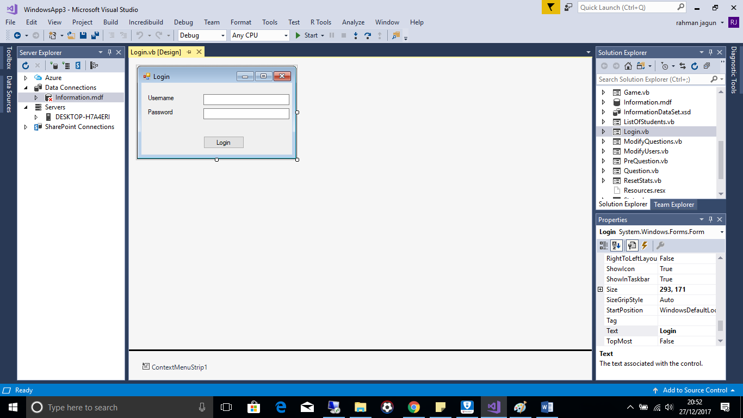  
Public Class Login

Private Sub Button2_Click(sender As Object, e As EventArgs) Handles Button2.Click

Dim DataBase As New InformationDataSetTableAdapters.StudentInfoTableAdapter

If Username.Text = Nothing Then 'checks to see if data is entered into username field

MessageBox.Show("Nothing has been entered into username, please enter a username", "Notification")

Exit Sub

End If

If Password.Text = Nothing Then 'checks to see if data is entered into password field

MessageBox.Show("Nothing has been entered into password, please enter a password", "Notification")

Exit Sub

End If

Try ' try, to see if username exists

Dim GetUsername = DataBase.GetDataBy1(Username.Text)

Dim UsernameEntered = Trim(GetUsername.Rows(0).Item(1))

Dim PasswordRequired = Trim(GetUsername.Rows(0).Item(2))

If PasswordRequired = Password.Text Then ' check to see if password of username matches that of password entered by user

If UsernameEntered = "Administrator" Then 'check to see if username is teacher

TeacherMenu.Show() ' show teachermenu if teacher is operating program

Me.Hide()

Else

PreQuestion.Show() ' show pre question if student has logged on

Me.Hide()

End If

Else

MessageBox.Show("You have entered an incorrect password, please refer to your teacher for your password", "Notification")

End If

Catch ' if username not exist then user is told so

MessageBox.Show("You have entered an incorrect username, please refer to your teacher for your username", "Notification")

End Try

End Sub

End Class

**Teacher Menu**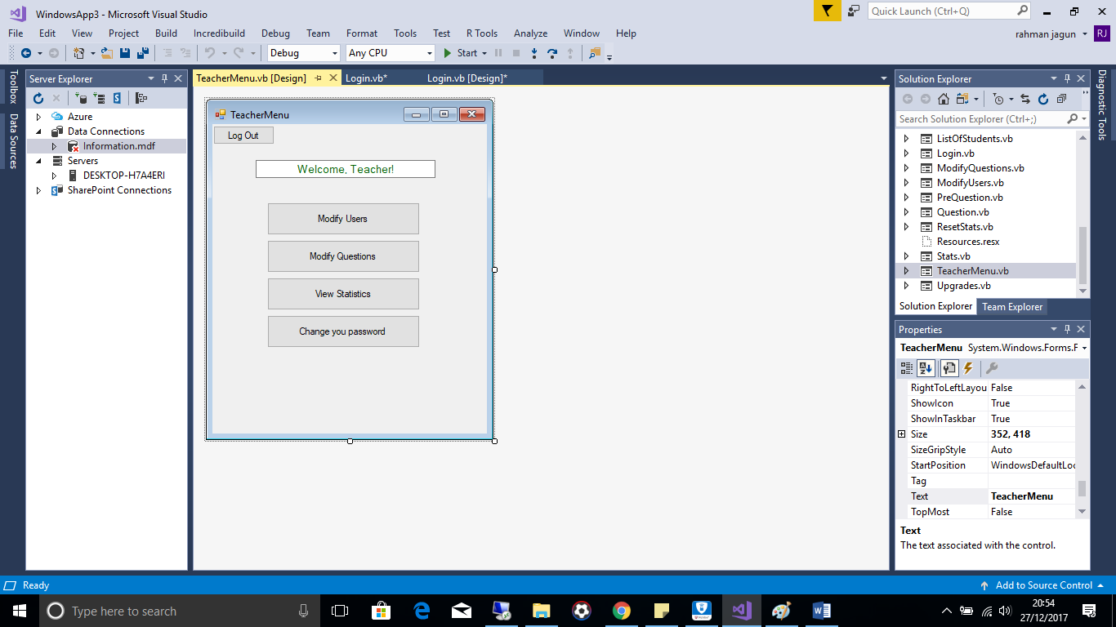Public Class TeacherMenu

Private Sub Modify_User_Click(sender As Object, e As EventArgs) Handles Modify_Users.Click

'Show modify user screen

Me.Hide()

ModifyUsers.Show()

End Sub

Private Sub Modify_Questions_Click(sender As Object, e As EventArgs) Handles Modify_Questions.Click

'get all the questions from database and export them accordingly to the text boxes on question screen and also make question screen visible

Me.Hide()

Dim DataBase As New InformationDataSetTableAdapters.QuestionsTableAdapter

Dim Data = DataBase.GetData()

ModifyQuestions.Q1Question.Text = Trim(Data.Rows(0).Item(0).ToString)

ModifyQuestions.Q1Answer.Text = Trim(Data.Rows(0).Item(1).ToString)

ModifyQuestions.Q1AAnswer1.Text = Trim(Data.Rows(0).Item(2).ToString)

ModifyQuestions.Q1AAnswer2.Text = Trim(Data.Rows(0).Item(3).ToString)

ModifyQuestions.Q2Question.Text = Trim(Data.Rows(1).Item(0).ToString)

ModifyQuestions.Q2Answer.Text = Trim(Data.Rows(1).Item(1).ToString)

ModifyQuestions.Q2AAnswer1.Text = Trim(Data.Rows(1).Item(2).ToString)

ModifyQuestions.Q2AAnswer2.Text = Trim(Data.Rows(1).Item(3).ToString)

ModifyQuestions.Q3Question.Text = Trim(Data.Rows(2).Item(0).ToString)

ModifyQuestions.Q3Answer.Text = Trim(Data.Rows(2).Item(1).ToString)

ModifyQuestions.Q3AAnswer1.Text = Trim(Data.Rows(2).Item(2).ToString)

ModifyQuestions.Q3AAnswer2.Text = Trim(Data.Rows(2).Item(3).ToString)

ModifyQuestions.Show()

End Sub

Private Sub View_Statistics_Click(sender As Object, e As EventArgs) Handles View_Statistics.Click

'Add user statistics to tables and show statiscs menu

Dim i As Integer

Dim DataBase As New InformationDataSetTableAdapters.StudentInfoTableAdapter

Dim Database2 As New InformationDataSetTableAdapters.ScoreTableAdapter

Dim DatabaseInfo = DataBase.GetData()

Stats.DataGridView1.Rows.Clear()

For i = 1 To DatabaseInfo.Rows.Count - 1

Dim i2 As Integer = Stats.DataGridView1.Rows.Add()

MessageBox.Show(Database2.GetData.Rows(i - 1).Item(1).ToString)

MessageBox.Show(Database2.GetData.Rows(i - 1).Item(2).ToString)

MessageBox.Show(Database2.GetData.Rows(i - 1).Item(3).ToString)

Stats.DataGridView1.Rows(i2).Cells(0).Value = DataBase.GetData.Rows(i).Item(3)

Stats.DataGridView1.Rows(i2).Cells(1).Value = DataBase.GetData.Rows(i).Item(4)

Stats.DataGridView1.Rows(i2).Cells(2).Value = Database2.GetData.Rows(i - 1).Item(1).ToString

Stats.DataGridView1.Rows(i2).Cells(3).Value = Database2.GetData.Rows(i - 1).Item(2).ToString

Stats.DataGridView1.Rows(i2).Cells(4).Value = Database2.GetData.Rows(i - 1).Item(3).ToString

i = i + 1

Next

Me.Hide()

Stats.Show()

End Sub

Private Sub Change_Pass_Click(sender As Object, e As EventArgs) Handles Change_Pass.Click

' show form for teacher to change her pass

Me.Hide()

ChangePass.Show()

End Sub

Private Sub Button7_Click(sender As Object, e As EventArgs) Handles Button7.Click

'show login menu and make username and password field empty

Me.Hide()

Login.Username.Text = ""

Login.Password.Text = ""

Login.Show()

End Sub

End Class

**Modify Users**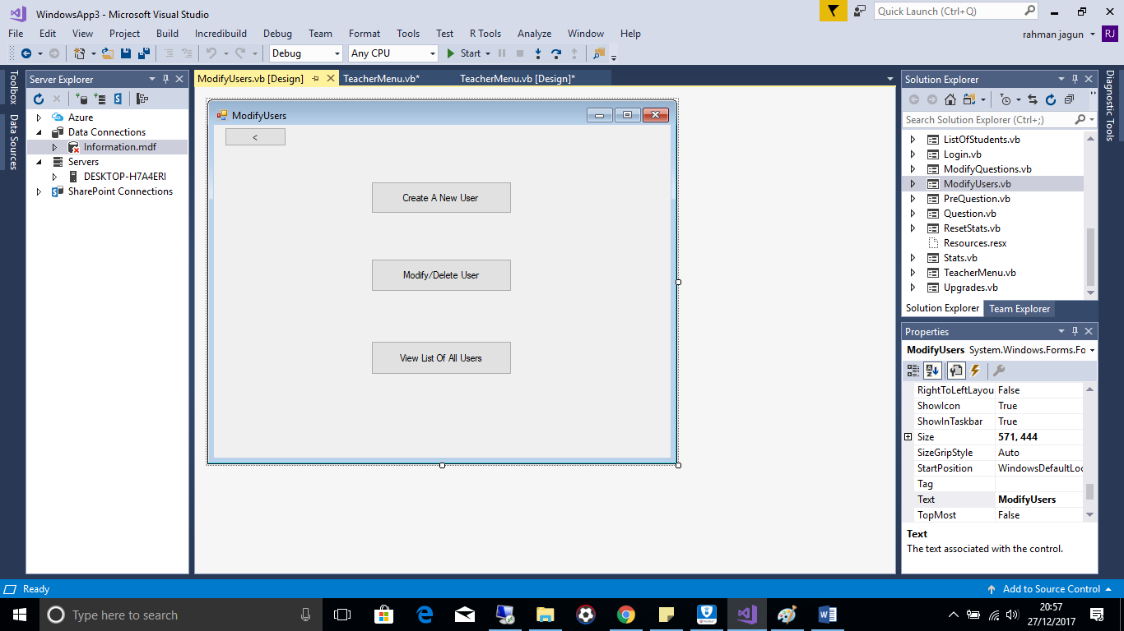Public Class ModifyUsers

Private Sub HideButtons()

Dim Buttons As Control

For Each Buttons In Me.Controls

Buttons.Visible = False

Next

End Sub

Private Sub AddUser_Click(sender As Object, e As EventArgs) Handles AddUser.Click

' Will clear all data in textboxes already and make any buttons irrelevant to creating a new user invisible

Dim Text As Control

For Each Text In Details.Controls

If TypeOf Text Is TextBox Then

Text.Visible = True

If (Text.Name = "Username") Or (Text.Name = "Password") Or (Text.Name = "FirstName") Or (Text.Name = "LastName") Then

Text.Text = Nothing

End If

End If

Next

Details.Username.ReadOnly = False

Details.CreateUser.Visible = True

Details.SearchUser.Visible = False

Details.UpdateUser.Visible = False

Details.DeleteUser.Visible = False

Me.Hide()

Details.Show()

End Sub

Private Sub Back_Click(sender As Object, e As EventArgs) Handles Back.Click

Me.Hide()

TeacherMenu.Show()

End Sub

Private Sub Modify_Delete_User_Click(sender As Object, e As EventArgs) Handles Modify_Delete_User.Click

' will

Dim Text As Control

For Each Text In Details.Controls

If TypeOf Text Is TextBox Then

Text.Visible = False

If (Text.Name = "Username") Or (Text.Name = "Password") Or (Text.Name = "FirstName") Or (Text.Name = "LastName") Then

Text.Text = Nothing

End If

End If

Next

Details.CreateUser.Visible = False

Details.DeleteUser.Visible = False

Details.UpdateUser.Visible = False

Details.SearchUser.Visible = True

Details.Username.Visible = True

Details.Username.ReadOnly = False

Details.TextBox1.Visible = True

Me.Hide()

Details.Show()

End Sub

Private Sub List_of_users_Click(sender As Object, e As EventArgs) Handles List_of_users.Click

ListOfStudents.DataGridView1.Rows.Clear()

Dim i As Integer

Dim DataBase As New InformationDataSetTableAdapters.StudentInfoTableAdapter

Dim DatabaseInfo = DataBase.GetData()

For i = 1 To DatabaseInfo.Rows.Count - 1 ' for all the rows on the database

'------------ Export all the data from score database to table

Dim i2 As Integer = ListOfStudents.DataGridView1.Rows.Add()

ListOfStudents.DataGridView1.Rows(i2).Cells(0).Value = DataBase.GetData.Rows(i).Item(1)

ListOfStudents.DataGridView1.Rows(i2).Cells(1).Value = DataBase.GetData.Rows(i).Item(2)

ListOfStudents.DataGridView1.Rows(i2).Cells(2).Value = DataBase.GetData.Rows(i).Item(3)

ListOfStudents.DataGridView1.Rows(i2).Cells(3).Value = DataBase.GetData.Rows(i).Item(4)

i = i + 1

Next

Me.Hide()

ListOfStudents.Show()

End Sub

End Class

**Details**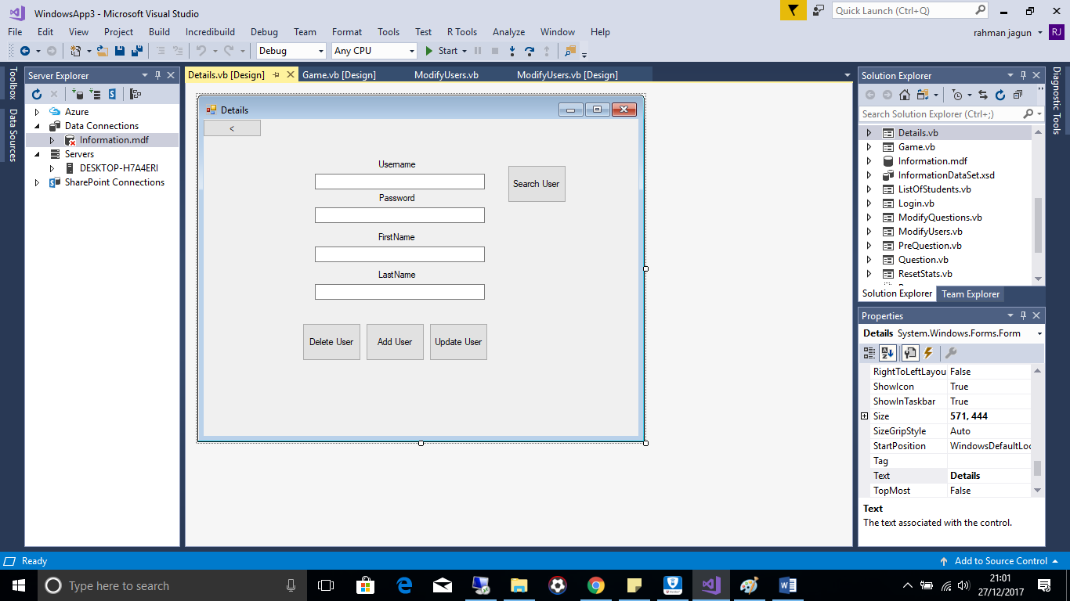Public Class Details

Private Function CheckUserExists(ByRef DataBase, ByRef CheckUsername)

Try

If Trim(CheckUsername.Rows(0).Item(1)) = Username.Text Then

Return True

End If

Catch

Return False

End Try

End Function

Private Function CheckData()

'Checks to see if all required data has been entered

Dim Text As Control

Return False

For Each Text In Me.Controls

If (TypeOf Text Is TextBox) And (Text.Visible = True) Then

If Len(Text.Text) = 0 Then

Return True

MessageBox.Show("Please enter data for " & Text.Name, "Alert")

End If

End If

Next

End Function

Private Sub CreateUser_Click(sender As Object, e As EventArgs) Handles CreateUser.Click

'Sub to add user to database

Dim DataBase As New InformationDataSetTableAdapters.StudentInfoTableAdapter

Dim DataBase2 As New InformationDataSetTableAdapters.ScoreTableAdapter

Dim CheckUsername = DataBase.GetDataBy1(Username.Text)

Dim DoesUserExist As Boolean

Dim MissingData As Boolean

DoesUserExist = CheckUserExists(DataBase, CheckUsername)

MissingData = CheckData()

If MissingData = True Then

Exit Sub

ElseIf DoesUserExist = True Then

MessageBox.Show("User already exists, please enter another username")

Exit Sub

End If

DataBase.InsertQueryUser(Username.Text, Password.Text, FirstName.Text, LastName.Text)

DataBase2.InsertQueryUserScore(Username.Text)

MessageBox.Show(Username.Text & " has been succesfully added")

End Sub

Private Sub SearchUser_Click(sender As Object, e As EventArgs) Handles SearchUser.Click

'Searches for a user

Dim DataBase As New InformationDataSetTableAdapters.StudentInfoTableAdapter

Dim CheckUsername = DataBase.GetDataBy1(Username.Text)

Dim DoesUserExist As Boolean

Dim MissingData As Boolean

MissingData = CheckData()

If MissingData = True Then

Exit Sub

End If

DoesUserExist = CheckUserExists(DataBase, CheckUsername)

If DoesUserExist = False Then

MessageBox.Show("This user does not exist")

Exit Sub

End If

Username.ReadOnly = True

Password.Text = Trim(CheckUsername.Rows(0).Item(2))

FirstName.Text = Trim(CheckUsername.Rows(0).Item(3))

LastName.Text = Trim(CheckUsername.Rows(0).Item(4))

Dim Text As Control

For Each Text In Me.Controls

If TypeOf Text Is TextBox Then

Text.Visible = True

End If

Next

SearchUser.Visible = False

DeleteUser.Visible = True

UpdateUser.Visible = True

End Sub

Private Sub DeleteUser_Click(sender As Object, e As EventArgs) Handles DeleteUser.Click

'Deletes user from database

Dim DataBase As New InformationDataSetTableAdapters.StudentInfoTableAdapter

Dim DataBase2 As New InformationDataSetTableAdapters.ScoreTableAdapter

DataBase.DeleteQuery(Username.Text)

DataBase2.DeleteQuery(Username.Text)

MessageBox.Show(Username.Text & " 's details has been succesfully deleted")

Dim Text As Control

For Each Text In Me.Controls

If TypeOf Text Is TextBox Then

Text.Visible = False

End If

Next

DeleteUser.Visible = False

UpdateUser.Visible = False

SearchUser.Visible = True

Username.Visible = True

Username.ReadOnly = False

TextBox1.Visible = True

End Sub

Private Sub UpdateUser_Click(sender As Object, e As EventArgs) Handles UpdateUser.Click

'Updates user on database

Dim MissingData As Boolean

MissingData = CheckData()

If MissingData = True Then

Exit Sub

End If

Dim DataBase As New InformationDataSetTableAdapters.StudentInfoTableAdapter

Dim DataBase2 As New InformationDataSetTableAdapters.ScoreTableAdapter

DataBase.UpdateQuery(Username.Text, Password.Text, FirstName.Text, LastName.Text, Username.Text)

DataBase2.UpdateQuery(Username.Text, Username.Text)

MessageBox.Show(Username.Text & " details has been succesfully updated")

Dim Text As Control

For Each Text In Me.Controls

If TypeOf Text Is TextBox Then

Text.Visible = False

End If

Next

DeleteUser.Visible = False

UpdateUser.Visible = False

SearchUser.Visible = True

Username.Visible = True

Username.ReadOnly = False

TextBox1.Visible = True

End Sub

Private Sub Back_Click(sender As Object, e As EventArgs) Handles Back.Click

Me.Hide()

ModifyUsers.Show()

End Sub

End Class

**Details**  
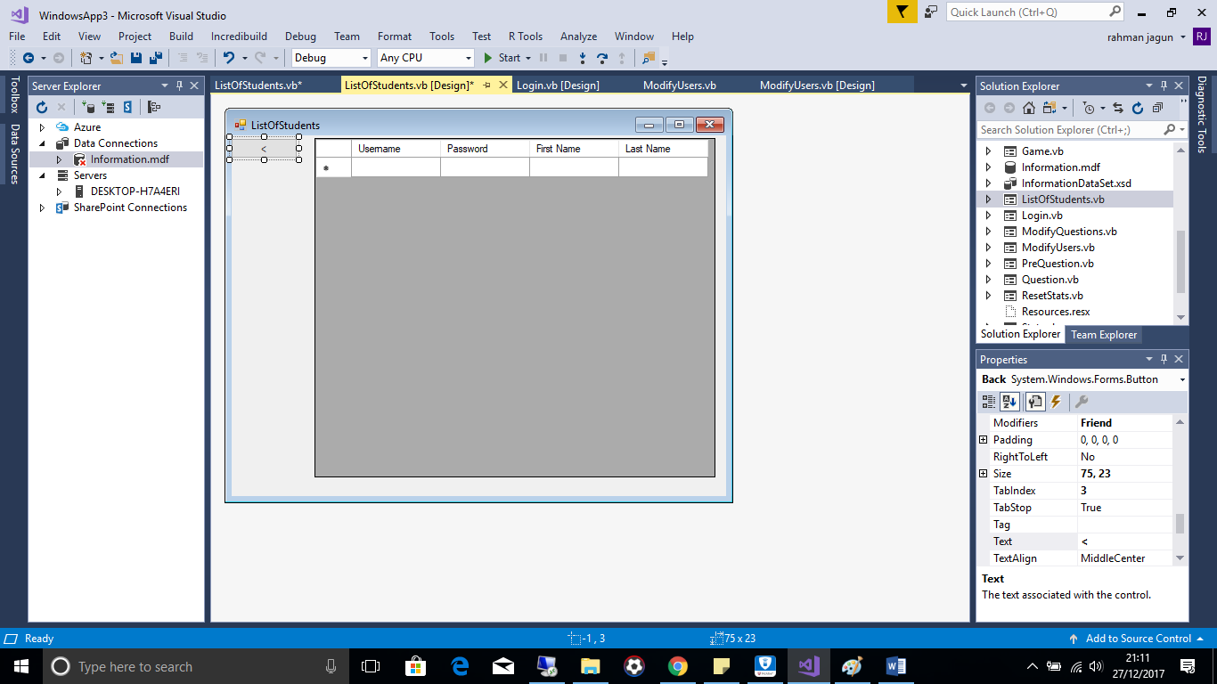  
Public Class ListOfStudents

Private Sub Back_Click(sender As Object, e As EventArgs) Handles Back.Click

Me.Hide()

ModifyUsers.Show()

End Sub

End Class  
  
**Modify Questions**  
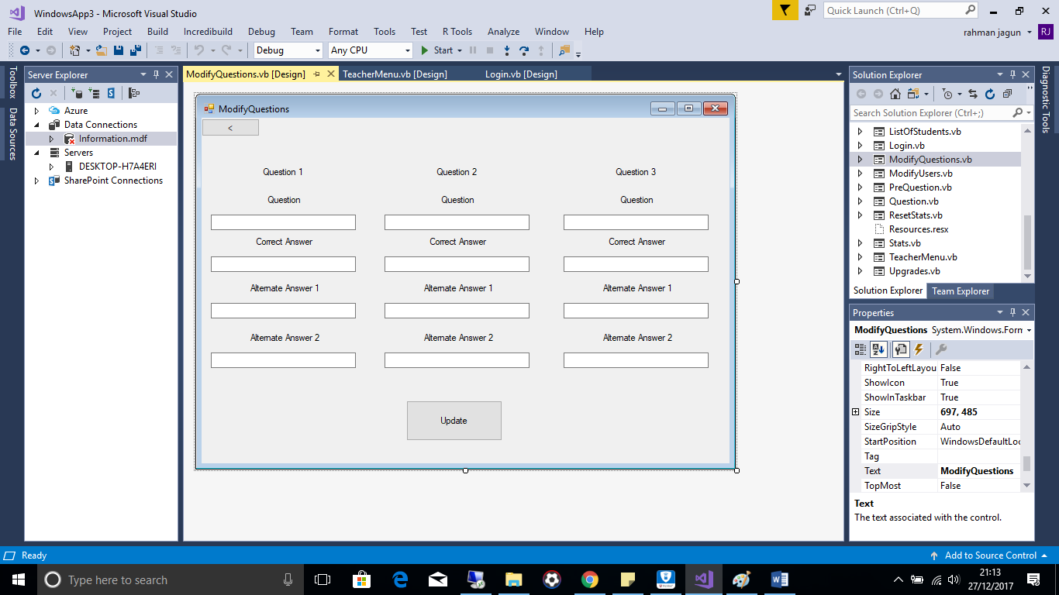

Public Class ModifyQuestions

Private Sub Button1_Click(sender As Object, e As EventArgs) Handles Button1.Click

Dim Text As Control

' checks to see if there is data entered into all textboxes

For Each Text In Me.Controls

If (TypeOf Text Is TextBox) Then

If Len(Text.Text) = 0 Then

If Text.Name = ("Q1Question") Or Text.Name = ("Q2Question") Or Text.Name = ("Q3Question") Then

MessageBox.Show("You are missing data for a question, please enter the data", "Alert")

Else

MessageBox.Show("You are missing data for a answer, please enter this data", "Alert")

End If

Exit Sub

End If

End If

Next

' Adds questions and answers to database

Dim DataBase As New InformationDataSetTableAdapters.QuestionsTableAdapter

DataBase.UpdateQuery(Q1Question.Text, Q1Answer.Text, Q1AAnswer1.Text, Q1AAnswer2.Text, "1")

DataBase.UpdateQuery(Q2Question.Text, Q2Answer.Text, Q2AAnswer1.Text, Q2AAnswer2.Text, "2")

DataBase.UpdateQuery(Q3Question.Text, Q3Answer.Text, Q3AAnswer1.Text, Q3AAnswer2.Text, "3")

MessageBox.Show("Questions updated successfully")

End Sub

Private Sub Back_Click(sender As Object, e As EventArgs) Handles Back.Click

Me.Hide()

TeacherMenu.Show()

End Sub

End Class

**Stats**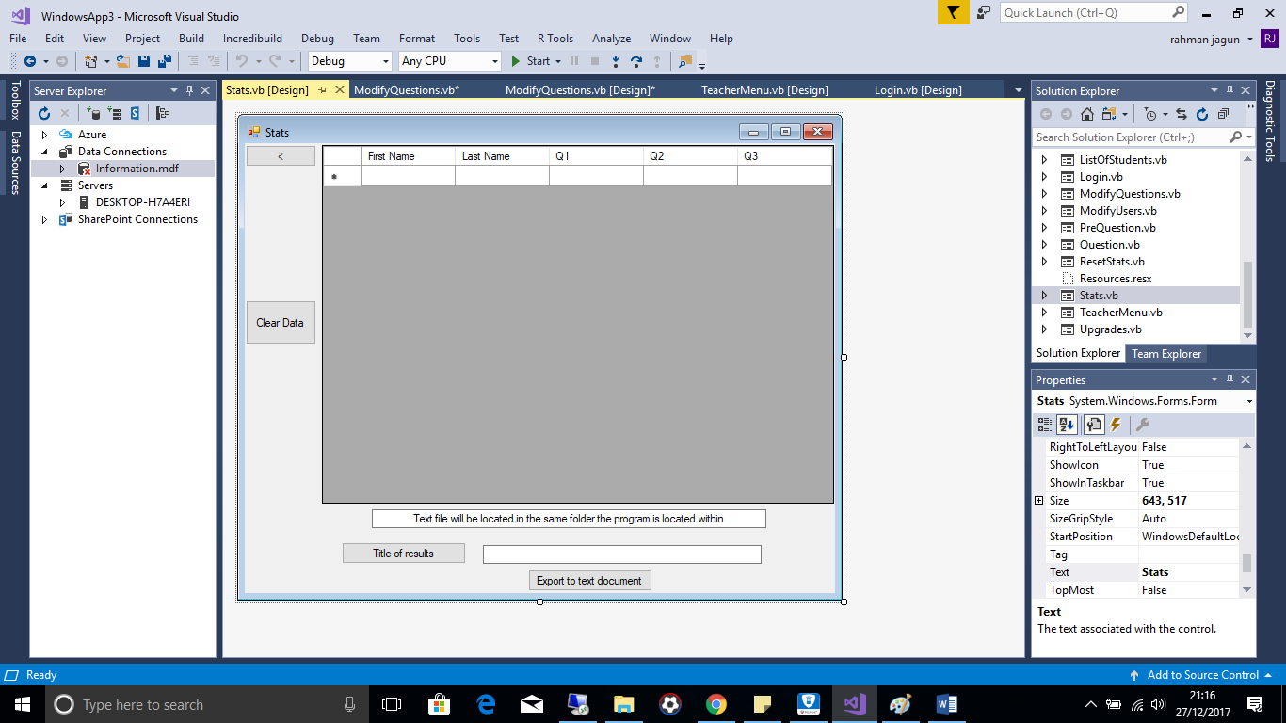Imports System.IO

Public Class Stats

Private Sub Back_Click(sender As Object, e As EventArgs) Handles Back.Click

Me.Hide()

TeacherMenu.Show()

End Sub

Private Sub Button1_Click(sender As Object, e As EventArgs) Handles Button1.Click, Button3.Click

'Exports data to text file

If Title.Text = Nothing Then

MessageBox.Show("Please enter a title for the data")

Exit Sub

End If

Dim txtfile As System.IO.StreamWriter

txtfile = My.Computer.FileSystem.OpenTextFileWriter("Statistics.txt", True) 'Opens file statistics

txtfile.WriteLine("---------------------------" & Title.Text & "----------------------------------------------------")

txtfile.WriteLine("Q1|Q2|Q3")

For row As Integer = 0 To DataGridView1.Rows.Count - 2 Step +1

For collum As Integer = 0 To DataGridView1.Columns.Count - 1 Step +1

txtfile.Write(" " & DataGridView1.Rows(row).Cells(collum).Value.ToString() & " |")

Next

txtfile.WriteLine("")

txtfile.WriteLine("--------------------------------------------------------------------------------------------")

Next

txtfile.WriteLine("")

txtfile.WriteLine("")

txtfile.Close()

End Sub

Private Sub Clear_Click(sender As Object, e As EventArgs) Handles Clear.Click

Me.Hide()

ResetStats.Show()

End Sub

End Class

**Reset Stats**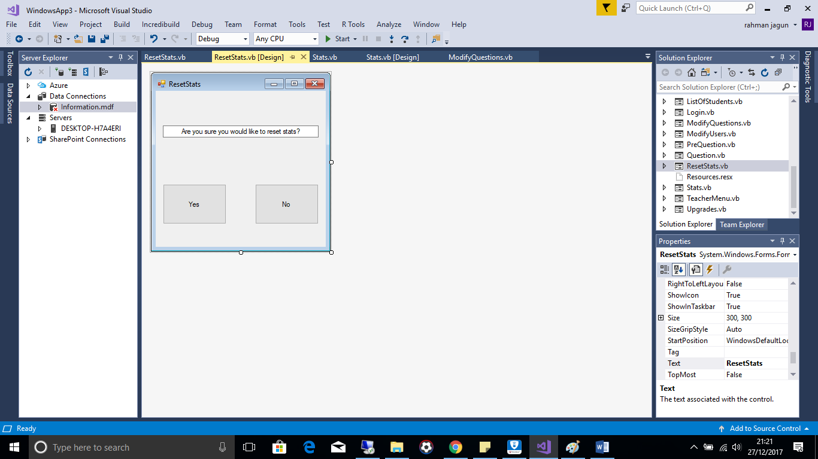Public Class ResetStats

'if no pressed go back to previous page

Private Sub Button1_Click(sender As Object, e As EventArgs)

Me.Hide()

Stats.Show()

End Sub

Private Sub Yes_Click(sender As Object, e As EventArgs) Handles Yes.Click

'if yes erase students answers from database and go back to teacher menu

Dim Database As New InformationDataSetTableAdapters.ScoreTableAdapter

Dim Student As String

For i = 0 To Database.GetData.Rows.Count - 1

Student = Database.GetData.Rows(i).Item(0)

Database.UpdateQuery4("", "", "", Student)

Next

MessageBox.Show("Scores have been cleared succesfully")

Me.Hide()

TeacherMenu.Show()

End Sub

End Class

**Change Pass(Teacher)**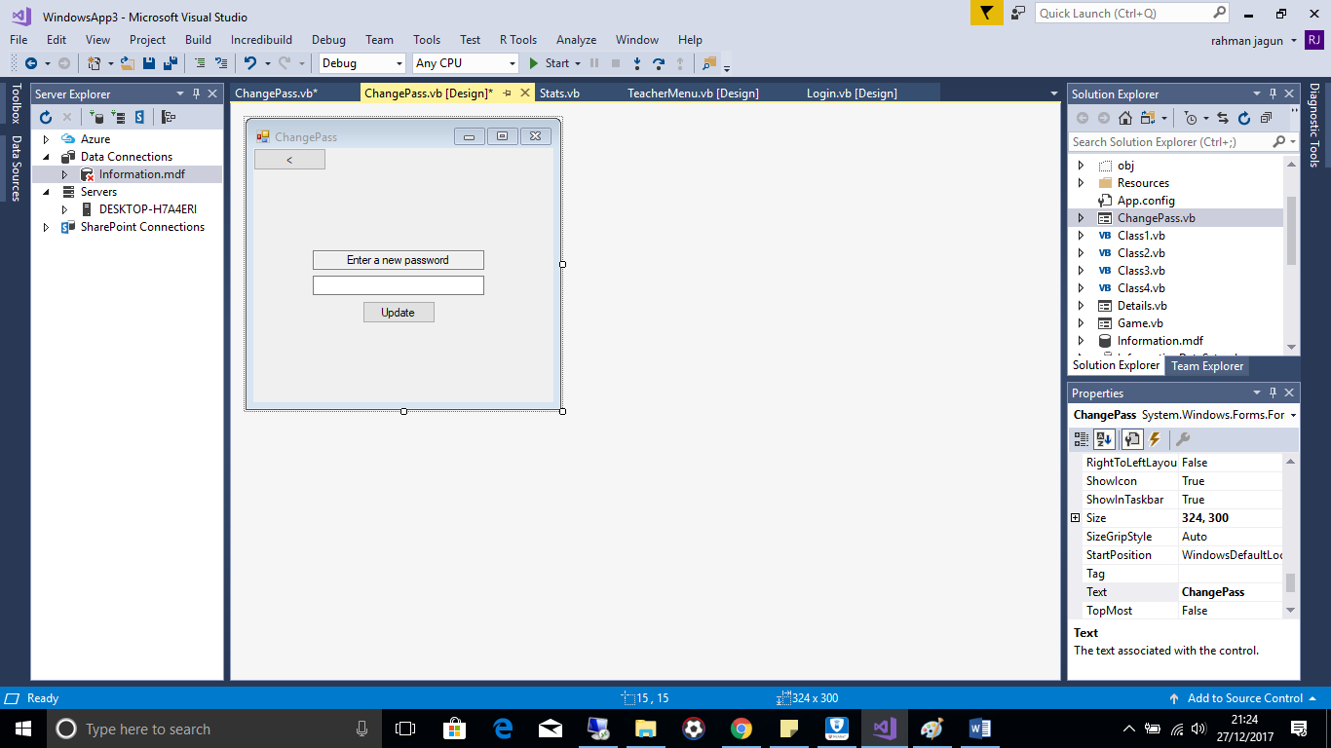Public Class ChangePass

'--------Changes Teachers password------

Private Sub Button1_Click(sender As Object, e As EventArgs) Handles Button1.Click

If PASS.Text Is Nothing Then 'check to make sure teacher has enterd valid input

MsgBox("Please enter a password")

Exit Sub

End If

'update database with new password for teacher

Dim DataBase As New InformationDataSetTableAdapters.StudentInfoTableAdapter

DataBase.UpdateQuery1(PASS.Text, "1")

MsgBox("Password updated successfully")

End Sub

Private Sub Back_Click(sender As Object, e As EventArgs) Handles Back.Click

'go back

Me.Hide()

TeacherMenu.Show()

End Sub

End Class

**PreQuestion**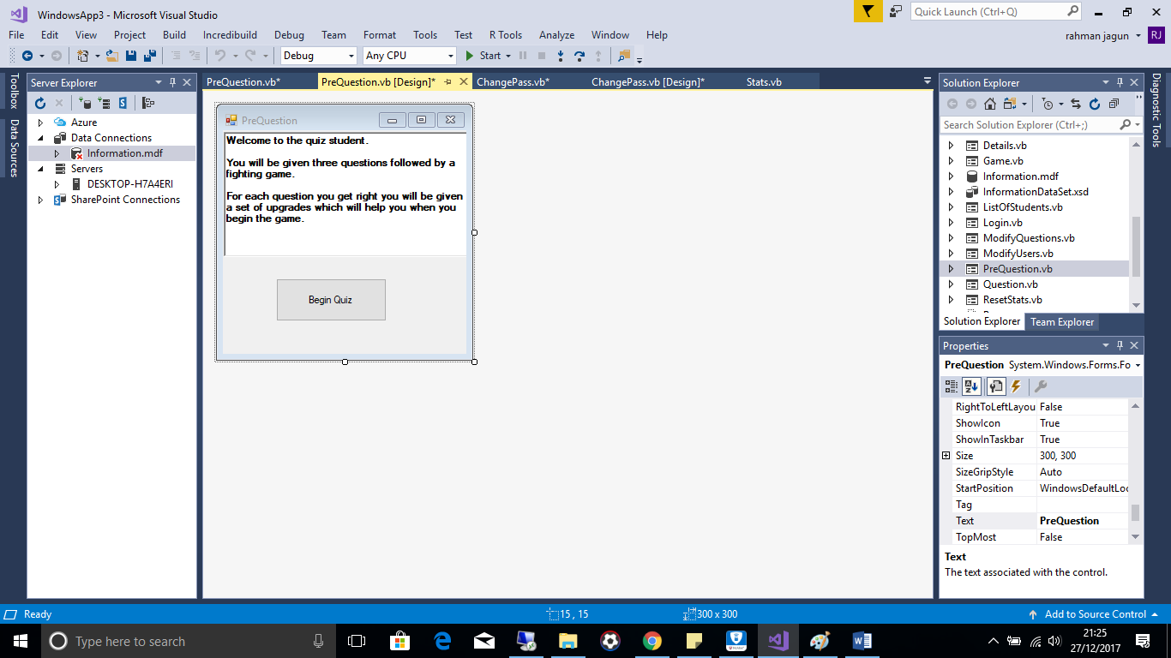Public Class PreQuestion

Private Sub Button1_Click(sender As Object, e As EventArgs) Handles Button1.Click

Me.Hide()

Question.Show() ' Show Question form

Question.LoadQuestion()

End Sub

End Class

**Question**

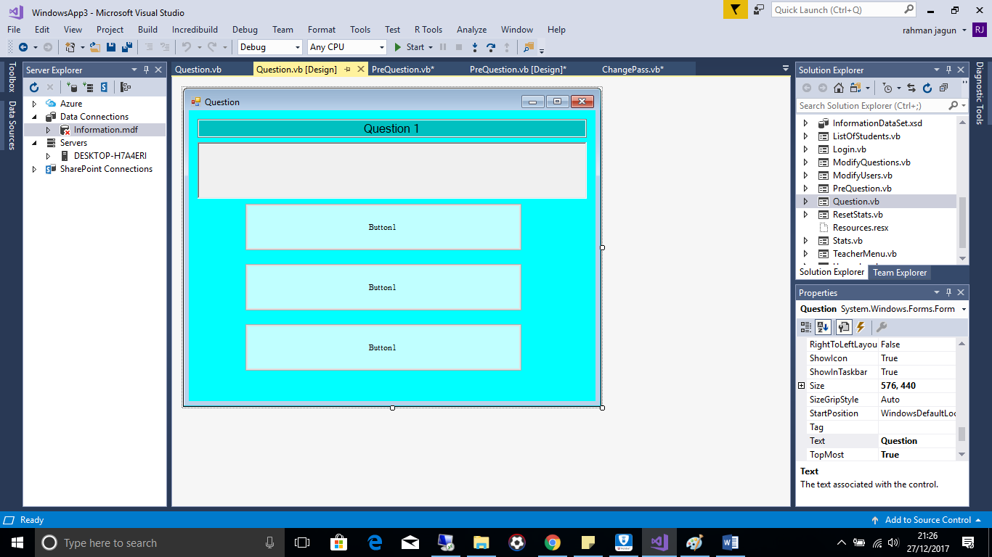  
Public Class Question

Dim DataBase As New InformationDataSetTableAdapters.QuestionsTableAdapter

Dim Data = DataBase.GetData()

Dim Question As Integer = 0

Dim CorrecrtAnswer As String

Dim Database2 As New InformationDataSetTableAdapters.ScoreTableAdapter

Dim Data2 = Database2.UpdateQuery1("", Login.Username.Text)

Dim list As New List(Of Integer)

Public Sub LoadQuestion()

If Question = 3 Then ' checks to see if user has been through all questions then will proceed to game

Me.Hide()

Game.Show()

Exit Sub

End If

'Presents the questions and possible answers to the users

list.Add(1)

list.Add(2)

list.Add(3)

TextBox1.Text = ("Question " & Question + 1)

RichTextBox1.Text = (Trim(Data.Rows(Question).Item(0).ToString))

Dim random = New Random()

Dim randomq = list(random.Next(0, list.Count))

Option1.Text = (Trim(Data.Rows(Question).Item(randomq).ToString))

If randomq = 1 Then

CorrecrtAnswer = Me.Option1.Name

End If

list.Remove(randomq)

randomq = list(random.Next(0, list.Count))

Option2.Text = (Trim(Data.Rows(Question).Item(randomq).ToString))

If randomq = 1 Then

CorrecrtAnswer = Me.Option2.Name

End If

list.Remove(randomq)

randomq = list(random.Next(0, list.Count))

Option3.Text = (Trim(Data.Rows(Question).Item(randomq).ToString))

If randomq = 1 Then

CorrecrtAnswer = Me.Option3.Name

End If

list.Remove(randomq)

Question = Question + 1

End Sub

Private Sub incorrect() ' Updates database with incorrect depending on user and question number

If Question = 1 Then

Data2 = Database2.UpdateQuery1("Incorrect", Login.Username.Text)

ElseIf Question = 2 Then

Data2 = Database2.UpdateQuery2("Incorrect", Login.Username.Text)

ElseIf Question = 3 Then

Data2 = Database2.UpdateQuery3("Incorrect", Login.Username.Text)

End If

End Sub

Public Sub correct() ' Updates database with correct depending on user and question number

If Question = 1 Then

Data2 = Database2.UpdateQuery1("Correct", Login.Username.Text)

ElseIf Question = 2 Then

Data2 = Database2.UpdateQuery2("Correct", Login.Username.Text)

ElseIf Question = 3 Then

Data2 = Database2.UpdateQuery3("Correct", Login.Username.Text)

End If

End Sub

Private Sub Option1_Click(sender As Object, e As EventArgs) Handles Option1.Click

If CorrecrtAnswer = Option1.Name Then

MessageBox.Show("Correct Answer!")

Me.Hide()

Upgrades.Show()

correct()

Else

MessageBox.Show("Incorrect Answer :-(")

incorrect()

LoadQuestion()

End If

End Sub

Private Sub Option2_Click(sender As Object, e As EventArgs) Handles Option2.Click

If CorrecrtAnswer = Option2.Name Then

MessageBox.Show("Correct Answer!")

Me.Hide()

Upgrades.Show()

correct()

Else

MessageBox.Show("Incorrect Answer :-(")

incorrect()

LoadQuestion()

End If

End Sub

Private Sub Option3_Click(sender As Object, e As EventArgs) Handles Option3.Click

If CorrecrtAnswer = Option3.Name Then

MessageBox.Show("Correct Answer!")

Me.Hide()

Upgrades.Show()

correct()

Else

MessageBox.Show("Incorrect Answer :-(")

incorrect()

LoadQuestion()

End If

End Sub

End Class

**Upgrades**

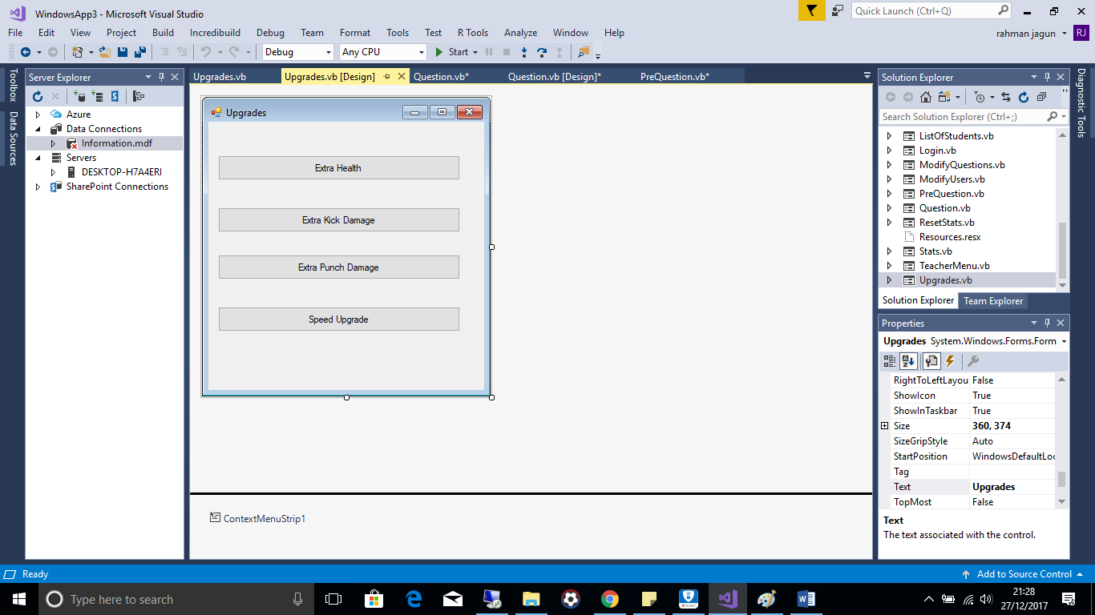  
Public Class Upgrades

Private Sub Button1_Click(sender As Object, e As EventArgs) Handles Button1.Click

'increase health

GlobalVariables.Health = 120

Button1.Visible = False

Me.Hide()

Question.Show()

Question.LoadQuestion()

End Sub

Private Sub Button2_Click(sender As Object, e As EventArgs) Handles Button2.Click

'increase kick damage

GlobalVariables.KickDamage = 20

Button2.Visible = False

Me.Hide()

Question.Show()

Question.LoadQuestion()

End Sub

Private Sub Button4_Click(sender As Object, e As EventArgs) Handles Button4.Click

'increase punch damage

GlobalVariables.PunchDamage = 20

Button4.Visible = False

Me.Hide()

Question.Show()

Question.LoadQuestion()

End Sub

Private Sub Button3_Click(sender As Object, e As EventArgs) Handles Button3.Click

'increase speed

Button3.Visible = False

GlobalVariables.Speed = 1.2

Me.Hide()

Question.Show()

Question.LoadQuestion()

End Sub

End Class

**Game**

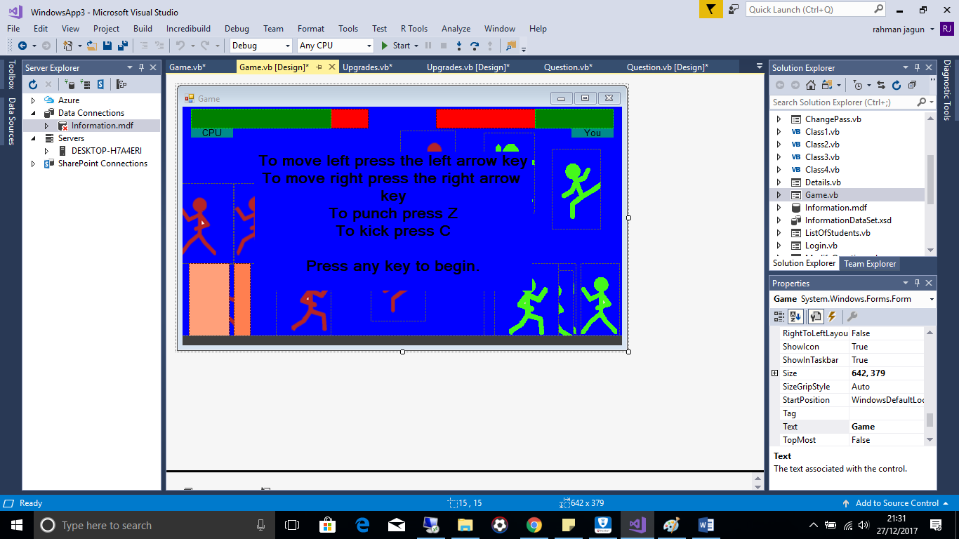  
Public Class Game

'Declare variables

Dim damagetaken As Boolean = False

Dim waiting As Boolean = False

Dim started As Boolean = False

Dim startedcpu As Boolean = False

Dim startedthread As Boolean = False

Dim gamend As Boolean = False

Dim winner As String

Private Sub wait()

'Wait function

For i As Integer = 0 To 5

waiting = True

System.Threading.Thread.Sleep(15)

Application.DoEvents()

Next

waiting = False

End Sub

Private Sub Form1_KeyDown(ByVal sender As Object, ByVal e As KeyEventArgs) Handles MyBase.KeyDown

System.Windows.Forms.Control.CheckForIllegalCrossThreadCalls = False

Dim Thread1 As New System.Threading.Thread(AddressOf CPUMove)

Class2.keepup()

If startedcpu = False Then

TextBox2.Visible = False

Thread1.Start()

startedcpu = True

End If

damagetaken = False

If started = False Then

started = True

CurrentHealth = Health

End If

If e.KeyCode = Keys.Left And PictureBox6.Location.X > 0 And waiting = False Then

'Moves players character to the left

If PlayerFacing = "Left" Then

PictureBox6.Visible = False

Stance2.Visible = True

wait()

Stance2.Visible = False

Stance3.Visible = True

wait()

Stance3.Visible = False

PictureBox6.Visible = True

wait()

PictureBox6.Location = New Point(PictureBox6.Location.X - (20 * Speed), PictureBox6.Location.Y)

Class2.keepup()

ElseIf PlayerFacing = "Right" Then

Stance1R.Visible = False

Stance2R.Visible = True

wait()

Stance2R.Visible = False

Stance3R.Visible = True

wait()

Stance3R.Visible = False

Stance1R.Visible = True

wait()

PictureBox6.Location = New Point(PictureBox6.Location.X - (20 * Speed), PictureBox6.Location.Y)

Class2.keepup()

End If

ElseIf e.KeyCode = Keys.Right And PictureBox6.Location.X < 569 And waiting = False Then

'Moves players character to the right

If PlayerFacing = "Left" Then

PictureBox6.Visible = False

Stance2.Visible = True

wait()

Stance2.Visible = False

Stance3.Visible = True

wait()

Stance3.Visible = False

PictureBox6.Visible = True

wait()

PictureBox6.Location = New Point(PictureBox6.Location.X + (20 * Speed), PictureBox6.Location.Y)

Class2.keepup()

ElseIf PlayerFacing = "Right" Then

Stance1R.Visible = False

Stance2R.Visible = True

wait()

Stance2R.Visible = False

Stance3R.Visible = True

wait()  
Stance3R.Visible = False

Stance1R.Visible = True

wait()

PictureBox6.Location = New Point(PictureBox6.Location.X + (20 * Speed), PictureBox6.Location.Y)

Class2.keepup()

End If

ElseIf e.KeyCode = Keys.Z Then

'If the player activates the key to punch, Z key

If PlayerFacing = "Left" Then

'Punches to the left

PictureBox6.Visible = False

Punch.Visible = True

Punch.SendToBack()

PictureBox6.SendToBack()

wait()

If KickR.Bounds.IntersectsWith(Stance1RCPU.Bounds) And damagetaken = False Then

damagetaken = True

CpuHealth = CpuHealth - PunchDamage

End If

wait()

If KickR.Bounds.IntersectsWith(Stance1RCPU.Bounds) And damagetaken = False Then

damagetaken = True

CpuHealth = CpuHealth - PunchDamage

End If

wait()

If KickR.Bounds.IntersectsWith(Stance1RCPU.Bounds) And damagetaken = False Then

damagetaken = True

CpuHealth = CpuHealth - PunchDamage

End If

PictureBox6.Visible = True

Punch.Visible = False

ElseIf PlayerFacing = "Right" Then

'Punches to the right

Stance1R.Visible = False

PunchR.Visible = True

PunchR.SendToBack()

Stance1R.SendToBack()

wait()

If KickR.Bounds.IntersectsWith(Stance1RCPU.Bounds) And damagetaken = False Then

damagetaken = True

CpuHealth = CpuHealth - PunchDamage

End If

wait()

If KickR.Bounds.IntersectsWith(Stance1RCPU.Bounds) And damagetaken = False Then

damagetaken = True

CpuHealth = CpuHealth - PunchDamage

End If

wait()

If KickR.Bounds.IntersectsWith(Stance1RCPU.Bounds) And damagetaken = False Then

damagetaken = True

CpuHealth = CpuHealth - PunchDamage

End If

Stance1R.Visible = True

PunchR.Visible = False

End If

ElseIf e.KeyCode = Keys.C Then

'If the player activates the key to kick, C key.

If PlayerFacing = "Left" Then

'Kick to the left

PictureBox6.Visible = False

Kick.Visible = True

Kick.SendToBack()

PictureBox6.SendToBack()

wait()

If KickR.Bounds.IntersectsWith(Stance1RCPU.Bounds) And damagetaken = False Then

damagetaken = True

CpuHealth = CpuHealth - KickDamage

End If

wait()

If KickR.Bounds.IntersectsWith(Stance1RCPU.Bounds) And damagetaken = False Then

damagetaken = True

CpuHealth = CpuHealth - KickDamage

End If

wait()

If KickR.Bounds.IntersectsWith(Stance1RCPU.Bounds) And damagetaken = False Then

damagetaken = True

CpuHealth = CpuHealth - KickDamage

End If

PictureBox6.Visible = True

Kick.Visible = False

ElseIf PlayerFacing = "Right" Then

'Kick to the right

Stance1R.Visible = False

KickR.Visible = True

KickR.SendToBack()

Stance1R.SendToBack()

wait()

If KickR.Bounds.IntersectsWith(Stance1RCPU.Bounds) And damagetaken = False Then

damagetaken = True

CpuHealth = CpuHealth - KickDamage

End If

wait()

If KickR.Bounds.IntersectsWith(Stance1RCPU.Bounds) And damagetaken = False Then

damagetaken = True

CpuHealth = CpuHealth - KickDamage

End If

wait()  
If KickR.Bounds.IntersectsWith(Stance1RCPU.Bounds) And damagetaken = False Then

damagetaken = True

CpuHealth = CpuHealth - KickDamage

End If

Stance1R.Visible = True

KickR.Visible = False

End If

End If

Class2.keepup()

End Sub

'------------------------------------------------------------------------------------------------

Public Shared Sub waitCPU()

'Sub to wait

For i As Integer = 0 To 5

waitingCPU = True

System.Threading.Thread.Sleep(15)

Application.DoEvents()

Next

waitingCPU = False

End Sub

Private Sub CPUMove()

While gamend = False

Dim Healthpercentageplayer As Integer

Dim Healthpercentagecpu As Integer

Dim OldWidth As Integer

Dim PositionChange As Integer

'Make CPU Versions keepup with each other

Stance2.Location = New Point(PictureBox6.Location.X, PictureBox6.Location.Y)

Stance3.Location = New Point(PictureBox6.Location.X, PictureBox6.Location.Y)

Punch.Location = New Point(PictureBox6.Location.X, PictureBox6.Location.Y)

Kick.Location = New Point(PictureBox6.Location.X, PictureBox6.Location.Y)

KickR.Location = New Point(PictureBox6.Location.X, PictureBox6.Location.Y)

PunchR.Location = New Point(PictureBox6.Location.X, PictureBox6.Location.Y)

Stance3R.Location = New Point(PictureBox6.Location.X, PictureBox6.Location.Y)

Stance2R.Location = New Point(PictureBox6.Location.X, PictureBox6.Location.Y)

Stance1R.Location = New Point(PictureBox6.Location.X, PictureBox6.Location.Y)

OldWidth = HealthFrontPlayer.Size.Width

Healthpercentageplayer = HealthBackPlayer.Width * (CurrentHealth / Health)

Healthpercentagecpu = HealthBackCpu.Width * (CpuHealth / 100)

HealthFrontCpu.Size = New Size(Healthpercentagecpu, HealthFrontCpu.Size.Height)

HealthFrontPlayer.Size = New Size(Healthpercentageplayer, HealthFrontPlayer.Size.Height)

PositionChange = OldWidth - HealthFrontPlayer.Size.Width

HealthFrontPlayer.Location = New Point(HealthFrontPlayer.Location.X + PositionChange, HealthFrontPlayer.Location.Y)

Stance2CPU.Location = New Point(Stance1RCPU.Location.X, Stance1RCPU.Location.Y)

Stance3CPU.Location = New Point(Stance1RCPU.Location.X, Stance1RCPU.Location.Y)

PunchCPU.Location = New Point(Stance1RCPU.Location.X, Stance1RCPU.Location.Y)

KickCPU.Location = New Point(Stance1RCPU.Location.X, Stance1RCPU.Location.Y)

KickRCPU.Location = New Point(Stance1RCPU.Location.X, Stance1RCPU.Location.Y)

PunchRCPU.Location = New Point(Stance1RCPU.Location.X, Stance1RCPU.Location.Y)

Stance3RCPU.Location = New Point(Stance1RCPU.Location.X, Stance1RCPU.Location.Y)

Stance2RCPU.Location = New Point(Stance1RCPU.Location.X, Stance1RCPU.Location.Y)

PictureBox6CPU.Location = New Point(Stance1RCPU.Location.X, Stance1RCPU.Location.Y)

DetectorLeft.Location = New Point(Stance1RCPU.Location.X, Stance1RCPU.Location.Y)

DetectorRight.Location = New Point(Stance1RCPU.Location.X + 67, Stance1RCPU.Location.Y)

System.Windows.Forms.Control.CheckForIllegalCrossThreadCalls = False

Dim damagetaken As Boolean = False

Dim waitingCPU As Boolean = False

Dim started As Boolean = False

Randomize()

Dim Random1 As Integer = CInt(Int((101 * Rnd()) + 0)) ' Select random number to randomise computer movement

If ((Random1 <= 15 And Random1 > 5) And CpuFacing = "Right" And waitingCPU = False And Stance1RCPU.Location.X > 0) Or ((Random1 <= 100 And Random1 > 15) And CpuFacing = "Left" And waitingCPU = False And Stance1RCPU.Location.X > 0) Then ' Prevents Cpu from going past bounds of game

'If the random number chosen is greater than 5 and less than or equal to 15 then...

If CpuFacing = "Left" Then

'cpu will move to the left if its character is facing left

PictureBox6CPU.Visible = False

Stance2CPU.Visible = True

waitCPU()

Stance2CPU.Visible = False

Stance3CPU.Visible = True

waitCPU()

Stance3CPU.Visible = False

PictureBox6CPU.Visible = True

waitCPU()

Stance1RCPU.Location = New Point(Stance1RCPU.Location.X - 20, Stance1RCPU.Location.Y)

If DetectorLeft.Bounds.IntersectsWith(PictureBox6.Bounds) Then

Dim Random2 As Integer = CInt(Int((3 * Rnd()) + 0)) ' select random number out 3

Stance2CPU.Location = New Point(Stance1RCPU.Location.X, Stance1RCPU.Location.Y)  
Stance3CPU.Location = New Point(Stance1RCPU.Location.X, Stance1RCPU.Location.Y)

PunchCPU.Location = New Point(Stance1RCPU.Location.X, Stance1RCPU.Location.Y)

KickCPU.Location = New Point(Stance1RCPU.Location.X, Stance1RCPU.Location.Y)

KickRCPU.Location = New Point(Stance1RCPU.Location.X, Stance1RCPU.Location.Y)

PunchRCPU.Location = New Point(Stance1RCPU.Location.X, Stance1RCPU.Location.Y)

Stance3RCPU.Location = New Point(Stance1RCPU.Location.X, Stance1RCPU.Location.Y)

Stance2RCPU.Location = New Point(Stance1RCPU.Location.X, Stance1RCPU.Location.Y)

PictureBox6CPU.Location = New Point(Stance1RCPU.Location.X, Stance1RCPU.Location.Y)

DetectorLeft.Location = New Point(Stance1RCPU.Location.X, Stance1RCPU.Location.Y)

DetectorRight.Location = New Point(Stance1RCPU.Location.X + 67, Stance1RCPU.Location.Y)

If Random2 = 1 Then 'if the random number is 1 then cpu will perform punch action

PictureBox6CPU.Visible = False

PunchCPU.Visible = True

PunchCPU.SendToBack()

PictureBox6CPU.SendToBack()

waitCPU()

If PictureBox6.Bounds.IntersectsWith(KickRCPU.Bounds) And damagetaken = False Then

damagetaken = True

CurrentHealth = CurrentHealth - 10

PictureBox6.Location = New Point(PictureBox6.Location.X - 40, PictureBox6.Location.Y)

End If

waitCPU()

If PictureBox6.Bounds.IntersectsWith(KickRCPU.Bounds) And damagetaken = False Then

damagetaken = True

CurrentHealth = CurrentHealth - 10

PictureBox6.Location = New Point(PictureBox6.Location.X - 40, PictureBox6.Location.Y)

End If

waitCPU()

If PictureBox6.Bounds.IntersectsWith(KickRCPU.Bounds) And damagetaken = False Then

damagetaken = True

CurrentHealth = CurrentHealth - 10

PictureBox6.Location = New Point(PictureBox6.Location.X - 40, PictureBox6.Location.Y)

End If

PictureBox6CPU.Visible = True

PunchCPU.Visible = False

ElseIf Random2 = 2 Then ' if the random number is 2 then cpu will perform kick action

Stance1RCPU.Visible = False

KickCPU.Visible = True

KickCPU.SendToBack()

Stance1RCPU.SendToBack()

waitCPU()

If PictureBox6.Bounds.IntersectsWith(KickRCPU.Bounds) And damagetaken = False Then

damagetaken = True

CurrentHealth = CurrentHealth - 10

PictureBox6.Location = New Point(PictureBox6.Location.X - 40, PictureBox6.Location.Y)

End If

waitCPU()

If PictureBox6.Bounds.IntersectsWith(KickRCPU.Bounds) And damagetaken = False Then

damagetaken = True

CurrentHealth = CurrentHealth - 10

PictureBox6.Location = New Point(PictureBox6.Location.X - 40, PictureBox6.Location.Y)

End If

waitCPU()

If PictureBox6.Bounds.IntersectsWith(KickRCPU.Bounds) And damagetaken = False Then

damagetaken = True

CurrentHealth = CurrentHealth - 10

PictureBox6.Location = New Point(PictureBox6.Location.X - 40, PictureBox6.Location.Y)

End If

Stance1RCPU.Visible = True

KickCPU.Visible = False

End If

End If

ElseIf CpuFacing = "Right" Then

'cpu will move to the right if its character is facing right

Stance1RCPU.Visible = False

Stance2RCPU.Visible = True

waitCPU()

Stance2RCPU.Visible = False

Stance3RCPU.Visible = True

waitCPU()

Stance3RCPU.Visible = False

Stance1RCPU.Visible = True

waitCPU()

Stance1RCPU.Location = New Point(Stance1RCPU.Location.X - (20), Stance1RCPU.Location.Y)

End If

ElseIf ((Random1 <= 100 And Random1 > 15) And CpuFacing = "Right" And waitingCPU = False And Stance1RCPU.Location.X < 544) Or ((Random1 <= 15 And Random1 > 5) And CpuFacing = "Left" And waitingCPU = False And Stance1RCPU.Location.X < 544) Then

'If the random number chosen is greater than 15 and less than or equal to 100 the...

If CpuFacing = "Left" Then

'cpu will move to the left if its character is facing left

PictureBox6CPU.Visible = False

Stance2CPU.Visible = True

waitCPU()

Stance2CPU.Visible = False

Stance3CPU.Visible = True

waitCPU()

Stance3CPU.Visible = False

PictureBox6CPU.Visible = True

waitCPU()

Stance1RCPU.Location = New Point(Stance1RCPU.Location.X + 20, Stance1RCPU.Location.Y)

ElseIf CpuFacing = "Right" Then

'cpu will move to the right if its character is facing right

Stance1RCPU.Visible = False

Stance2RCPU.Visible = True

waitCPU()

Stance2RCPU.Visible = False

Stance3RCPU.Visible = True

waitCPU()

Stance3RCPU.Visible = False

Stance1RCPU.Visible = True

waitCPU()

Stance1RCPU.Location = New Point(Stance1RCPU.Location.X + 20, Stance1RCPU.Location.Y)

If DetectorRight.Bounds.IntersectsWith(PictureBox6.Bounds) Then

'If cpu touches player then

Dim Random2 As Integer = CInt(Int((3 * Rnd()) + 0)) ' creates another random number between 1 and 3 in which action will be performed on the basis of.

Stance2CPU.Location = New Point(Stance1RCPU.Location.X, Stance1RCPU.Location.Y)

Stance3CPU.Location = New Point(Stance1RCPU.Location.X, Stance1RCPU.Location.Y)

PunchCPU.Location = New Point(Stance1RCPU.Location.X, Stance1RCPU.Location.Y)

KickCPU.Location = New Point(Stance1RCPU.Location.X, Stance1RCPU.Location.Y)

KickRCPU.Location = New Point(Stance1RCPU.Location.X, Stance1RCPU.Location.Y)

PunchRCPU.Location = New Point(Stance1RCPU.Location.X, Stance1RCPU.Location.Y)

Stance3RCPU.Location = New Point(Stance1RCPU.Location.X, Stance1RCPU.Location.Y)

Stance2RCPU.Location = New Point(Stance1RCPU.Location.X, Stance1RCPU.Location.Y)

PictureBox6CPU.Location = New Point(Stance1RCPU.Location.X, Stance1RCPU.Location.Y)

DetectorLeft.Location = New Point(Stance1RCPU.Location.X, Stance1RCPU.Location.Y)

DetectorRight.Location = New Point(Stance1RCPU.Location.X + 67, Stance1RCPU.Location.Y)

If Random2 = 1 Then ' if the random number is 1 then cpu will perform punch action

Stance1RCPU.Visible = False

PunchRCPU.Visible = True

PunchRCPU.SendToBack()

Stance1R.SendToBack()

waitCPU()

If PictureBox6.Bounds.IntersectsWith(KickRCPU.Bounds) And damagetaken = False Then

damagetaken = True

CurrentHealth = CurrentHealth - 10

PictureBox6.Location = New Point(PictureBox6.Location.X + 30, PictureBox6.Location.Y)

End If

waitCPU()

If PictureBox6.Bounds.IntersectsWith(KickRCPU.Bounds) And damagetaken = False Then

damagetaken = True

CurrentHealth = CurrentHealth - 10

PictureBox6.Location = New Point(PictureBox6.Location.X + 30, PictureBox6.Location.Y)

End If

waitCPU()

If PictureBox6.Bounds.IntersectsWith(KickRCPU.Bounds) And damagetaken = False Then

damagetaken = True

CurrentHealth = CurrentHealth - 10

PictureBox6.Location = New Point(PictureBox6.Location.X + 30, PictureBox6.Location.Y)

End If

Stance1RCPU.Visible = True

PunchRCPU.Visible = False

ElseIf Random2 = 2 Then ' if the random number is 2 then cpu will perform kick action

Stance1RCPU.Visible = False

KickRCPU.Visible = True

waitCPU()

KickRCPU.SendToBack()

Stance1R.SendToBack()

If PictureBox6.Bounds.IntersectsWith(KickRCPU.Bounds) And damagetaken = False Then

damagetaken = True

CurrentHealth = CurrentHealth - 10

PictureBox6.Location = New Point(PictureBox6.Location.X + 30, PictureBox6.Location.Y)

End If

waitCPU()

If PictureBox6.Bounds.IntersectsWith(KickRCPU.Bounds) And damagetaken = False Then

damagetaken = True

CurrentHealth = CurrentHealth - 10

PictureBox6.Location = New Point(PictureBox6.Location.X + 30, PictureBox6.Location.Y)

End If

waitCPU()

If PictureBox6.Bounds.IntersectsWith(KickRCPU.Bounds) And damagetaken = False Then

damagetaken = True

CurrentHealth = CurrentHealth - 10

PictureBox6.Location = New Point(PictureBox6.Location.X + 30, PictureBox6.Location.Y)

End If

Stance1RCPU.Visible = True

KickRCPU.Visible = False

End If

End If

End If

ElseIf Random1 <= 2.5 And Random1 > 0 Then

'If the random number chosen is greater than 0 and less than or equal to 2.5 then cpu will initiate punch action

If CpuFacing = "Left" Then

PictureBox6CPU.Visible = False

PunchCPU.Visible = True

PunchCPU.SendToBack()

PictureBox6CPU.SendToBack()

waitCPU()

If PictureBox6.Bounds.IntersectsWith(KickRCPU.Bounds) And damagetaken = False Then

damagetaken = True

CurrentHealth = CurrentHealth - 10

PictureBox6.Location = New Point(PictureBox6.Location.X - 40, PictureBox6.Location.Y)

End If

waitCPU()  
If PictureBox6.Bounds.IntersectsWith(KickRCPU.Bounds) And damagetaken = False Then

damagetaken = True

CurrentHealth = CurrentHealth - 10

PictureBox6.Location = New Point(PictureBox6.Location.X - 40, PictureBox6.Location.Y)

End If

waitCPU()

If PictureBox6.Bounds.IntersectsWith(KickRCPU.Bounds) And damagetaken = False Then

damagetaken = True

CurrentHealth = CurrentHealth - 10

PictureBox6.Location = New Point(PictureBox6.Location.X - 40, PictureBox6.Location.Y)

End If

PictureBox6CPU.Visible = True

PunchCPU.Visible = False

ElseIf CpuFacing = "Right" Then

Stance1RCPU.Visible = False

PunchRCPU.Visible = True

PunchRCPU.SendToBack()

PictureBox6CPU.SendToBack()

waitCPU()

If PictureBox6.Bounds.IntersectsWith(KickRCPU.Bounds) And damagetaken = False Then

damagetaken = True

CurrentHealth = CurrentHealth - 10

PictureBox6.Location = New Point(PictureBox6.Location.X + 30, PictureBox6.Location.Y)

End If

waitCPU()

If PictureBox6.Bounds.IntersectsWith(KickRCPU.Bounds) And damagetaken = False Then

damagetaken = True

CurrentHealth = CurrentHealth - 10

PictureBox6.Location = New Point(PictureBox6.Location.X + 30, PictureBox6.Location.Y)

End If

waitCPU()

If PictureBox6.Bounds.IntersectsWith(KickRCPU.Bounds) And damagetaken = False Then

damagetaken = True

CurrentHealth = CurrentHealth - 10

PictureBox6.Location = New Point(PictureBox6.Location.X + 30, PictureBox6.Location.Y)

End If

Stance1RCPU.Visible = True

PunchRCPU.Visible = False

End If

ElseIf Random1 <= 5 And Random1 > 2.5 Then

'If the random number chosen is greater than 2.5 and less than or equal to 5 then cpu will initiate kick action

If CpuFacing = "Left" Then

PictureBox6CPU.Visible = False

KickCPU.Visible = True

KickCPU.SendToBack()

PictureBox6CPU.SendToBack()

waitCPU()

If PictureBox6.Bounds.IntersectsWith(KickRCPU.Bounds) And damagetaken = False Then

damagetaken = True

CurrentHealth = CurrentHealth - 10

PictureBox6.Location = New Point(PictureBox6.Location.X - 40, PictureBox6.Location.Y)

End If

waitCPU()

If PictureBox6.Bounds.IntersectsWith(KickRCPU.Bounds) And damagetaken = False Then

damagetaken = True

CurrentHealth = CurrentHealth - 10

PictureBox6.Location = New Point(PictureBox6.Location.X - 40, PictureBox6.Location.Y)

End If

waitCPU()

If PictureBox6.Bounds.IntersectsWith(KickRCPU.Bounds) And damagetaken = False Then

damagetaken = True

CurrentHealth = CurrentHealth - 10

PictureBox6.Location = New Point(PictureBox6.Location.X - 40, PictureBox6.Location.Y)

End If

PictureBox6CPU.Visible = True

KickCPU.Visible = False

ElseIf CpuFacing = "Right" Then

Stance1RCPU.Visible = False

KickRCPU.Visible = True

KickRCPU.SendToBack()

PictureBox6CPU.SendToBack()

waitCPU()

If PictureBox6.Bounds.IntersectsWith(KickRCPU.Bounds) And damagetaken = False Then

damagetaken = True

CurrentHealth = CurrentHealth - 10

If (PictureBox6.Location.X < 569) And (PictureBox6.Location.X > 1) Then

PictureBox6.Location = New Point(PictureBox6.Location.X + 30, PictureBox6.Location.Y)

End If

End If

waitCPU()

If PictureBox6.Bounds.IntersectsWith(KickRCPU.Bounds) And damagetaken = False Then

damagetaken = True

CurrentHealth = CurrentHealth - 10

If (PictureBox6.Location.X < 569) And (PictureBox6.Location.X > 1) Then

PictureBox6.Location = New Point(PictureBox6.Location.X + 30, PictureBox6.Location.Y)

End If

End If

waitCPU()

If PictureBox6.Bounds.IntersectsWith(KickRCPU.Bounds) And damagetaken = False Then

damagetaken = True

CurrentHealth = CurrentHealth - 10.0

If (PictureBox6.Location.X < 569) And (PictureBox6.Location.X > 1) Then

PictureBox6.Location = New Point(PictureBox6.Location.X + 30, PictureBox6.Location.Y)

End If

End If

Stance1RCPU.Visible = True

KickRCPU.Visible = False

End If

End If

Stance2CPU.Location = New Point(Stance1RCPU.Location.X, Stance1RCPU.Location.Y)

Stance3CPU.Location = New Point(Stance1RCPU.Location.X, Stance1RCPU.Location.Y)

PunchCPU.Location = New Point(Stance1RCPU.Location.X, Stance1RCPU.Location.Y)

KickCPU.Location = New Point(Stance1RCPU.Location.X, Stance1RCPU.Location.Y)

KickRCPU.Location = New Point(Stance1RCPU.Location.X, Stance1RCPU.Location.Y)

PunchRCPU.Location = New Point(Stance1RCPU.Location.X, Stance1RCPU.Location.Y)

Stance3RCPU.Location = New Point(Stance1RCPU.Location.X, Stance1RCPU.Location.Y)

Stance2RCPU.Location = New Point(Stance1RCPU.Location.X, Stance1RCPU.Location.Y)

PictureBox6CPU.Location = New Point(Stance1RCPU.Location.X, Stance1RCPU.Location.Y)

DetectorLeft.Location = New Point(Stance1RCPU.Location.X, Stance1RCPU.Location.Y)

DetectorRight.Location = New Point(Stance1RCPU.Location.X + 67, Stance1RCPU.Location.Y)

If PictureBox6.Location.X < Stance1RCPU.Location.X Then

'Makes Cpu face left and player face right if cpu is closer to right side in comparison to player

Stance1R.Visible = True

PictureBox6.Visible = False

PlayerFacing = "Right"

CpuFacing = "Left"

Stance1RCPU.Visible = False

PictureBox6CPU.Visible = True

ElseIf PictureBox6.Location.X > Stance1RCPU.Location.X Then

'Makes Cpu face right and player face left if cpu is closer to left side in comparison to player

Stance1R.Visible = False

PictureBox6.Visible = True

PlayerFacing = "Left"

CpuFacing = "Right"

PictureBox6CPU.Visible = False

Stance1RCPU.Visible = True

End If

waitCPU()

waitCPU()

'Checks for winner

If CurrentHealth <= 0 And CpuHealth <= 0 Then

MessageBox.Show("No one won, better luck next time.")

Me.Hide()

gamend = True

ElseIf CpuHealth <= 0 Then

MessageBox.Show("You Won!!! Well done.")

Me.Hide()

gamend = True

ElseIf CurrentHealth <= 0 Then

MessageBox.Show("You lost, you were no match for the computer.")

Me.Hide()

gamend = True

End If

End While

End Sub

End Class

**Keep background in front**Public Class KeepBackgroundInFront

'Keep background to the front

Sub Main()

While True

For i As Integer = 0 To 5

System.Threading.Thread.Sleep(5)

Application.DoEvents()

Next

Game.PictureBox2.BringToFront()

End While

End Sub

End Class

**Variables**

'---Variables for game--------

Module GlobalVariables

Public Health As Integer = 100

Public CpuHealth As Integer = 100

Public CurrentHealth As Integer = 100

Public KickDamage As Integer = 7

Public PunchDamage As Integer = 10

Public Speed As Integer = 1

Public waitingCPU As Boolean = False

Public CpuFacing As String = "Right"

Public PlayerFacing As String = "Left"

End Module

**Wait**Public Class Wait

Public Shared Sub wait2()

Dim waiting As Boolean = False

For i As Integer = 0 To 5

waiting = True

System.Threading.Thread.Sleep(10)

Application.DoEvents()

Next

waiting = False

End Sub

End Class

**Wait, Keep Up And, Update Health**Public Class WaitKeepUpAndUpdateHealth

Public Shared Sub waitUpdate()

'-------Wait Function-------

For i As Integer = 0 To 5

waitingCPU = True

System.Threading.Thread.Sleep(30)

Application.DoEvents()

Next

waitingCPU = False

End Sub

Public Shared Sub keepup()

'--------Make different phases of player's character be in same position as character-------

Dim Healthpercentageplayer As Integer

Dim Healthpercentagecpu As Integer

Dim OldWidth As Integer

Dim PositionChange As Integer

Game.Stance2.Location = New Point(Game.PictureBox6.Location.X, Game.PictureBox6.Location.Y)

Game.Stance3.Location = New Point(Game.PictureBox6.Location.X, Game.PictureBox6.Location.Y)

Game.Punch.Location = New Point(Game.PictureBox6.Location.X, Game.PictureBox6.Location.Y)

Game.Kick.Location = New Point(Game.PictureBox6.Location.X, Game.PictureBox6.Location.Y)

Game.KickR.Location = New Point(Game.PictureBox6.Location.X, Game.PictureBox6.Location.Y)

Game.PunchR.Location = New Point(Game.PictureBox6.Location.X, Game.PictureBox6.Location.Y)

Game.Stance3R.Location = New Point(Game.PictureBox6.Location.X, Game.PictureBox6.Location.Y)

Game.Stance2R.Location = New Point(Game.PictureBox6.Location.X, Game.PictureBox6.Location.Y)

Game.Stance1R.Location = New Point(Game.PictureBox6.Location.X, Game.PictureBox6.Location.Y)

'------Update health bar for player and cpu----------

OldWidth = Game.HealthFrontPlayer.Size.Width

Healthpercentageplayer = Game.HealthBackPlayer.Width * (CurrentHealth / Health)

Healthpercentagecpu = Game.HealthBackCpu.Width * (CpuHealth / 100)

Game.HealthFrontCpu.Size = New Size(Healthpercentagecpu, Game.HealthFrontCpu.Size.Height)

Game.HealthFrontPlayer.Size = New Size(Healthpercentageplayer, Game.HealthFrontPlayer.Size.Height)

PositionChange = OldWidth - Game.HealthFrontPlayer.Size.Width

Game.HealthFrontPlayer.Location = New Point(Game.HealthFrontPlayer.Location.X + PositionChange, Game.HealthFrontPlayer.Location.Y)

End Sub

End Class

**Database**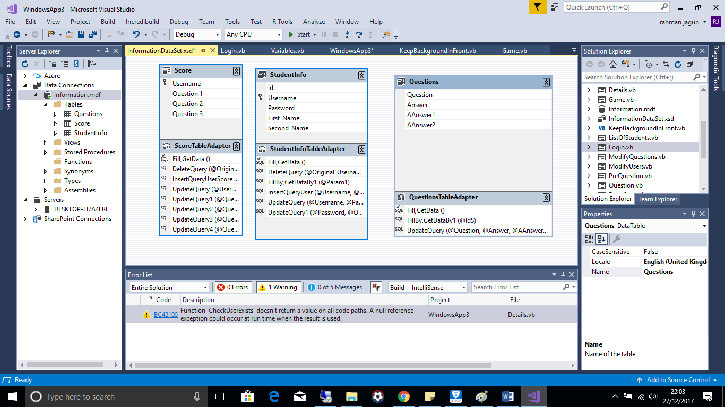

**Table “Score” SQL Statements**

1.  
DELETE FROM Score

WHERE (Username = @Original_Username)

2.  
INSERT INTO Score

(Username)

VALUES (@Username);

3.  
UPDATE Score

SET Username = @Username

WHERE (Username = @Original_Username);

4.  
UPDATE Score

SET [Question 1] = @Question_1

WHERE (Username = @Original_Username);

5.  
UPDATE Score

SET [Question 2] = @Question_2

WHERE (Username = @Original_Username);

6.  
UPDATE Score

SET [Question 3] = @Question_3

WHERE (Username = @Original_Username);

7.  
UPDATE Score

SET [Question 1] = @Question_1, [Question 2] = @Question_2, [Question 3] = @Question_3;

SELECT [Question 1], [Question 2], [Question 3] FROM Score WHERE (Username = @Username)

**Table “StudentInfo” SQL Statements**

1.  
DELETE FROM StudentInfo

WHERE (Username = @Original_Username)

2.  
SELECT Username, Password, First_Name, Second_Name

FROM StudentInfo

WHERE (Username = @Param1)

3.  
INSERT INTO [dbo].[StudentInfo] ([Username], [Password], [First_Name], [Second_Name]) VALUES (@Username, @Password, @First_Name, @Second_Name);

4.  
UPDATE StudentInfo

SET Username = @Username, Password = @Password, First_Name = @First_Name, Second_Name = @Second_Name

WHERE (Username = @Original_Username);

5.  
UPDATE StudentInfo

SET Password = @Password

WHERE (Id = @Original_Id);

**Table “Questions” SQL Statements**

1.  
SELECT AAnswer1, AAnswer2, Answer, Question FROM Questions WHERE (Id = @IdS)

2.  
 UPDATE Questions

SET Question = @Question, Answer = @Answer, AAnswer1 = @AAnswer1, AAnswer2 = @AAnswer2

WHERE (Id = @Original_Id);

**Testing**

|  |  |  |  |  |  |
| --- | --- | --- | --- | --- | --- |
| Test Number | Description | Data Type | Expected Result | Pass/Fail | Cross Reference |
| 1 | Attempt to sign in with invalid login details (login details not present on the database) or leave fileds missing. This is to ensure there will be no unauthorised access to the system also to ensure all sessions are linked to a user. | Erroneous | Message telling user login details are invalid and to consult teacher for login details. or  Message telling user data is missing for one of the fields | Pass | Test 1 |
| 2 | Sign in with teacher/administrator account to ensure teacher can access their part of the system | Typical | Teacher menu form should show. | Pass | Test 2 |
| 3 | Sign in with a student account to ensure student can access their part of the system | Typical | PreQuestion form should show. | Pass | Test 3 |
| 4 | Fill in all required information to add a user to the database then click add user. This is to test the teacher can add her students to the system. | Typical | Message saying user added successfully should appear, and the student’s details should be added to the database. | PASS | Test 4 |
| 5 | Run through add user form, missing data for each required field at a time to test the program will not attempt to add a user without all the necessary information. | Erroneous | Program should prompt teacher stating they have missed out data. | FAIL | Test 5 |
| 6 | Attempt to add user that with same username already present on database | Erroneous | Program should prompt teacher that user already exists | FAIL | Test 6 |
| 7 | Perform a user search of a user present on the database. This is to ensure teacher can find users in the instance they would like to delete a user or modify data held regarding a user | Typical | Details form should display all the information about the student | PASS | Test 7 |
| 8 | Perform a search of a user not on the database. This is to ensure if a user is not present on database it will prompt teacher and the system will not pull up information about a different user. | Erroneous | Message Informing teacher that user does not exist |  | Test 8 |
| 9 | Attempt to search without anything entered into user field. This is so teacher cannot a query with nothing as this may cause a fault in the system. | Erroneous | Alert teacher no data is entered and teacher needs to enter data | FAIL | Test 9 |
| 10 | Attempt to update user with field(s) missing. This will help to test that a teacher cannot modify information regarding a user without all the required details entered | Erroneous | Alert teacher no data is entered and teacher needs to enter data | FAIL | Test 10 |
| 11 | Attempt update user with all required information entered. To ensure teacher is able to change data about a user. | Typical | Users details should be changed on database | PASS | Test 11 |
| 12 | Attempt to delete a user. This will help ensure a teacher can remove a student if required, for example if a student is no longer in her lesson. | Typical | User should no longer appear on database | PASS | Test 12 |
| 13 | Click view list of all users in Modify Users form | Typical | Table showing list of users along with usernames and passwords should be visible | PASS | Test 13 |
| 14 | Leave field empty when updating teacher’s password. To test system will not crash due to the teacher attempting to add nothing to a field that cannot be nil in the database. | Erroneous | Alert teacher no data is entered and teacher needs to enter data | FAIL | Test 14 |
| 15 | Enter all required info to update teachers password | Typical | Message saying password successfully updated | PASS | Test 15 |
| 16 | Leave data missing then attempt to add question to database | Erroneous | Alert teacher no data is entered and teacher needs to enter data | PASS | Test 16 |
| 17 | Attempt to add questions and answers to database with information required filled in. | Typical | Message displaying questions added successfully and questions should be added to database | PASS | Test 17 |
| 18 | After adding questions close system then navigate back to form to add questions. | Typical | All fields should be filled in with current set of questions and answers | PASS | Test 18 |
| 19 | Attempt to modify current set of questions. | Typical | Message displaying questions added successfully and Changed components should change on database | PASS | Test 19 |
| 20 | Navigate to stats form. |  | Table of students results should be shown | PASS | Test 20 |
| 21 | Attempt to export results to text file with data required for title of results field missing. | Erroneous | Alert teacher no data is entered and teacher needs to enter data | PASS | Test 21 |
| 22 | Attempt to export to text file with all required data entered. | Typical | Text file within folder with results should be present | PASS | Test 22 |
| 23 | Clear Attempt to clear data. | Typical | All students results should be erased on database | PASS | Test 23 |
| 24 | Start quiz | Typical | Question one should be displayed along with all the possible answers set by teacher | PASS | Test 24 |
| 25 | Select a correct answer | Typical | Message telling user they got question should appear along with upgrade menu | PASS | Test 25 |
| 26 | Select an incorrect answer | Typical | Message telling user they got the answer incorrect. | PASS | Test 26 |
| 27 | Run through all of quiz | Typical | All three questions should be displayed along with possible answers set by teacher | PASS | Test 27 |
| 28 | Select extra health upgrade | Typical | Health stats should increase | PASS | Test 28 |
| 29 | Select extra kick damage upgrade | Typical | Kick damage stats should increase | PASS | Test 29 |
| 30 | Select extra punch damage upgrade | Typical | Punch damage stats should increase | PASS | Test 30 |
| 31 | Select faster speed upgrade | Typical | Speed stats should increase | PASS | Test 31 |
| 32 | Press left arrow key in game | Typical | Player’s character should move to the left | PASS | Test 32 |
| 33 | Press right arrow key in game | Typical | Player’s character should move to the right | PASS | Test 33 |
| 34 | Press Z key in game | Typical | Players character should perform punch action. If it touches CPU it should take damage. | PASS | Test 34 |
| 35 | Press C key in game | Typical | Players action should perform kick action. If it touches CPU it should take damage. | PASS | Test 35 |
| 36 | Press any other key in game | Erroneous | No character actions should occur | PASS | Test 36 |
| 37 | Move around in game | Typical | CPU should eventually follow and attack when near most times | PASS | Test 37 |
| 38 | Allow CPU to perform kick action on user | Typical | Users health bar should decrease | PASS | Test 38 |
| 39 | Allow CPU to perform punch action on user | Typical | Users health bar should decrease | PASS | Test 39 |
| 40 | Let CPU take all of user’s health. | Typical | Message stating user lost should appear | PASS | Test 40 |
| 41 | Take all of CPU’S health. | Typical | Message stating user won should appear | PASS | Test 41 |
| 42 | Make both user and CPU’S health 0 | Boundary | Message stating neither CPU or user won | PASS | Test 42 |

**Test 1**

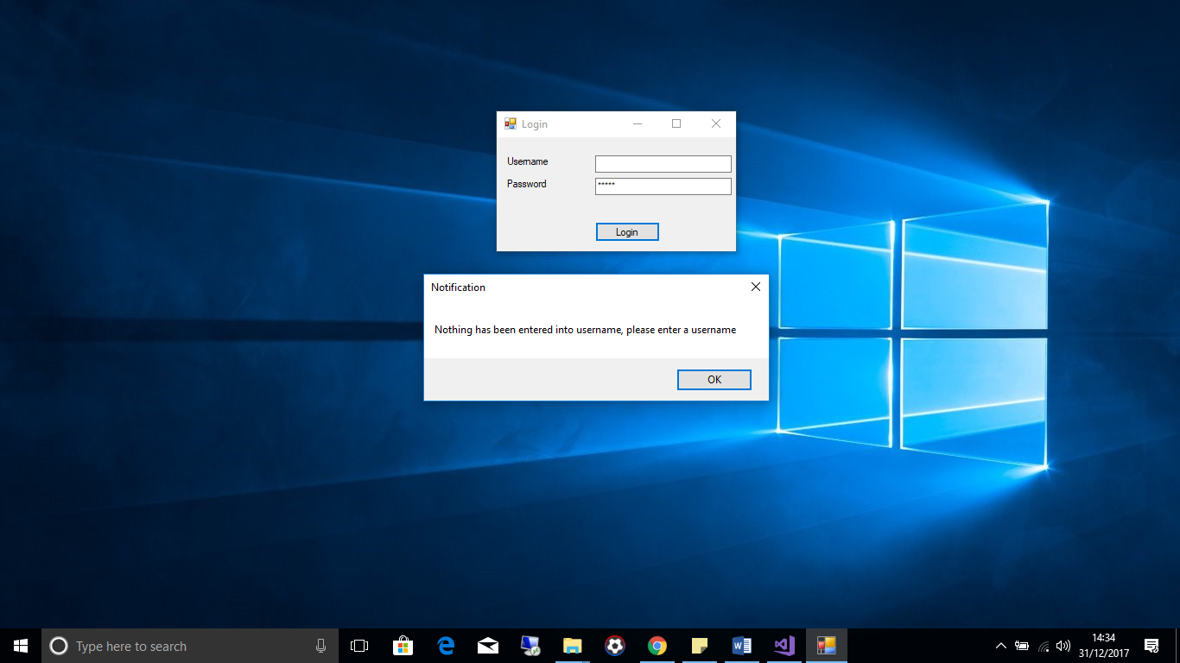  
  
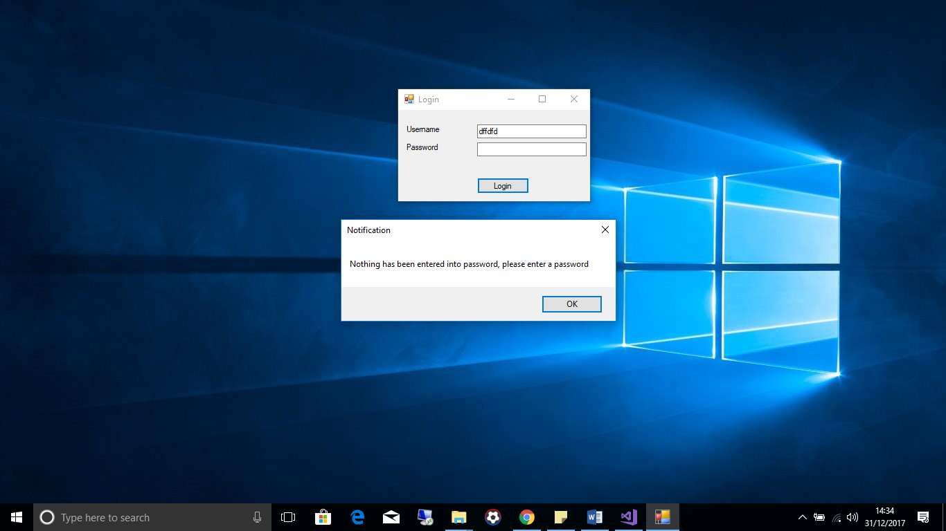  
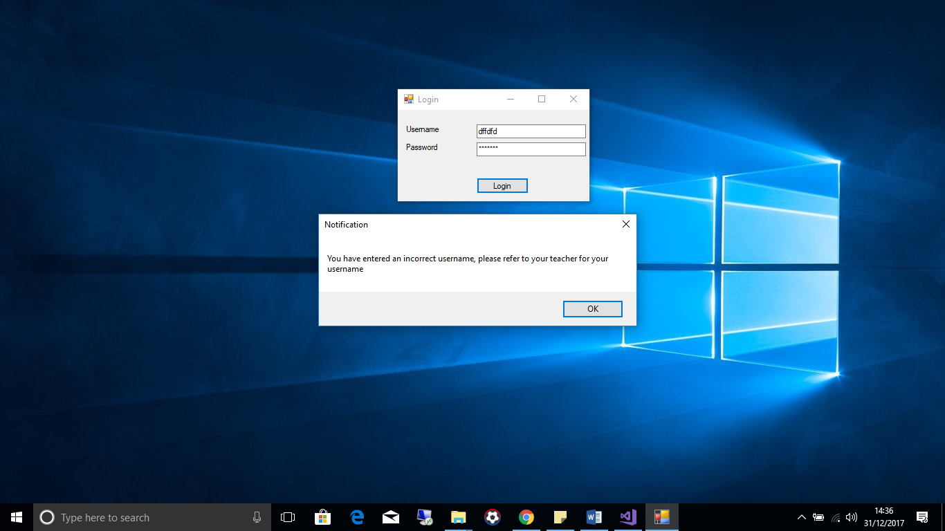  
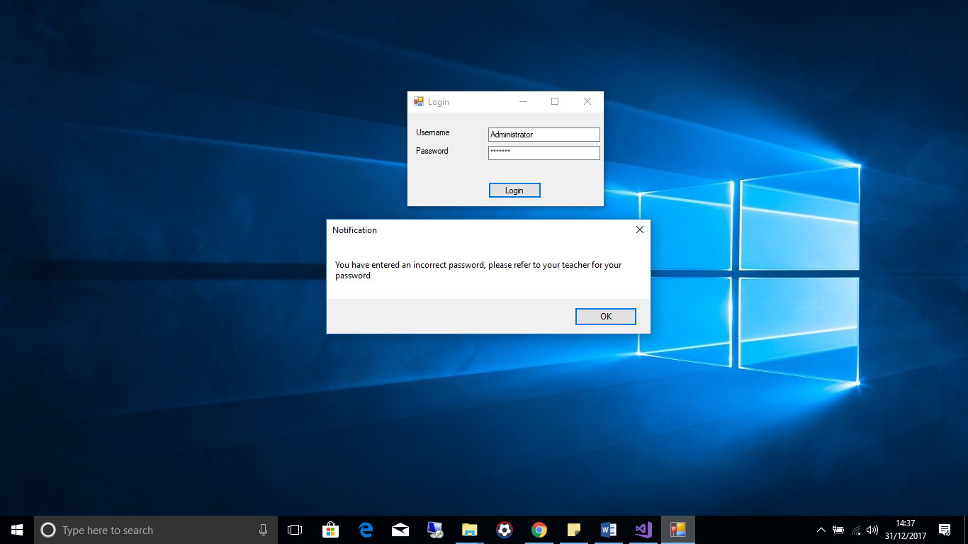

**Test 2**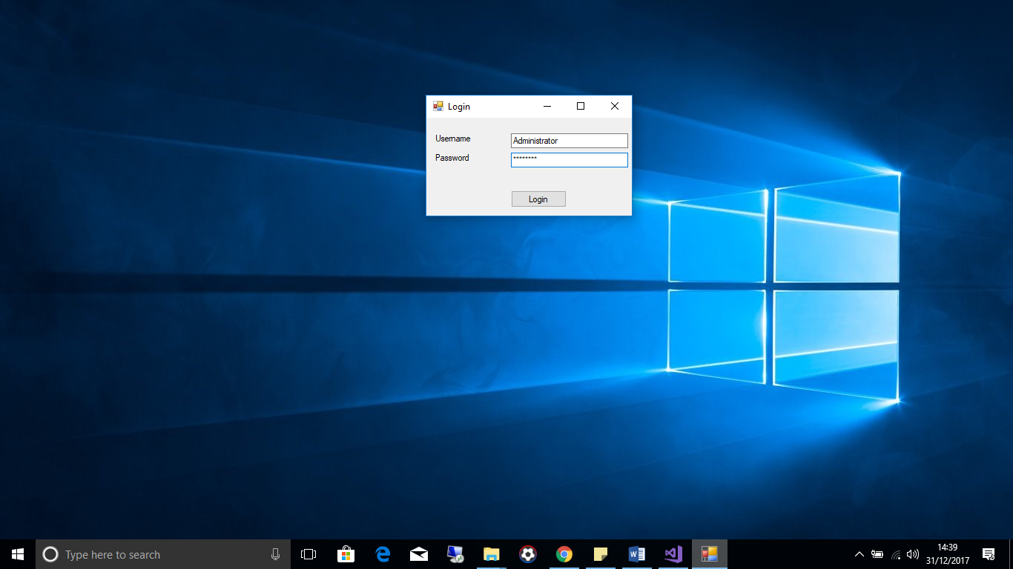

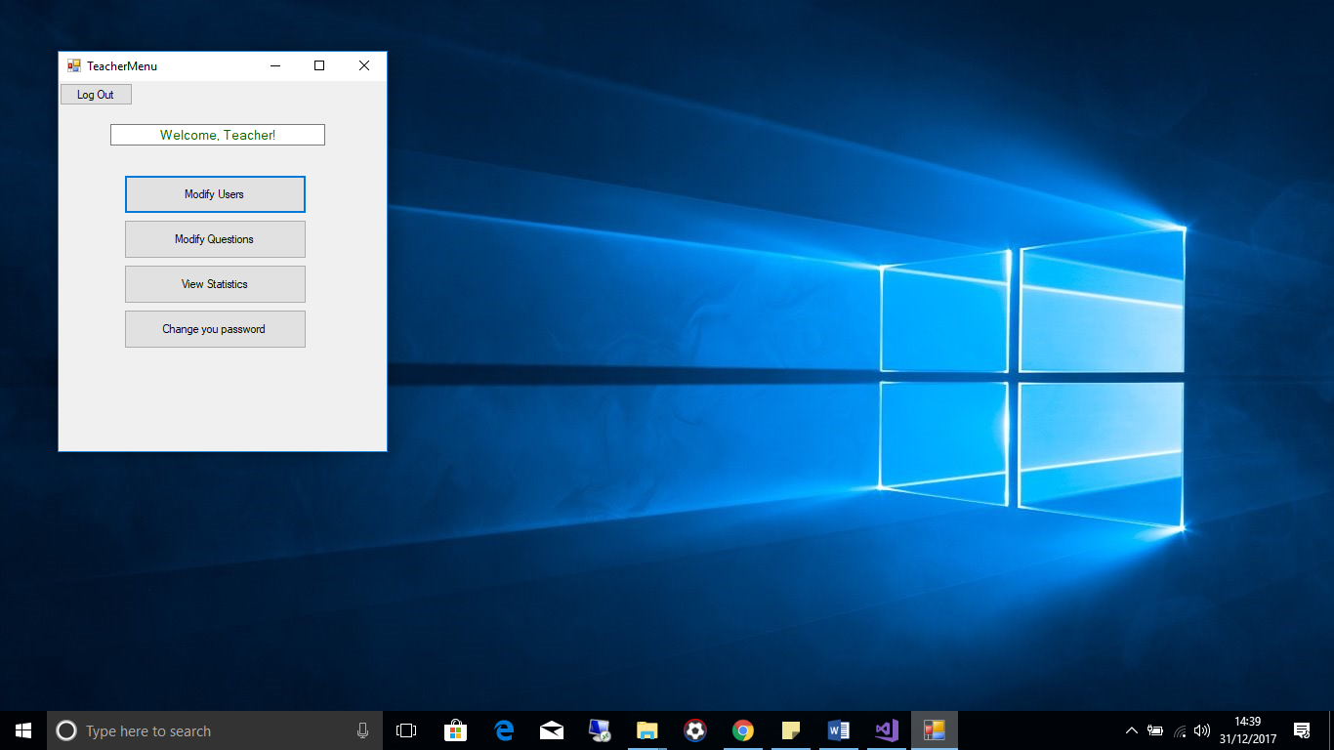

**Test 3**

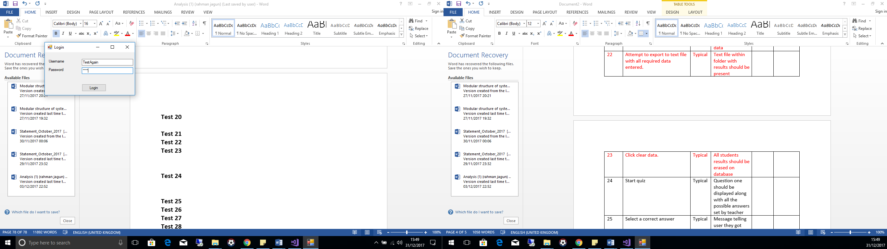

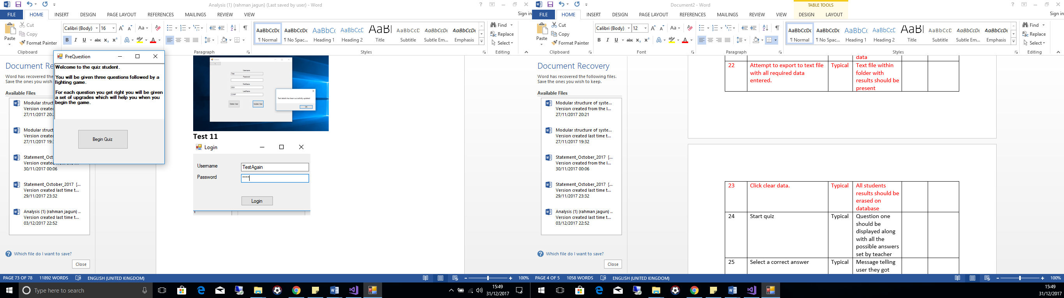

**Test 4**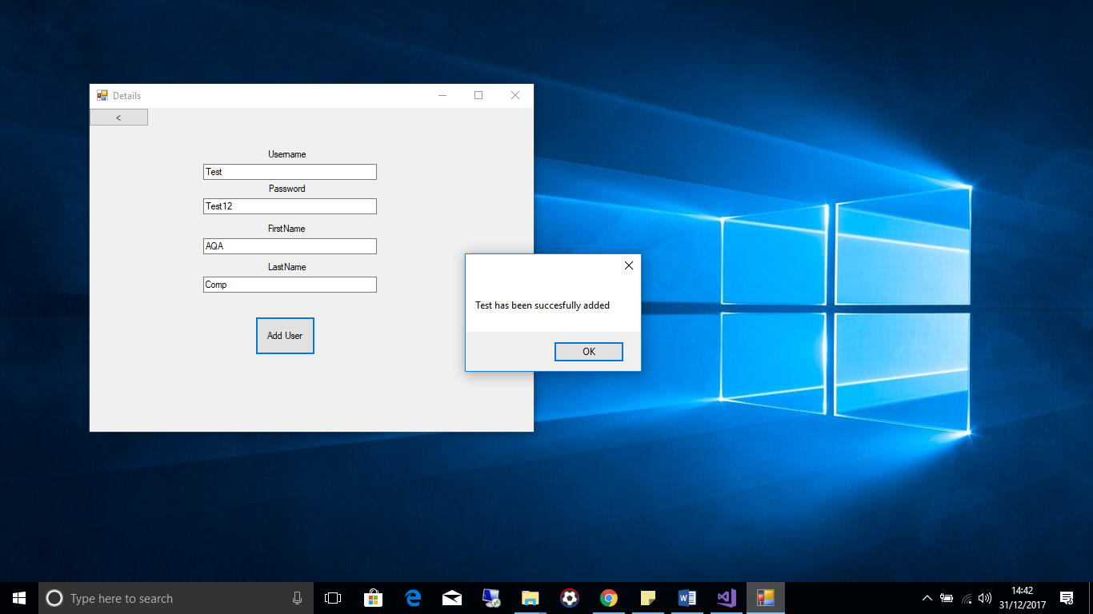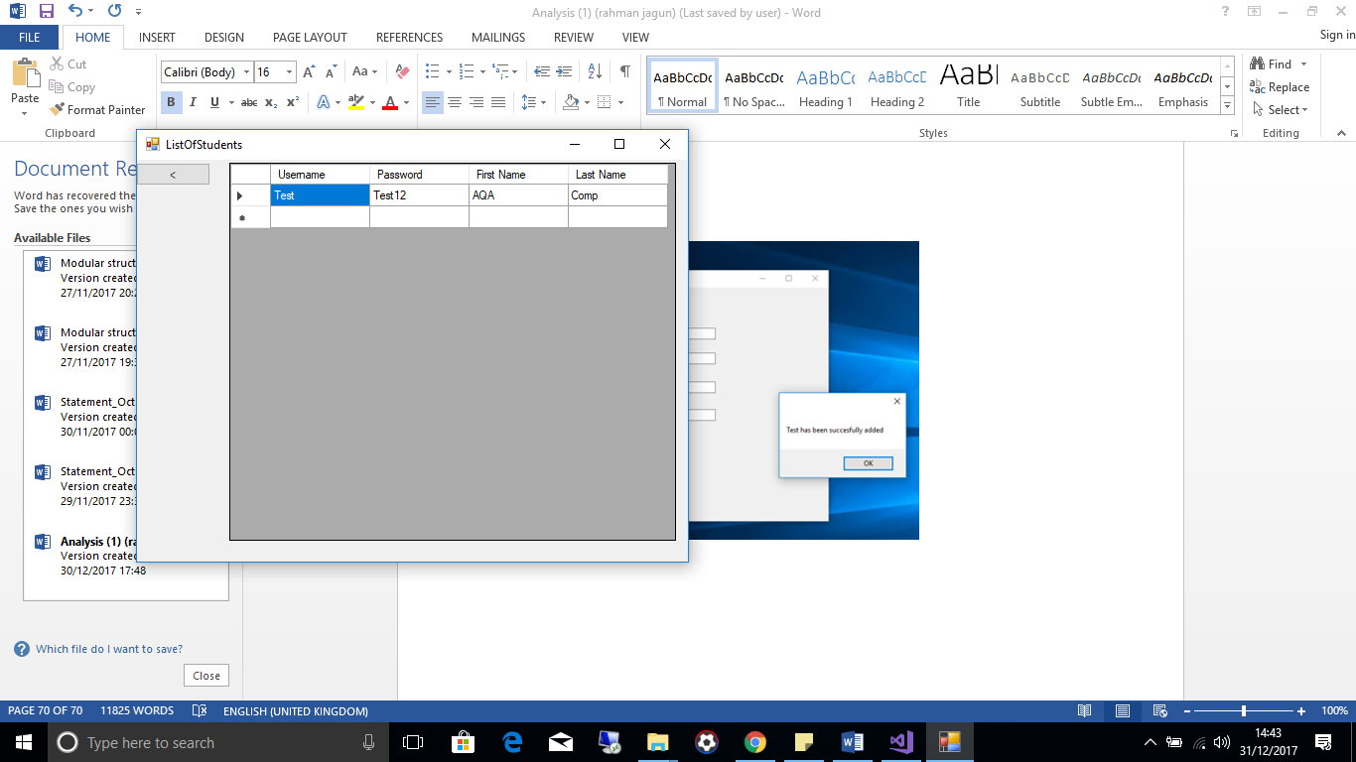

**Test 5**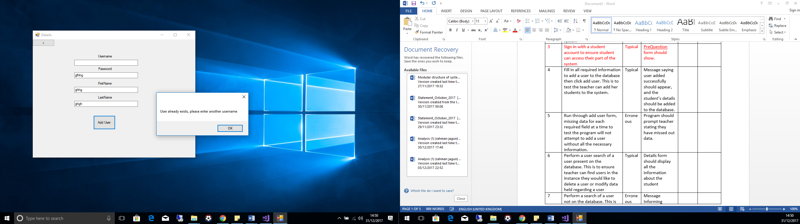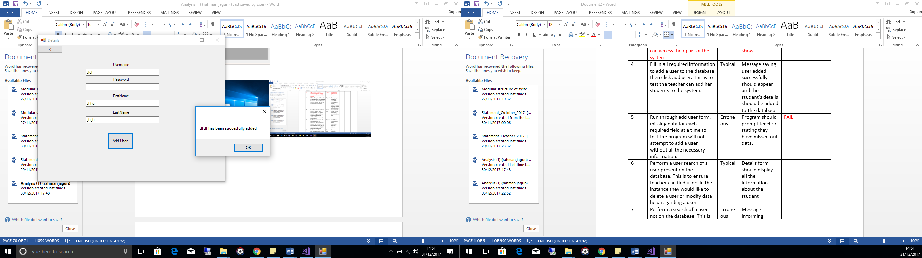

**Test 6**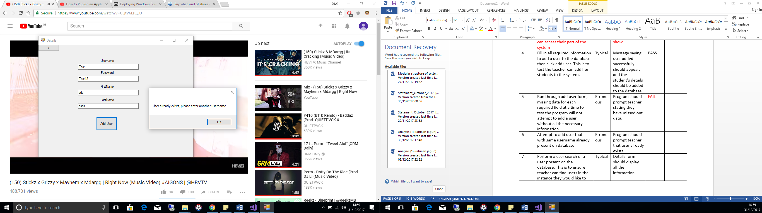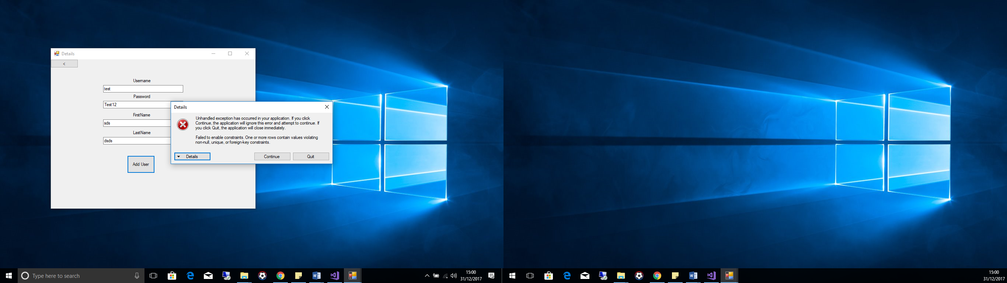

**Test 7**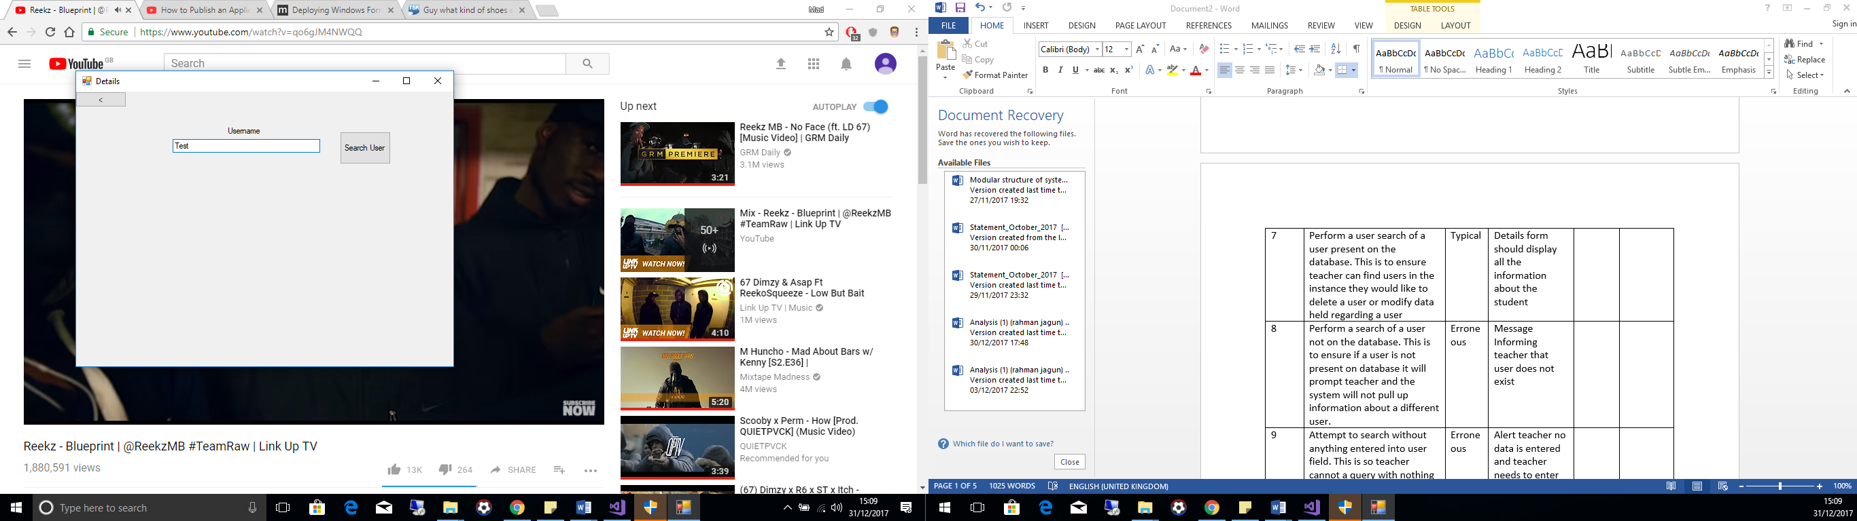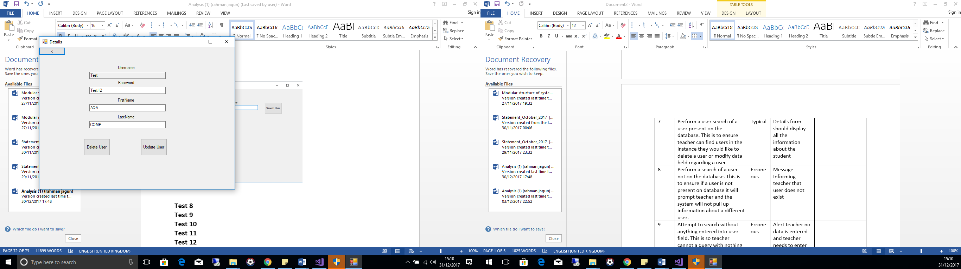

**Test 8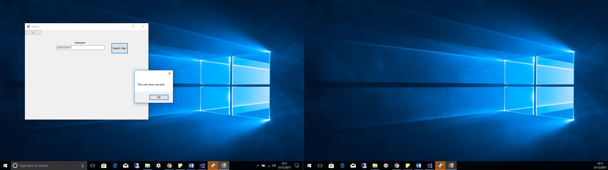 Test 9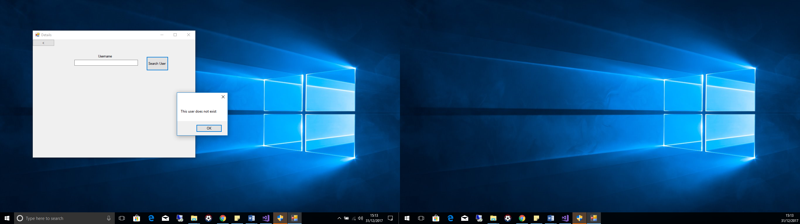 Test 10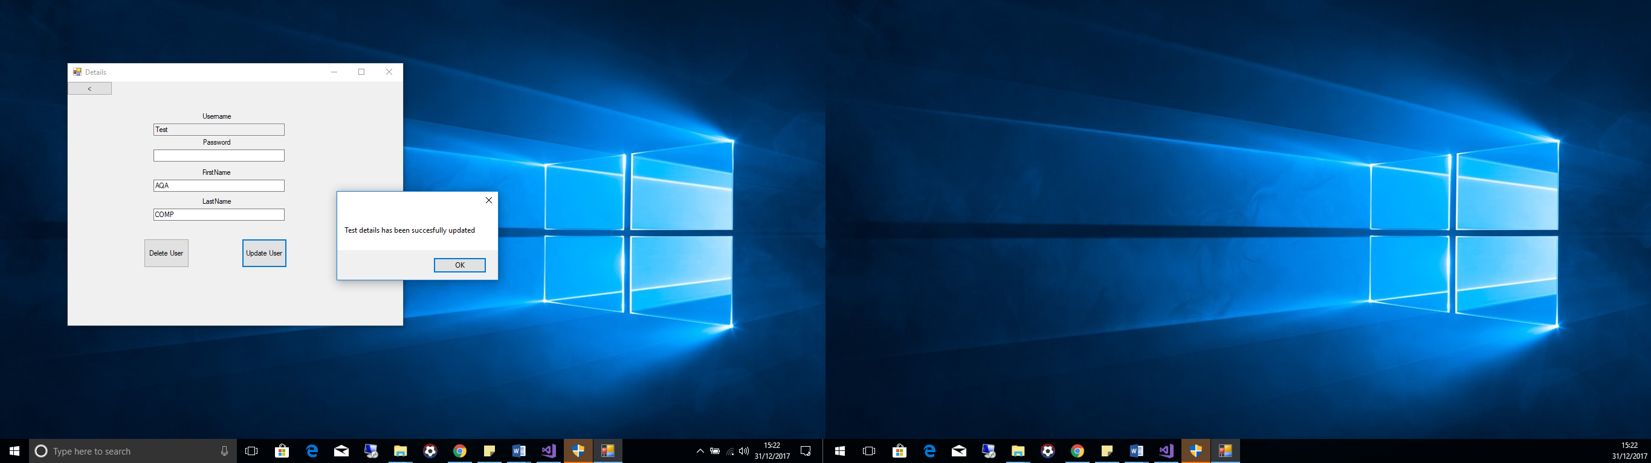 Test 11**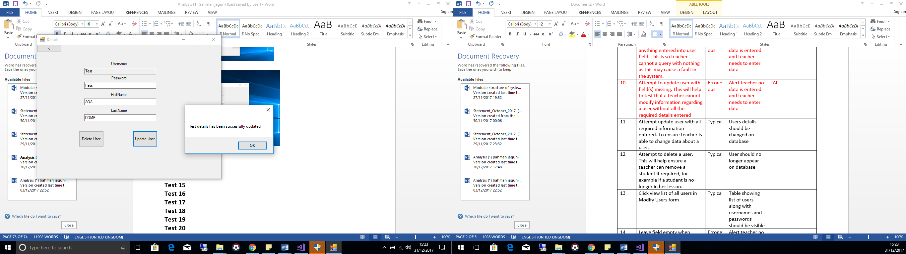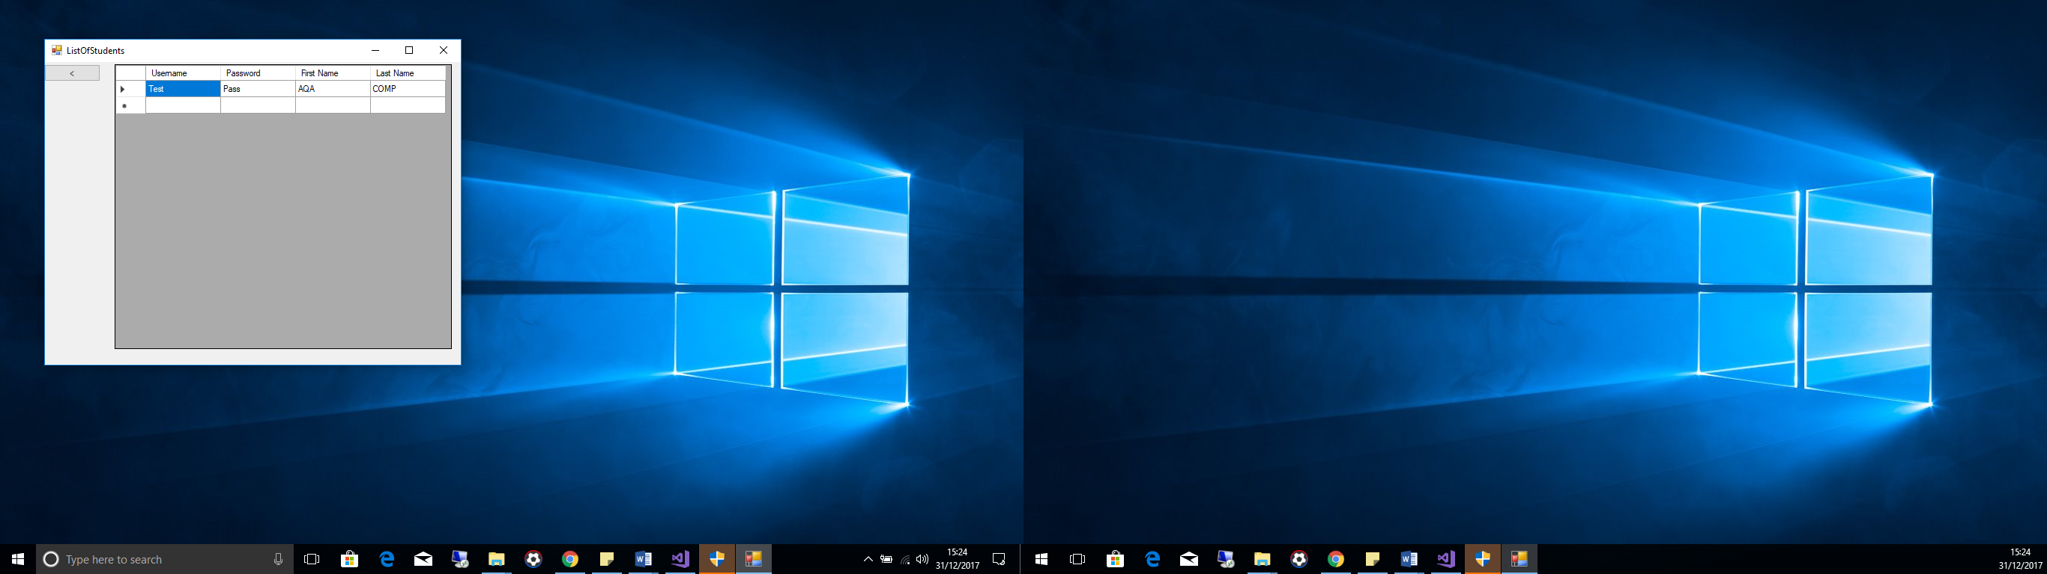

**Test 12**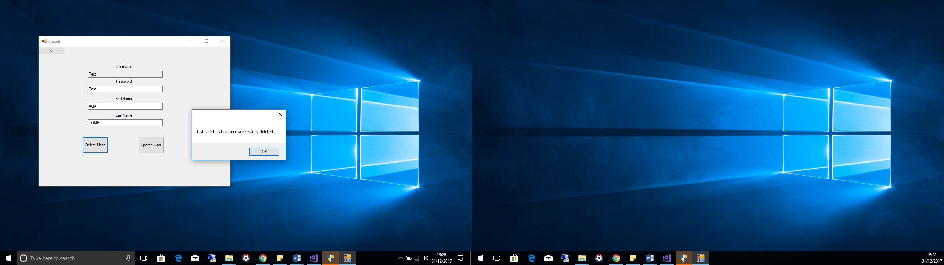

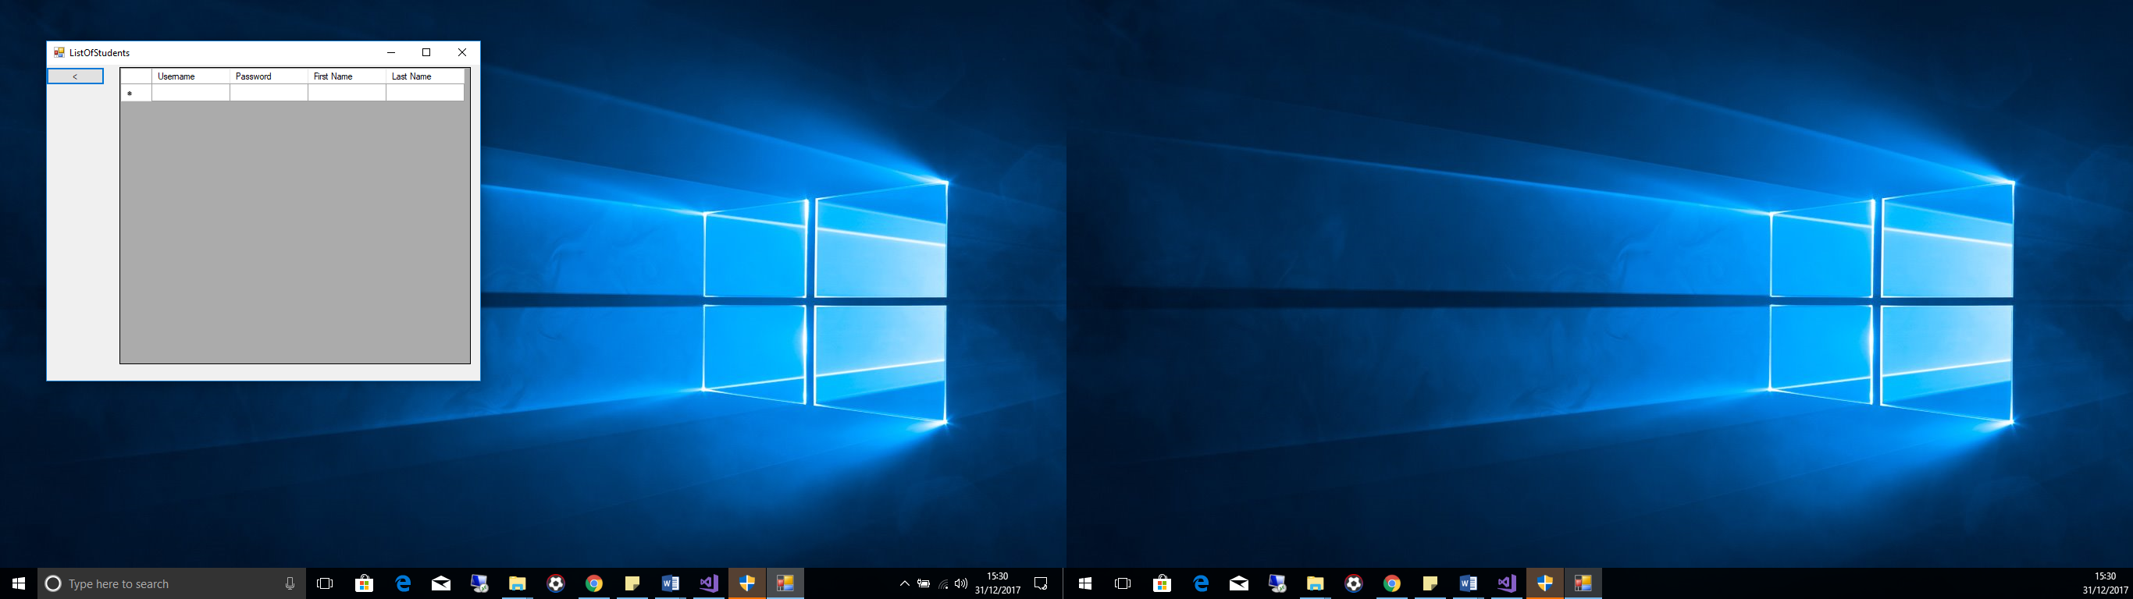 **Test 13  
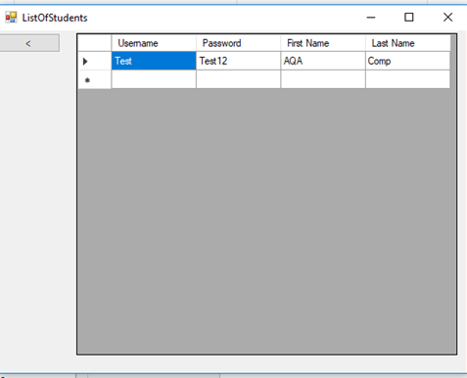**

**Test 14**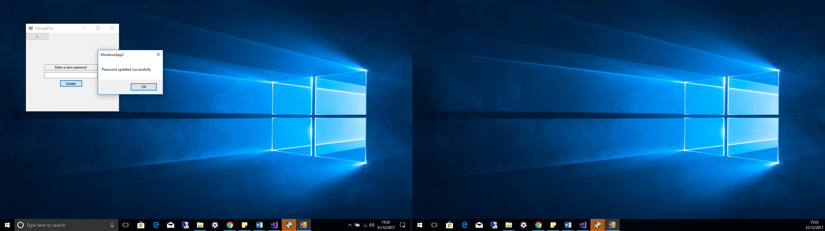

**Test 15**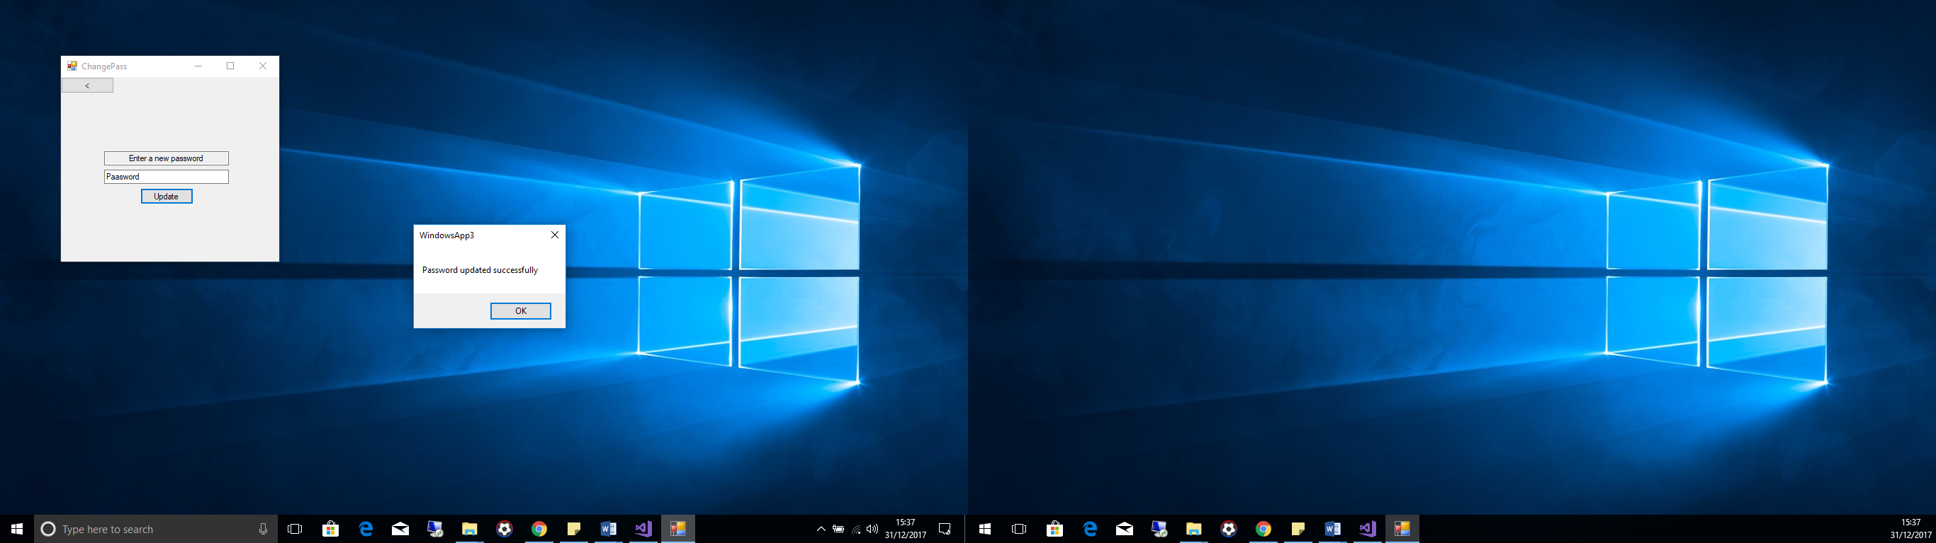

**Test 16**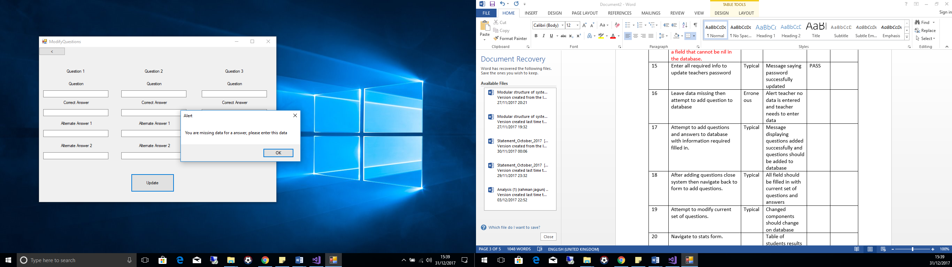

**Test 17**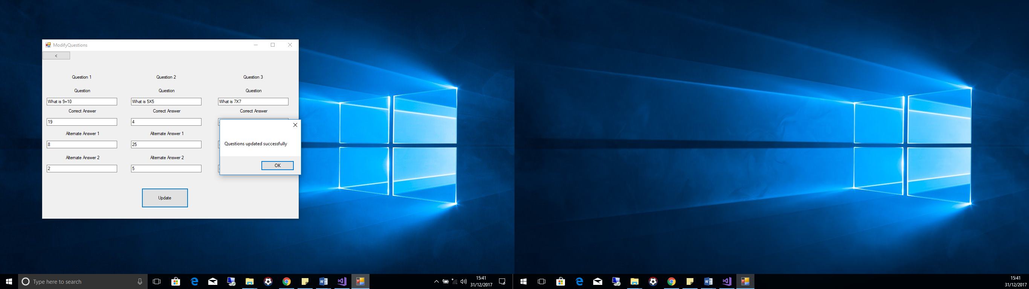

**Test 18**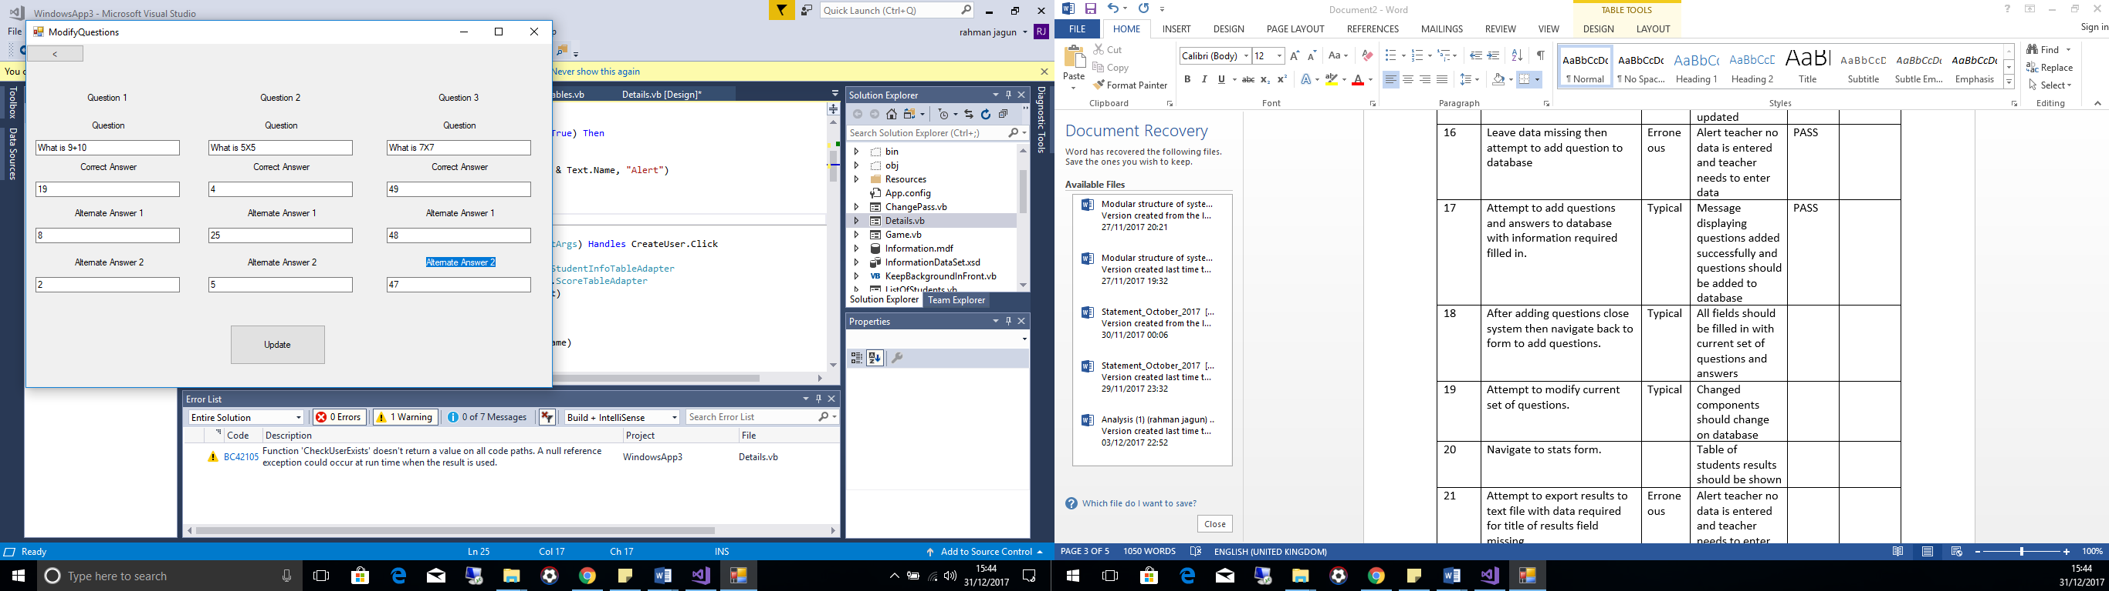

**Test 19**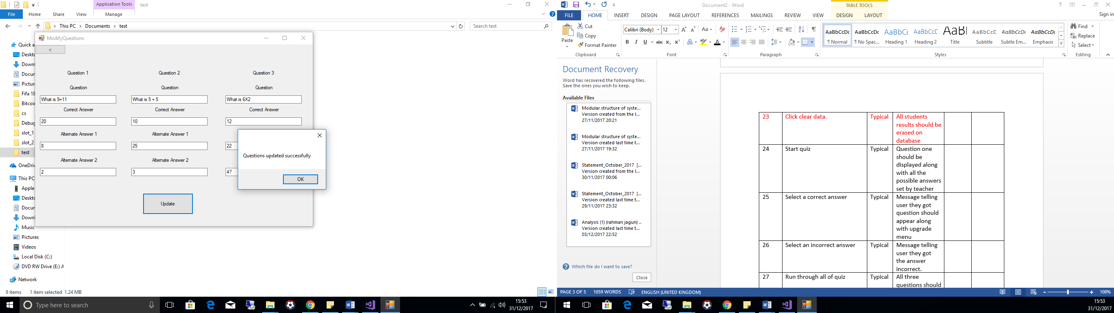

**Test 20**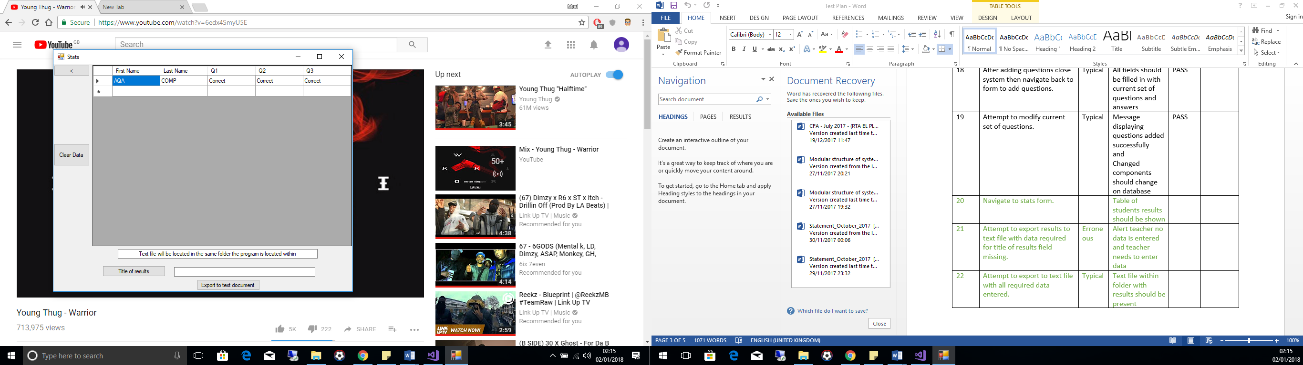

**Test 21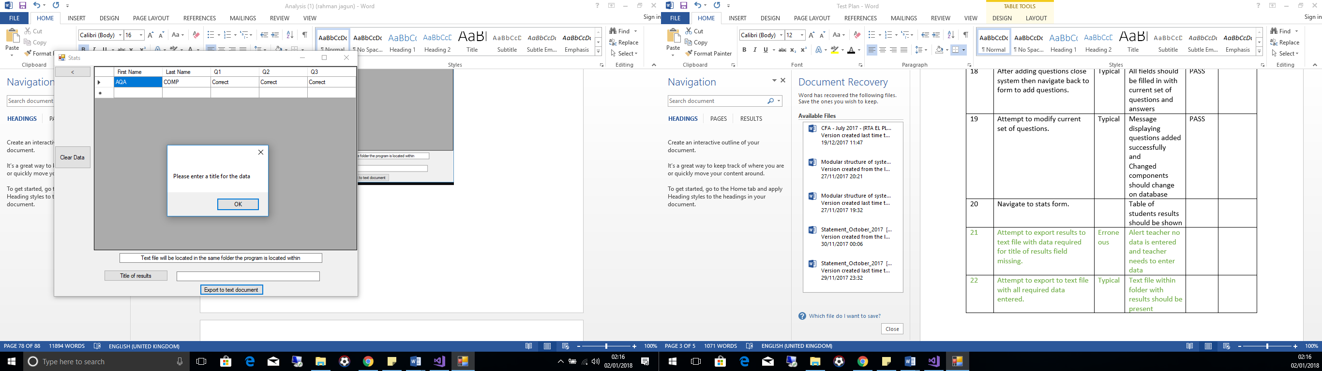 Test 22**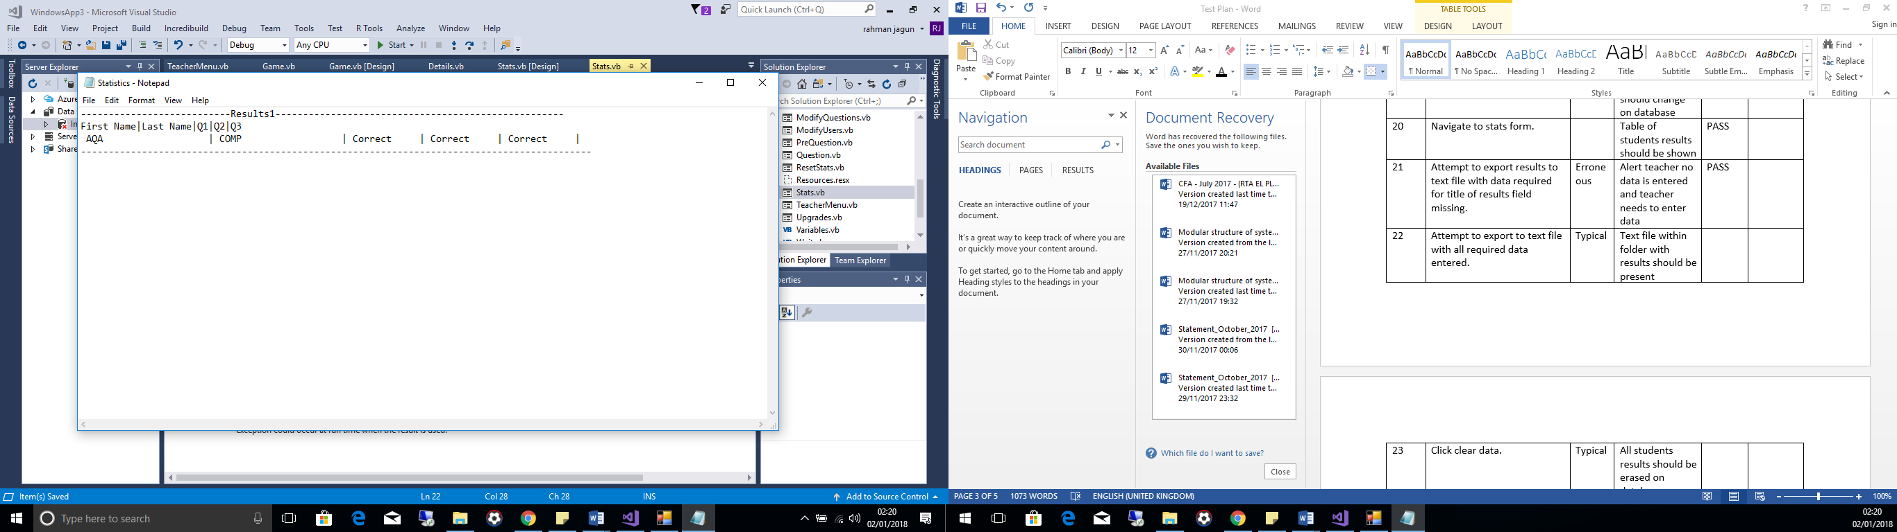

**Test 23**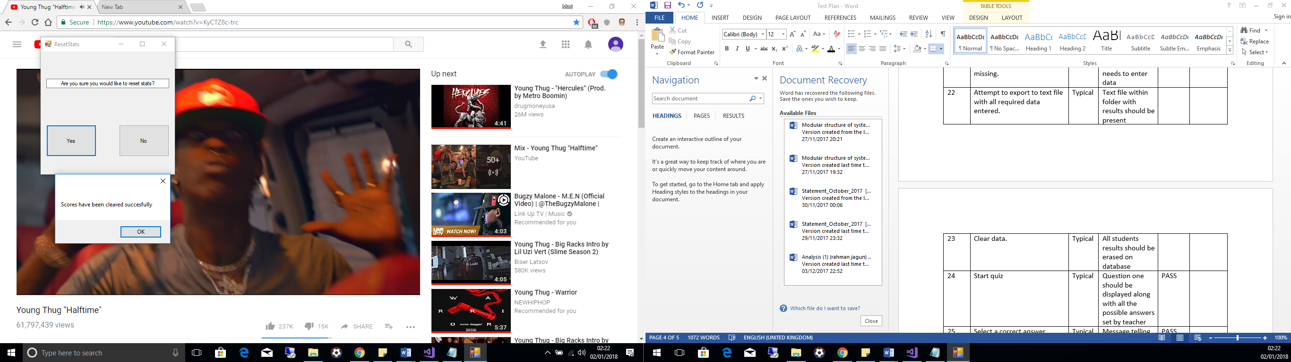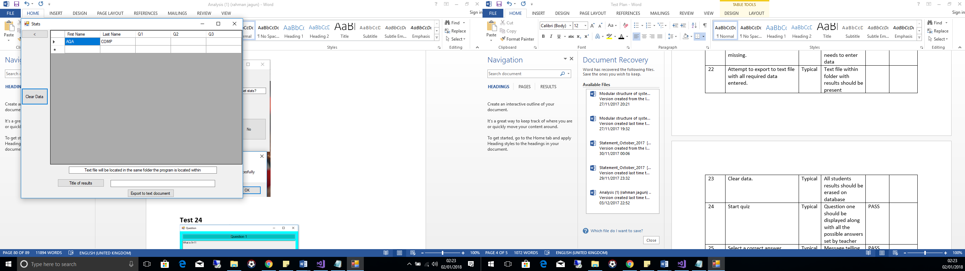

**Test 24**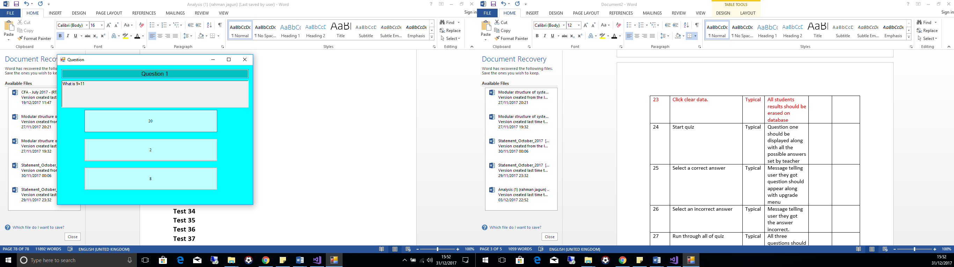

**Test 25**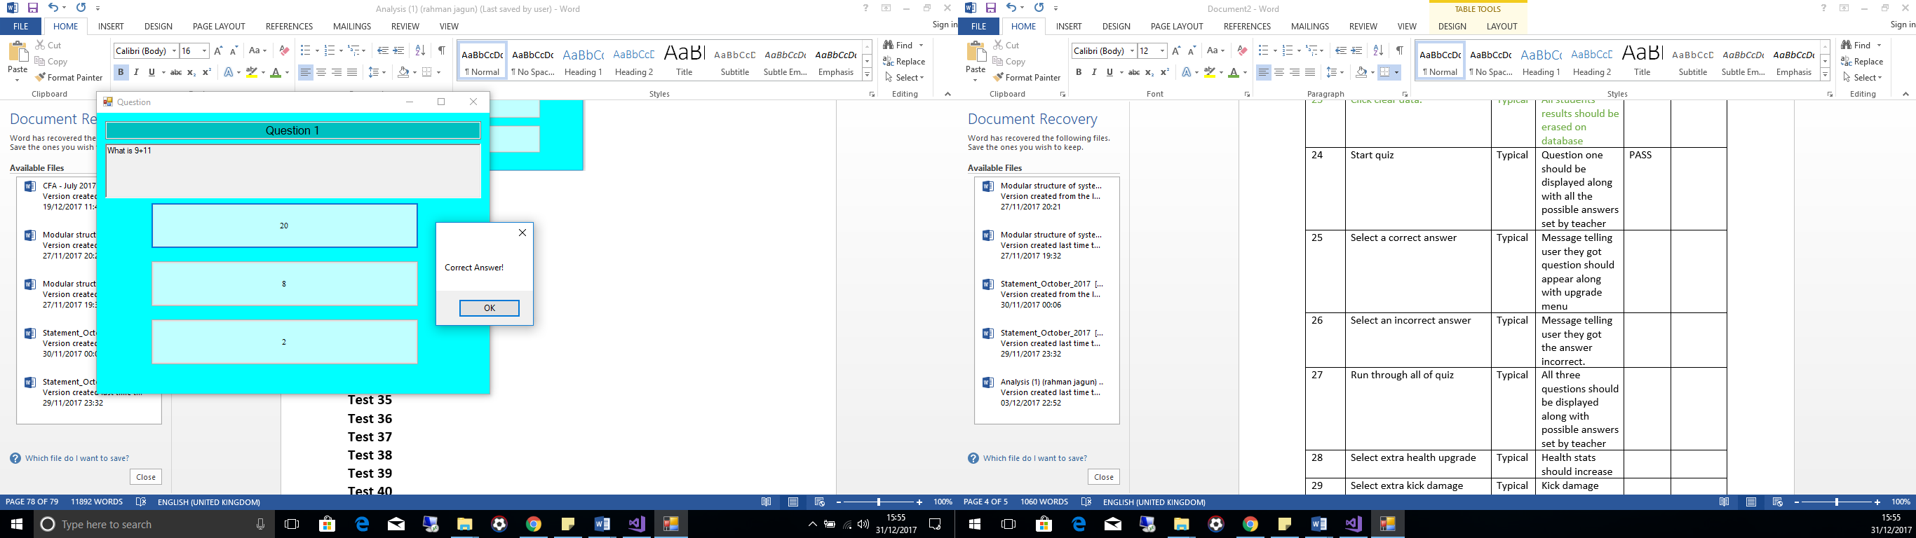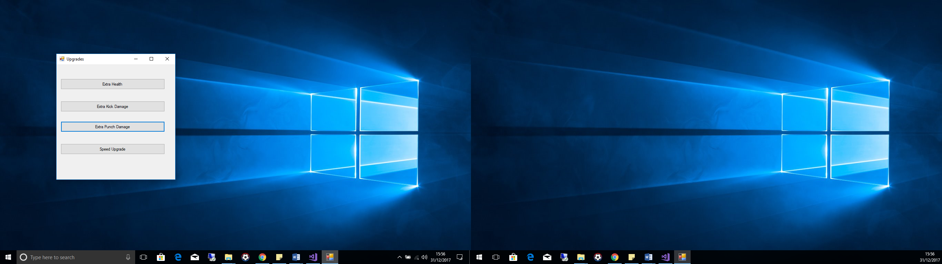

**Test 26**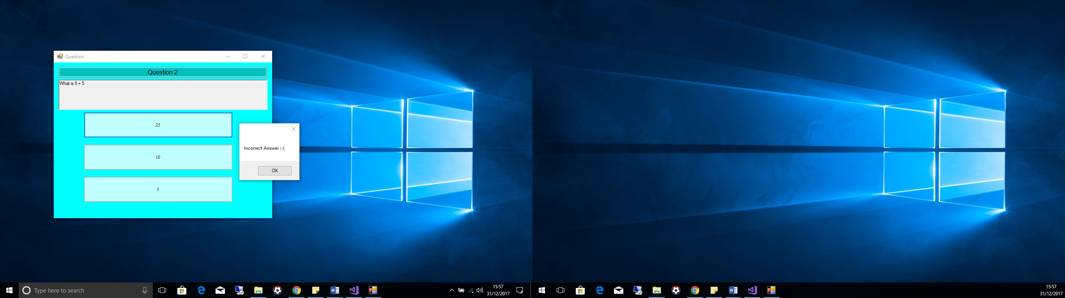

**Test 27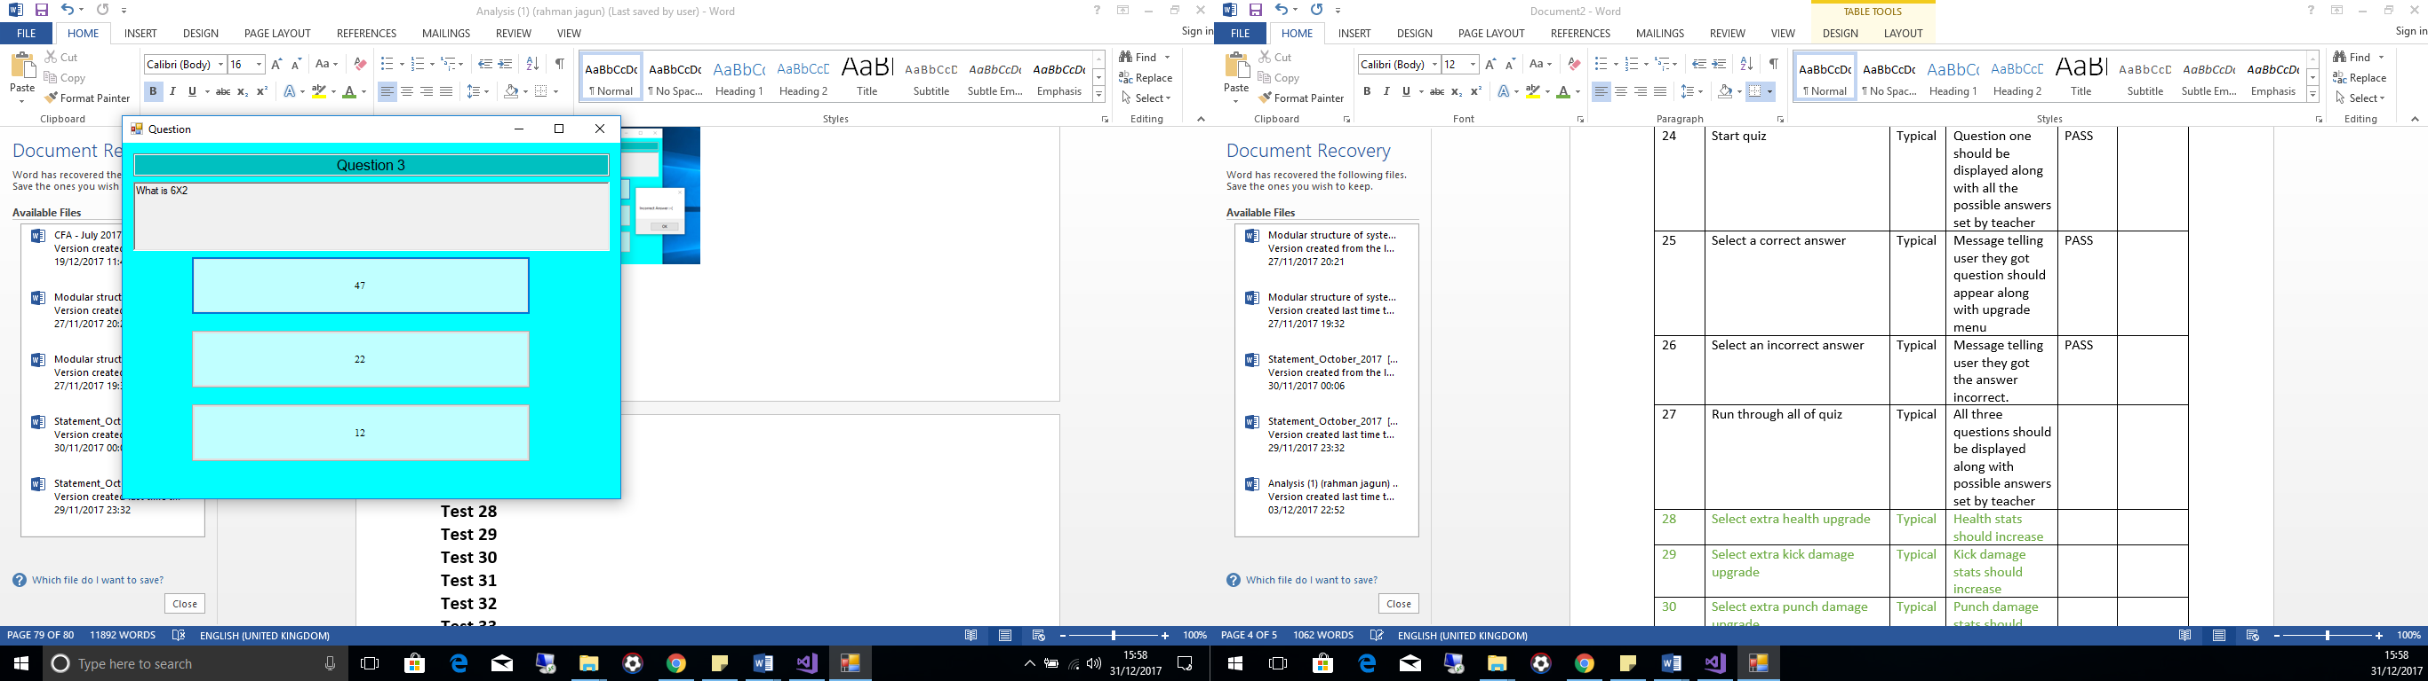 Test 28**  
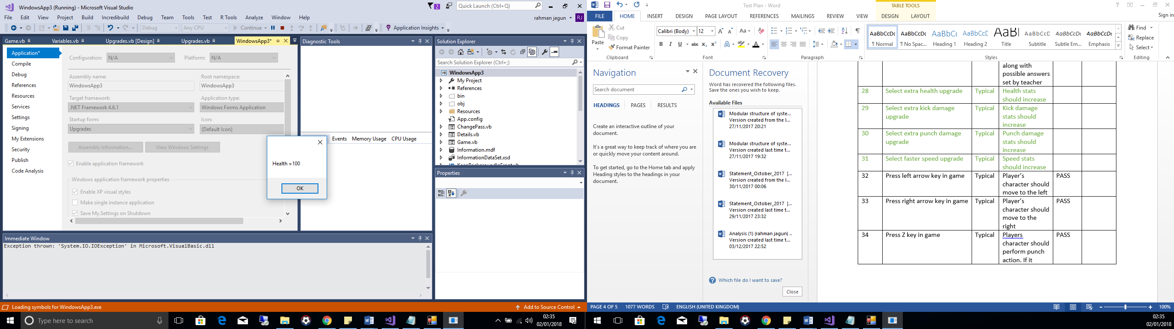  
  
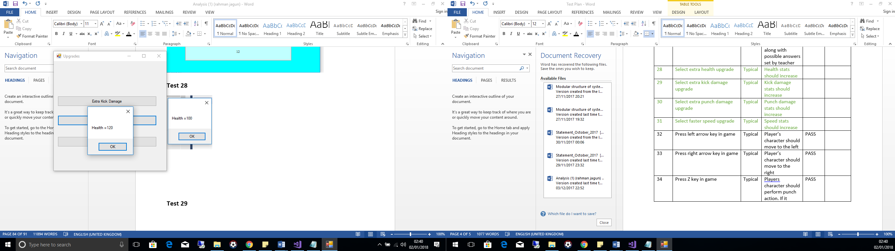

**Test 29**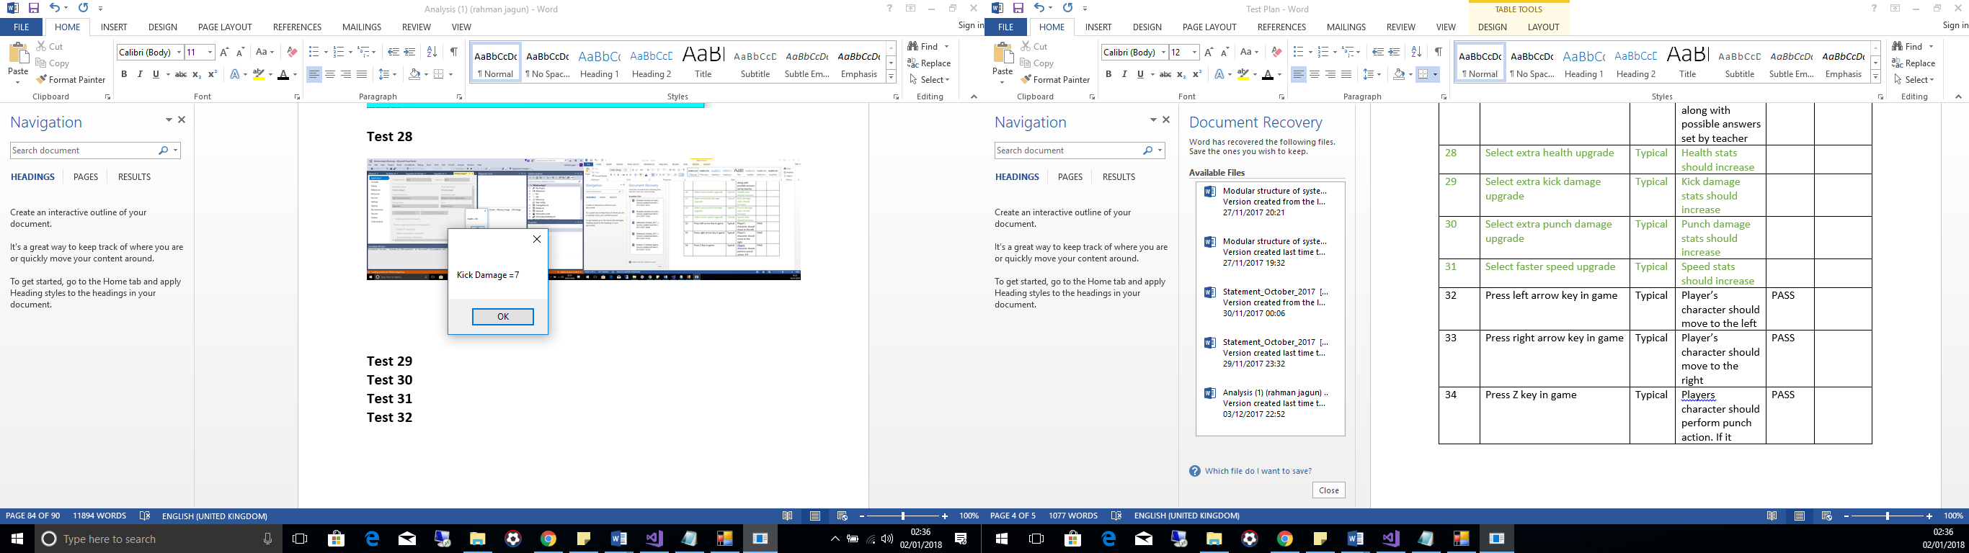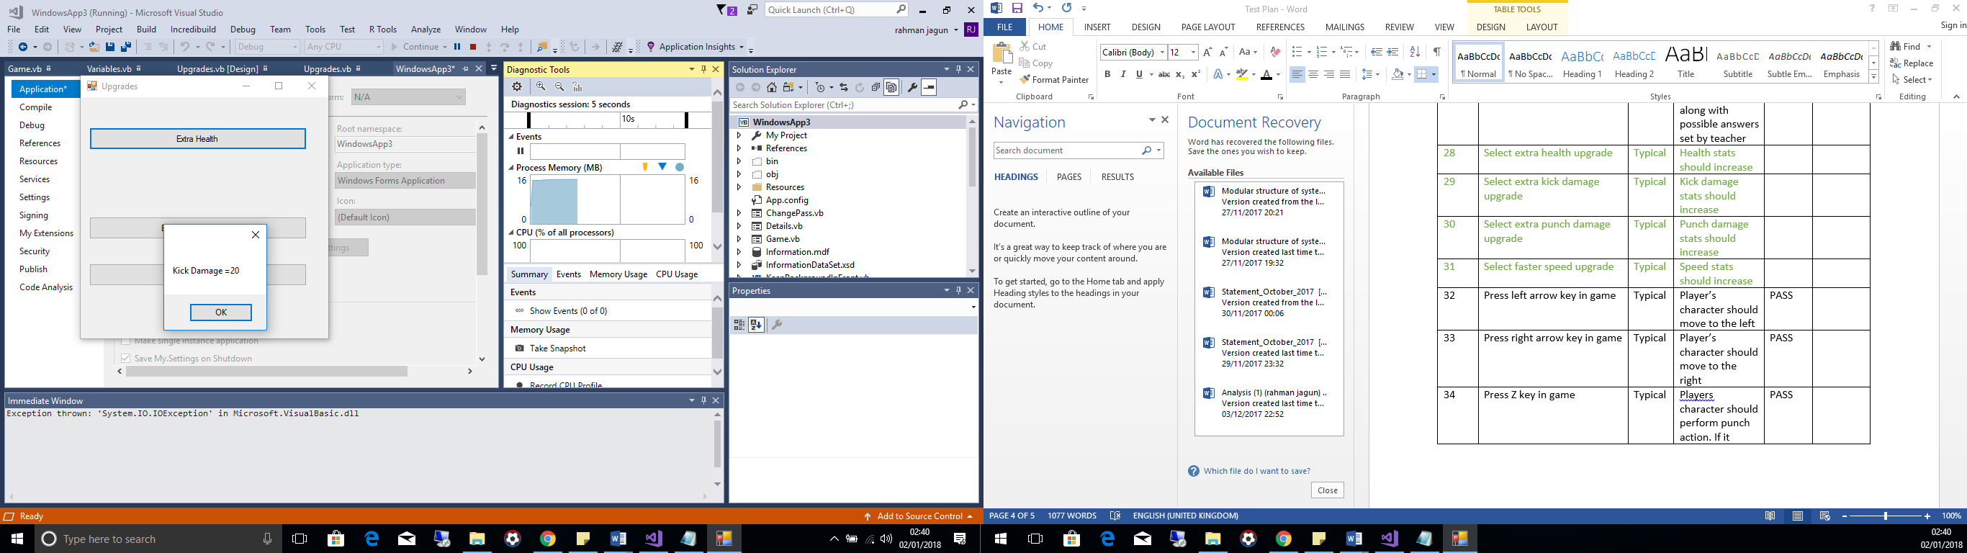

**Test 30**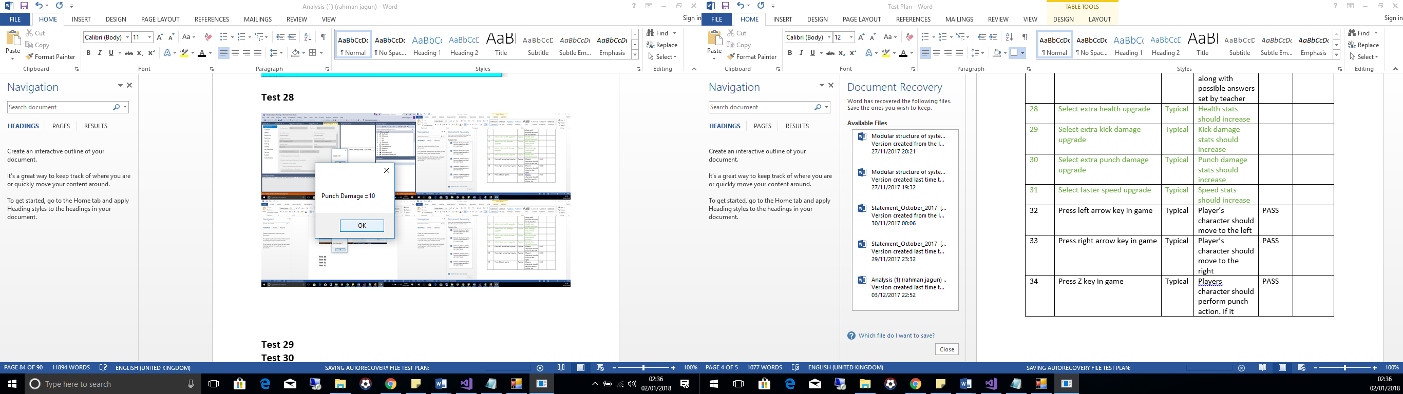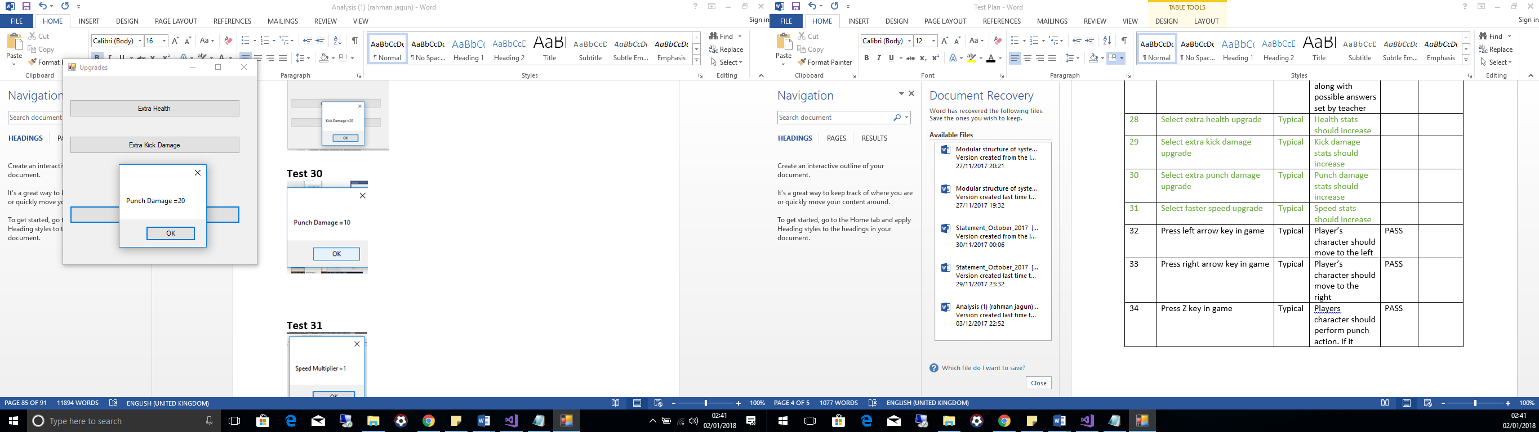

**Test 31**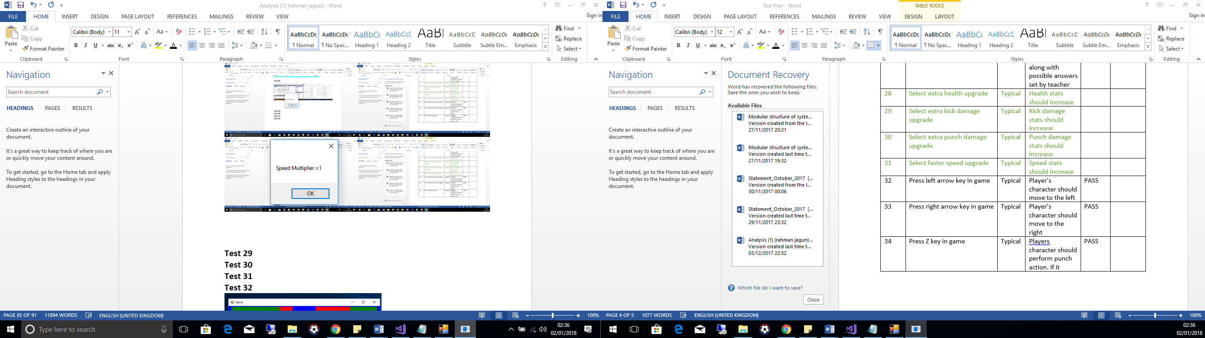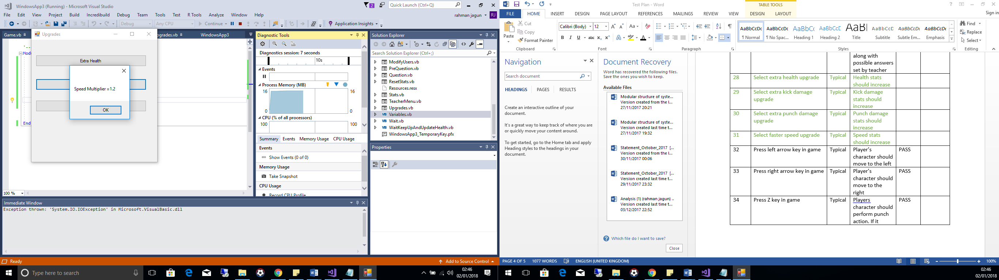

**Test 32**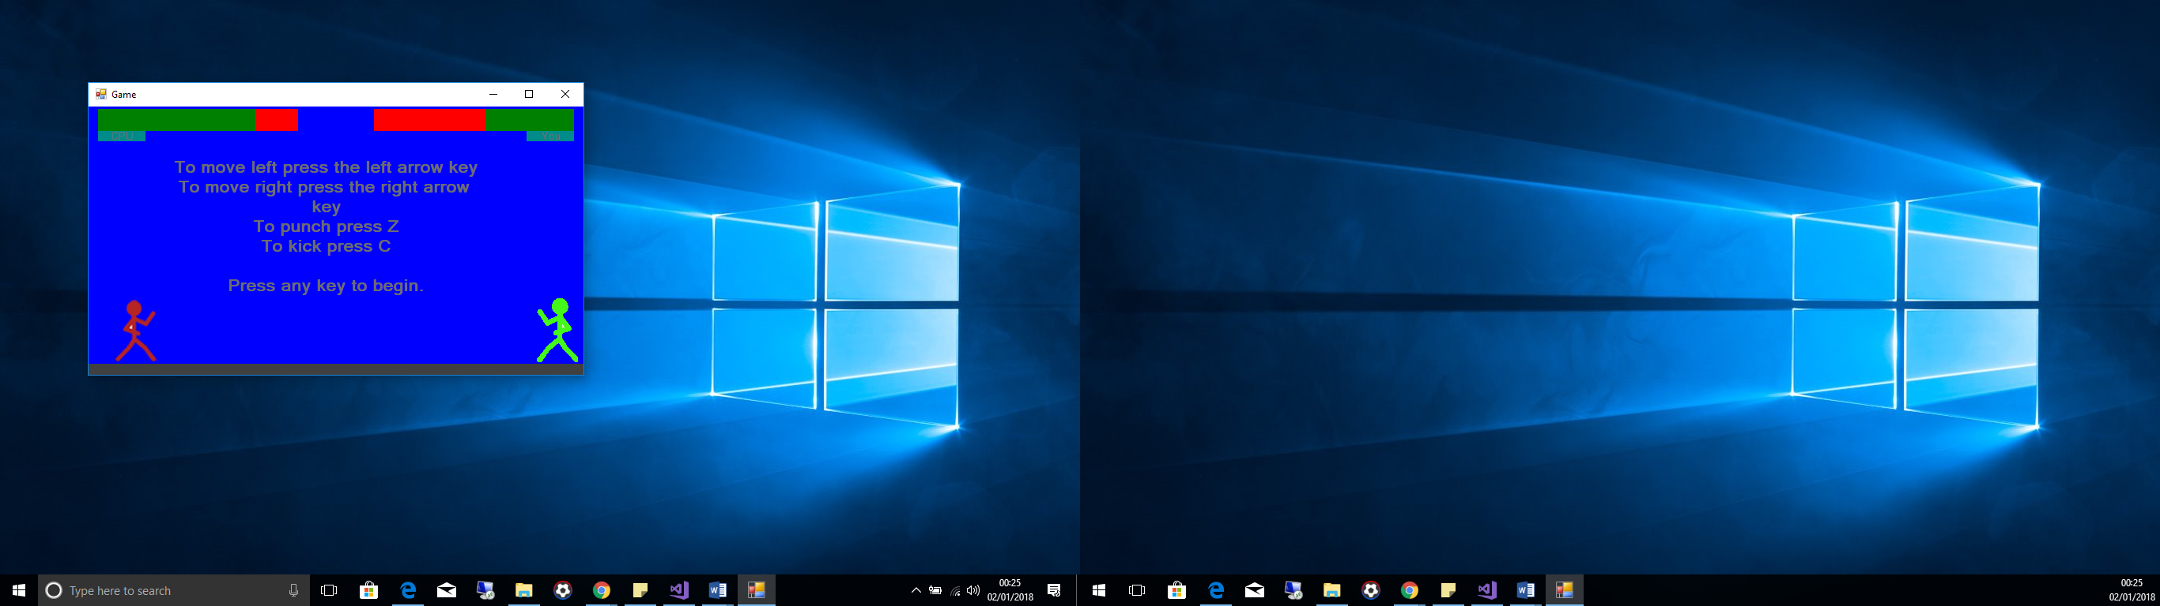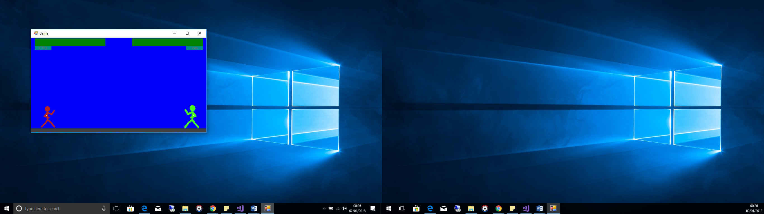

**Test 33**

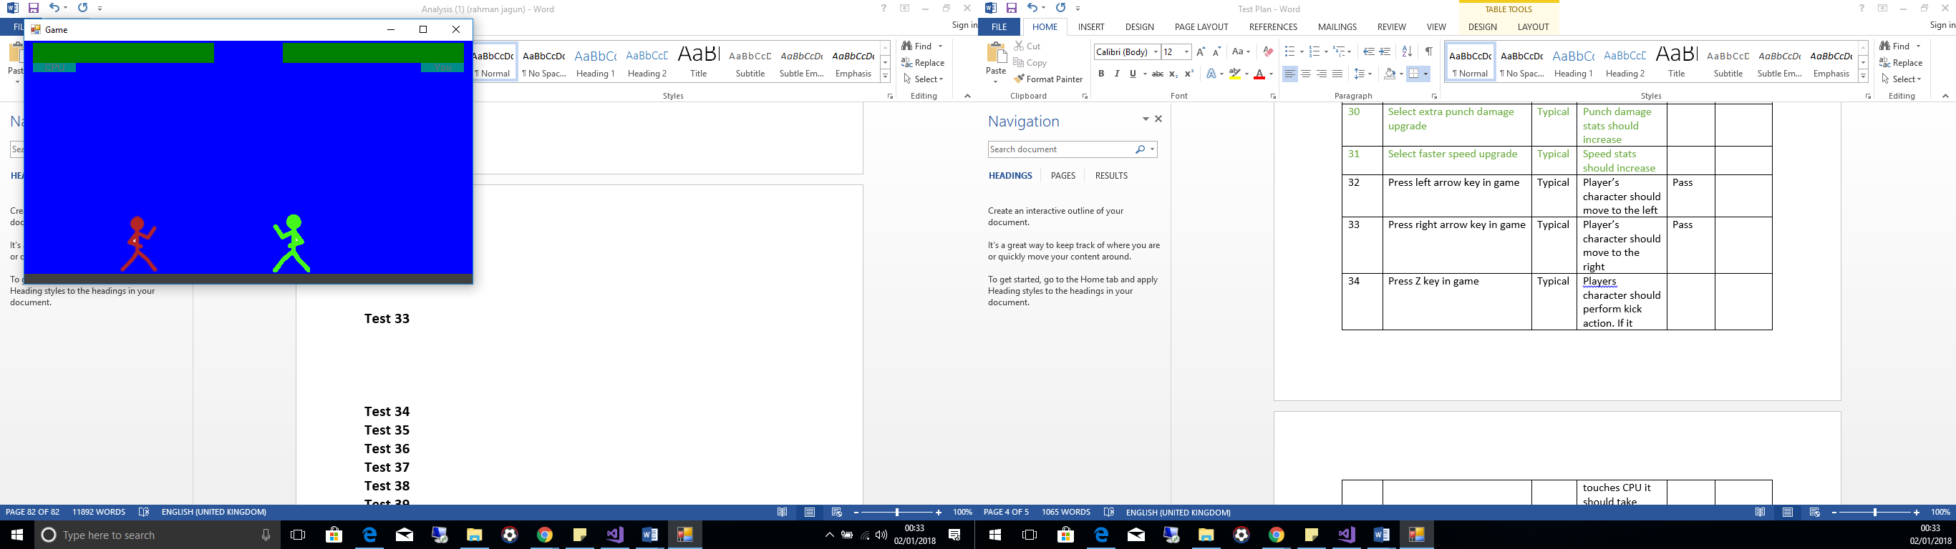

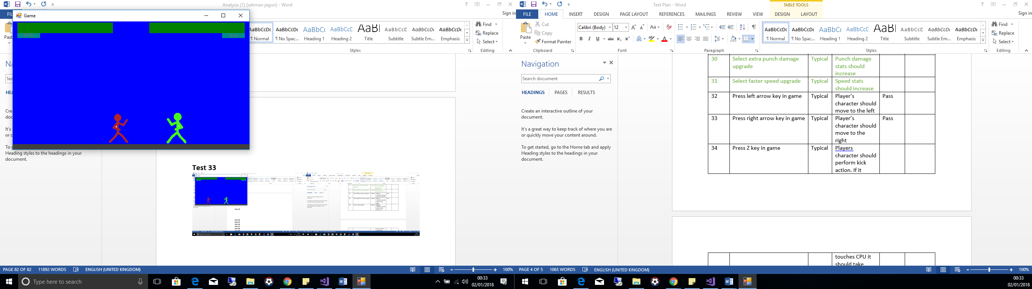

**Test 34**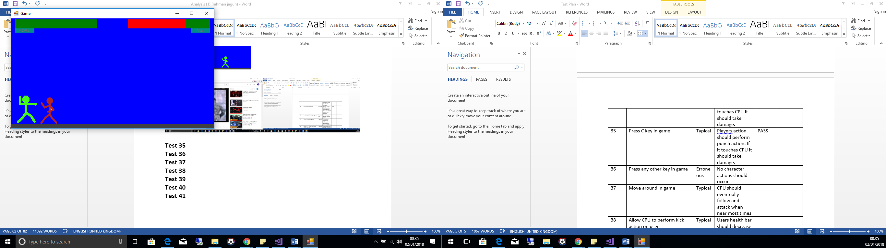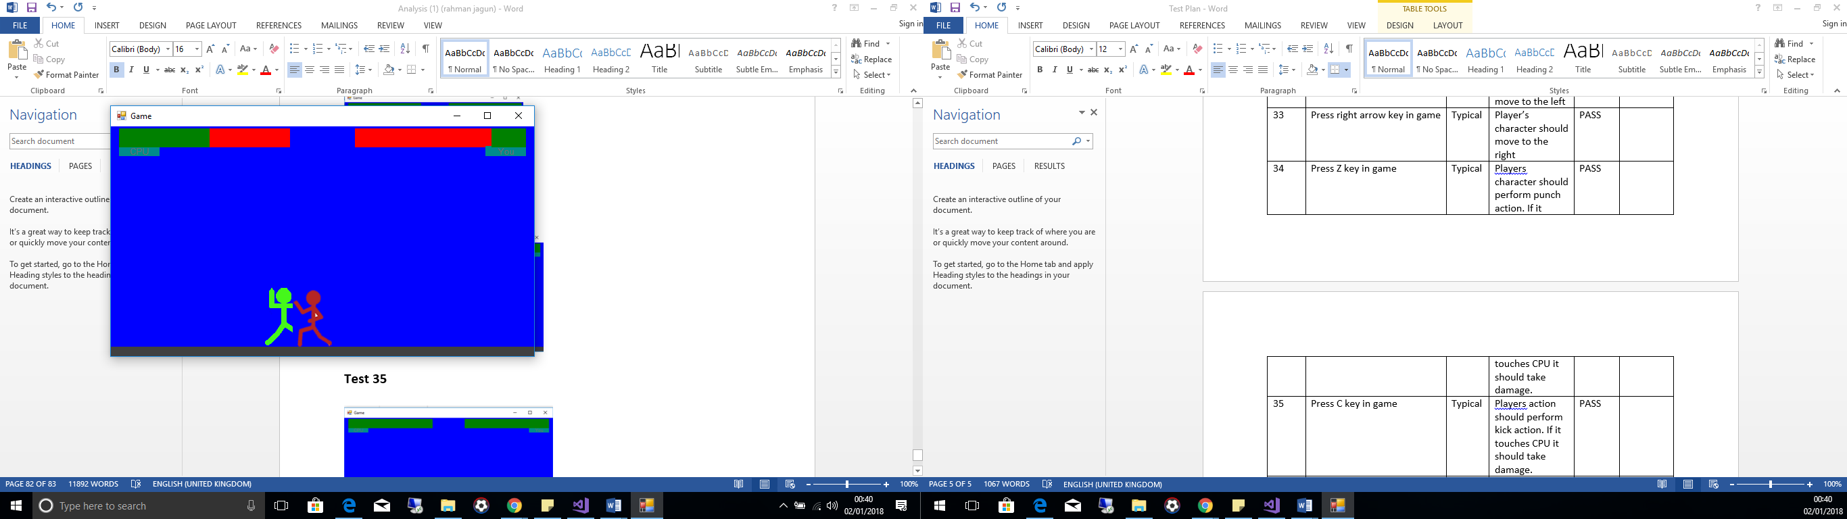

**Test 35**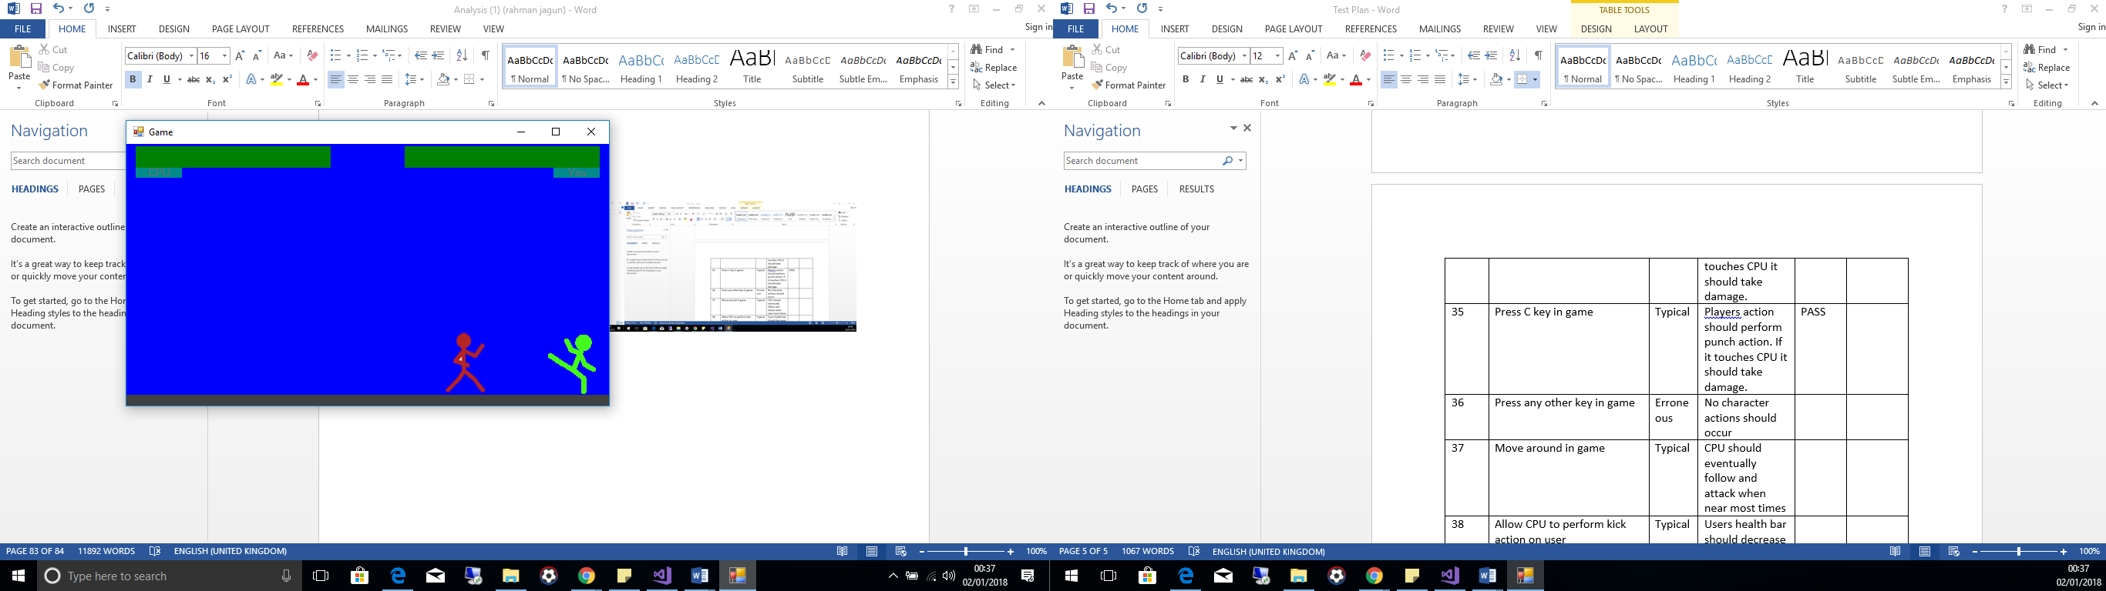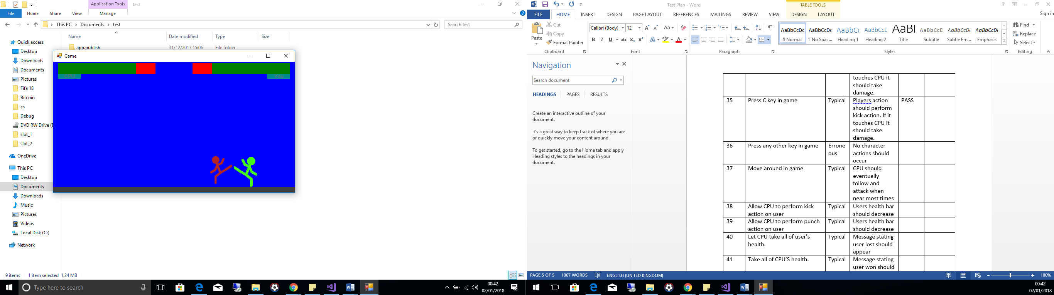

**Test 36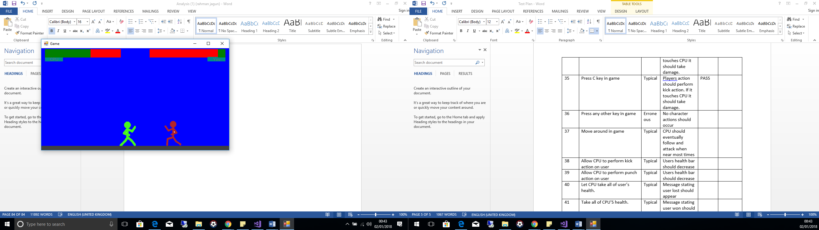 Test 37**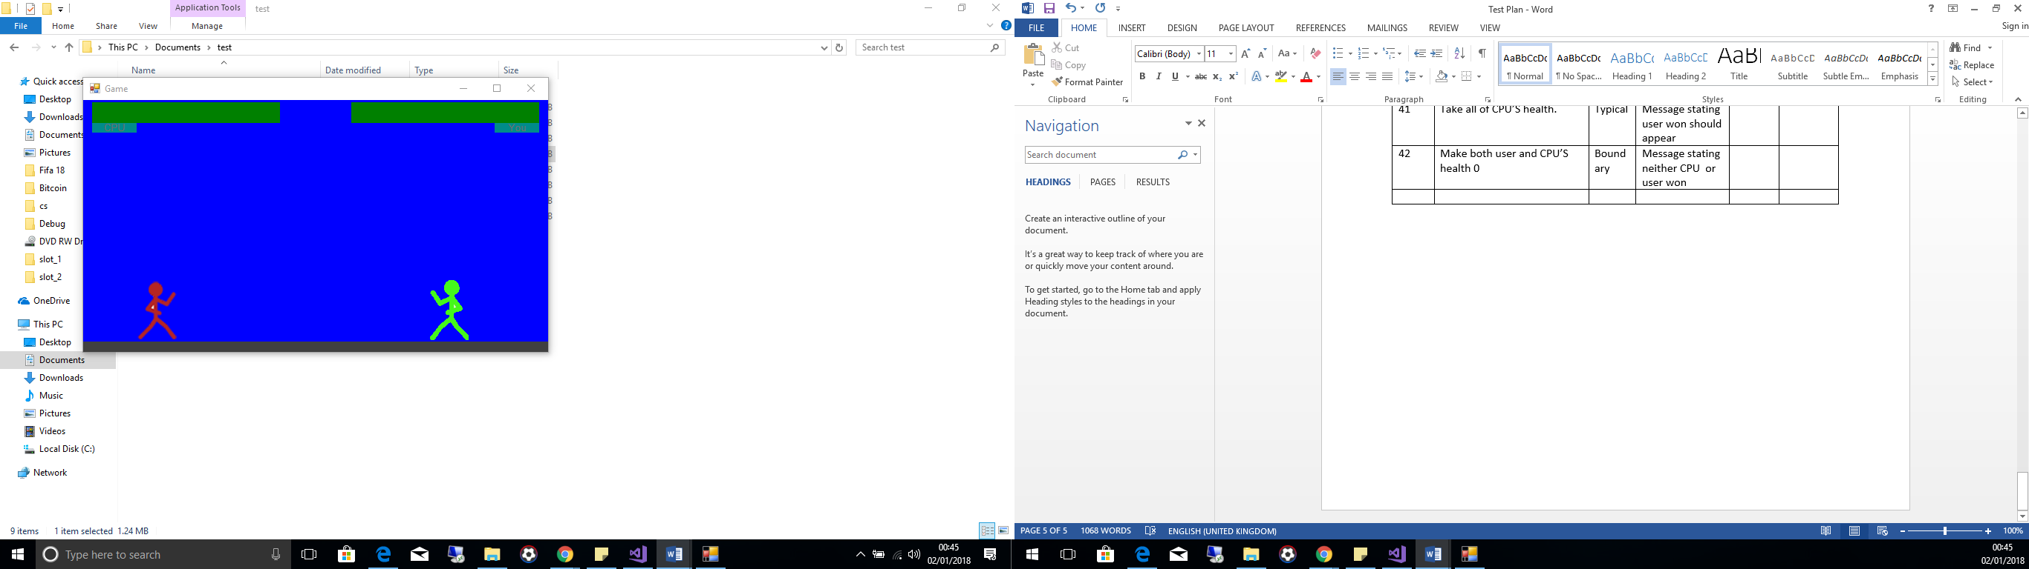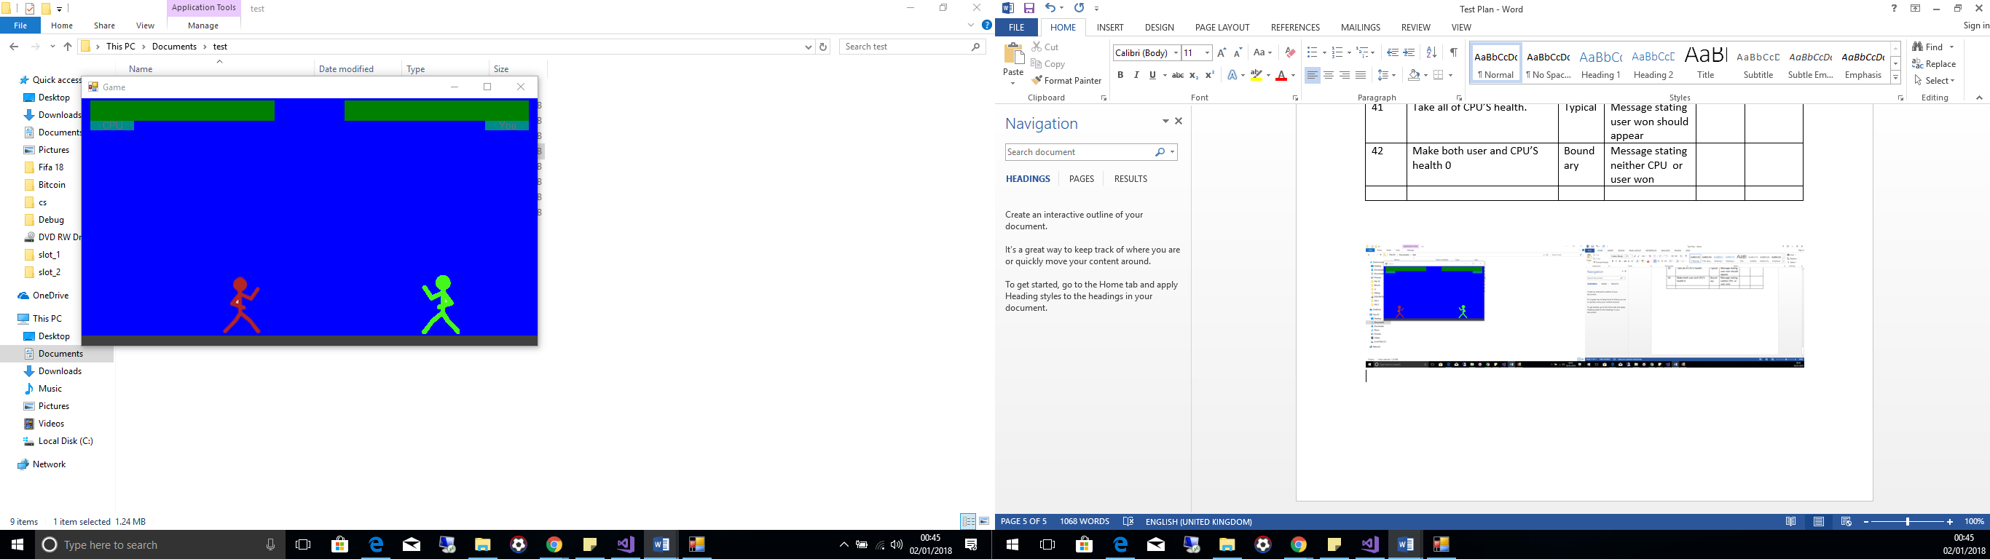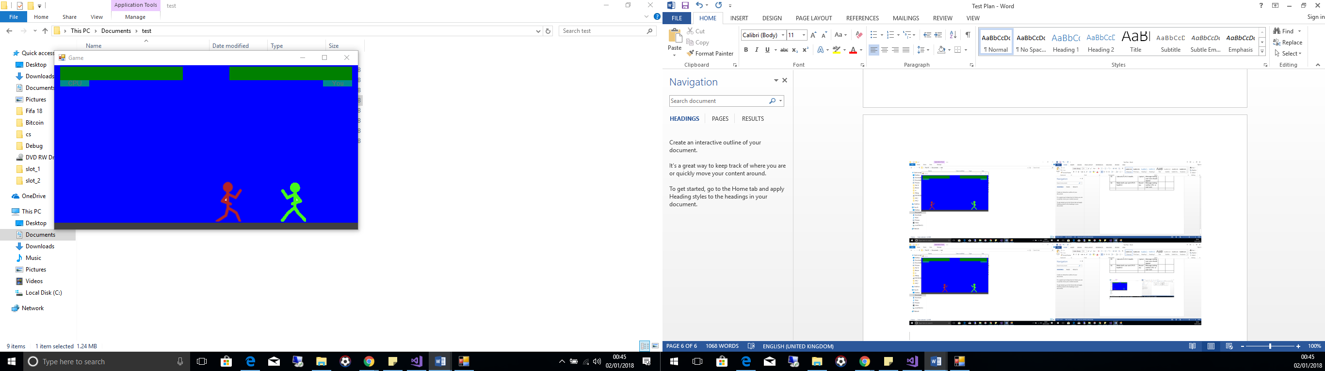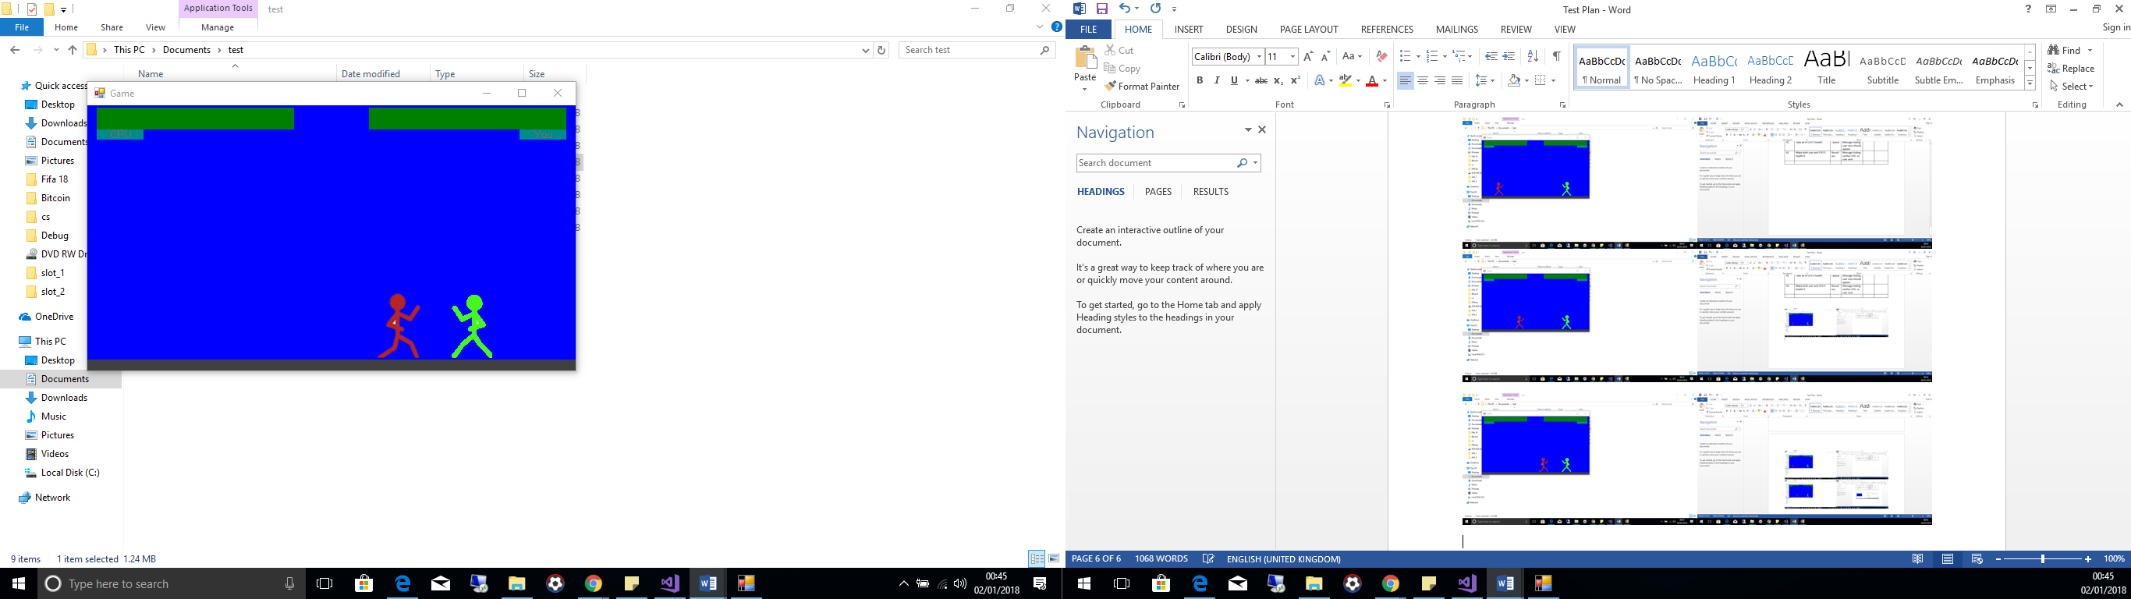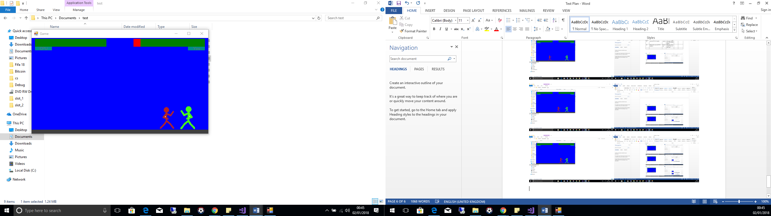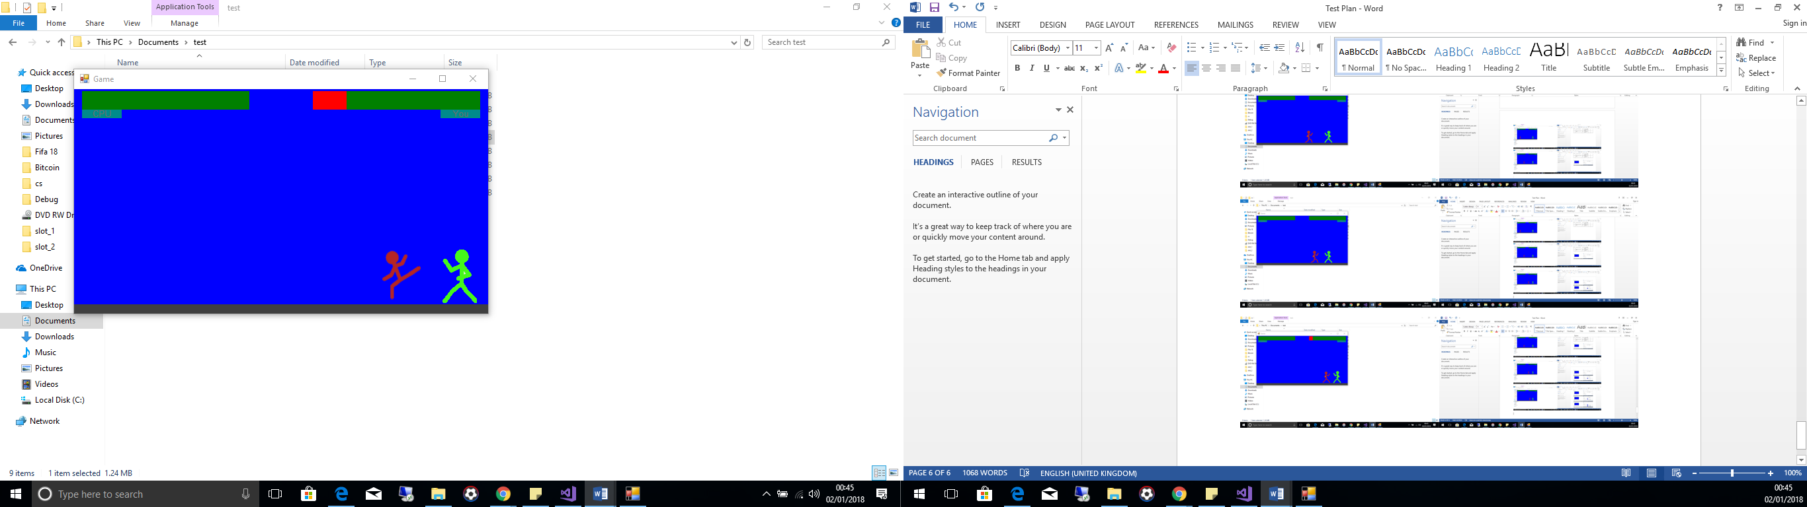

**Test 38**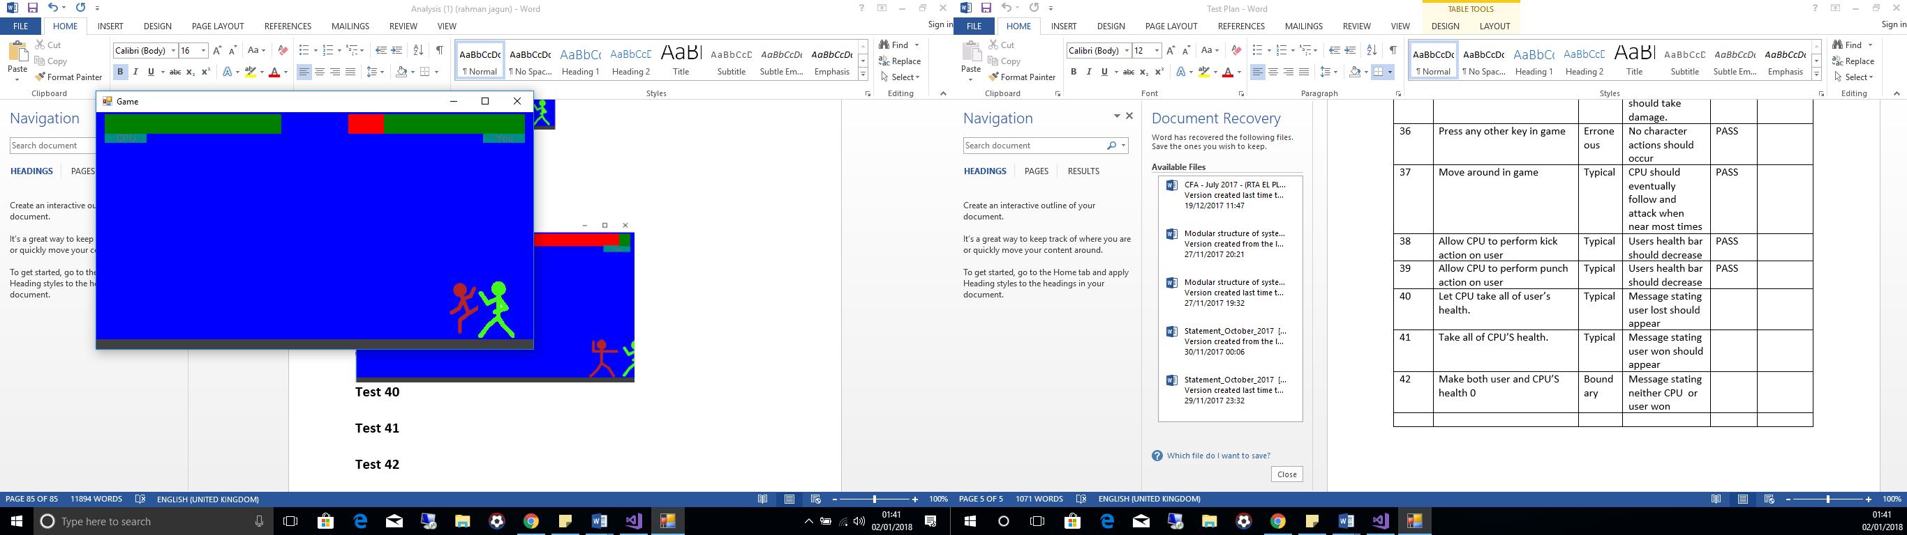

**Test 39**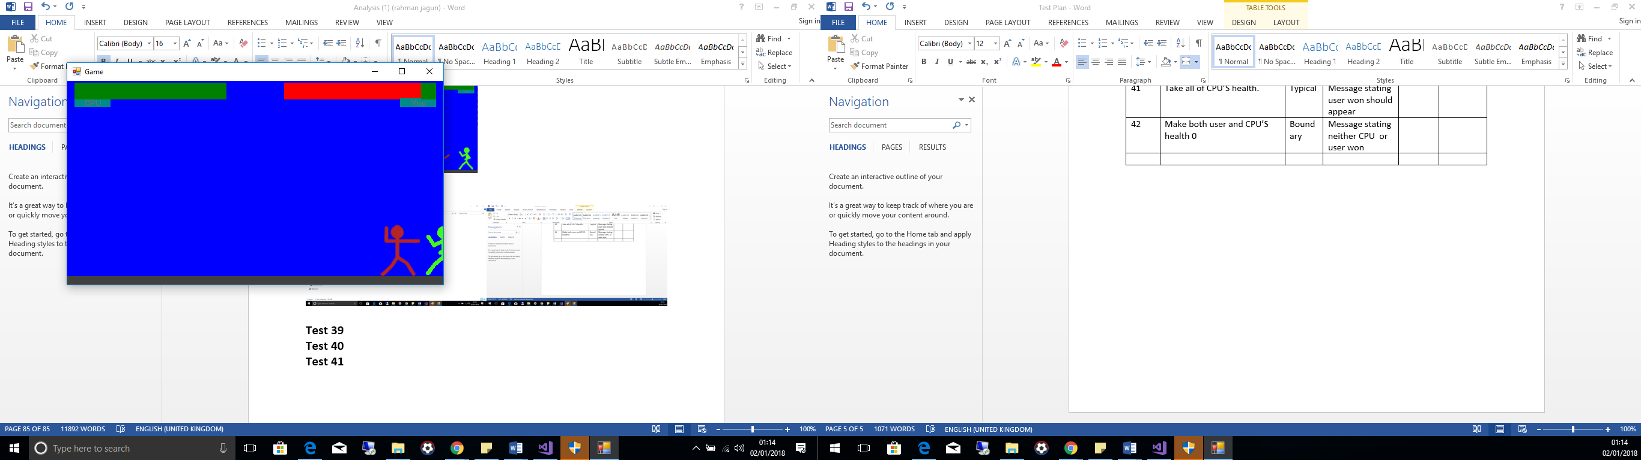

**Test 40**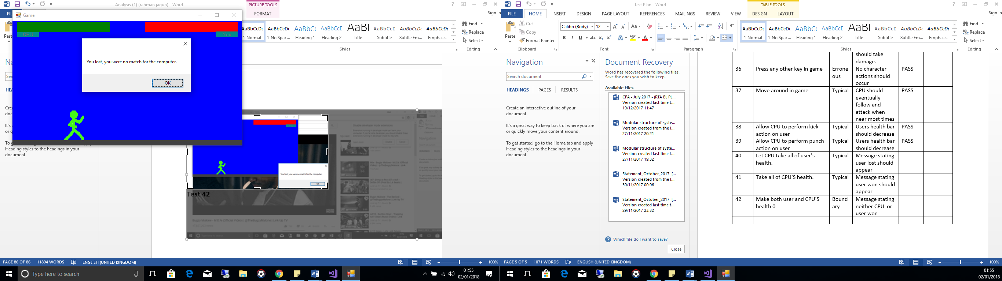

**Test 41**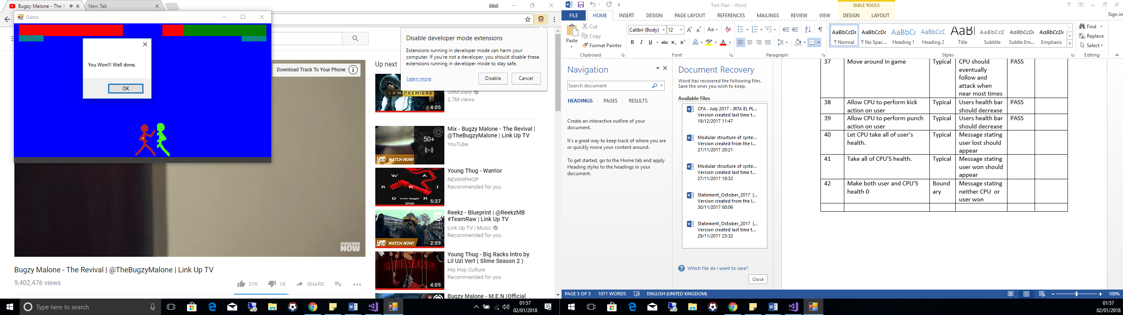

**Test 42**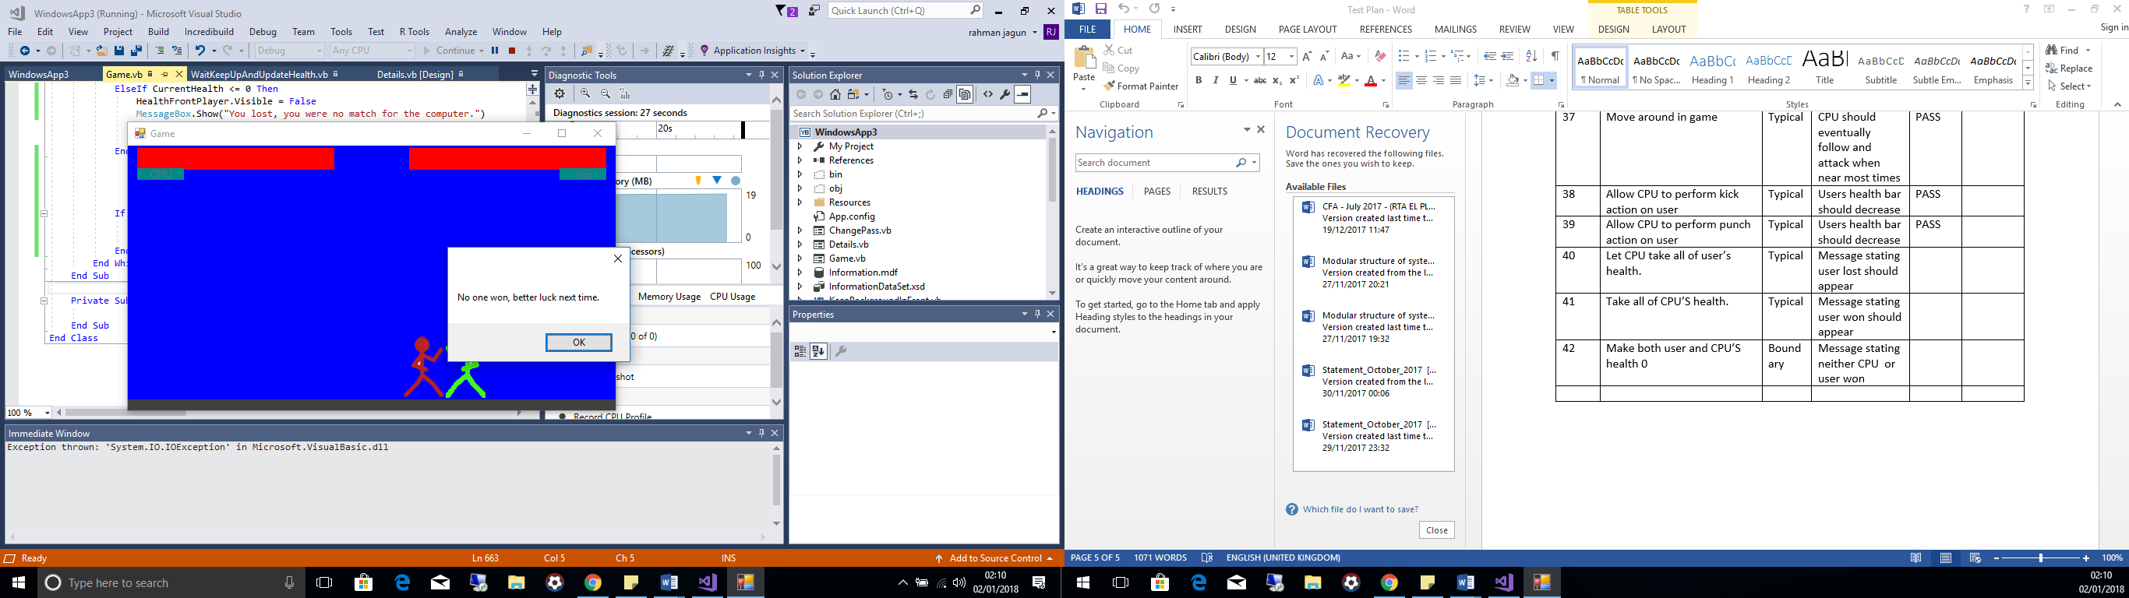

**System Re-Testing**

The system failed to meet the following tests in the initial testing stage

|  |  |  |  |  |  |
| --- | --- | --- | --- | --- | --- |
| 5 | Run through add user form, missing data for each required field at a time to test the program will not attempt to add a user without all the necessary information. | Erroneous | Program should prompt teacher stating they have missed out data. | FAIL doesn’t check for nothing | Test 5 |
| 6 | Attempt to add user that with same username already present on database | Erroneous | Program should prompt teacher that user already exists | FAIL need to make all capital or lowercase | Test 6 |
| 9 | Attempt to search without anything entered into user field. This is so teacher cannot a query with nothing as this may cause a fault in the system. | Erroneous | Alert teacher no data is entered and teacher needs to enter data | FAIL | Test 9 |
| 10 | Attempt to update user with field(s) missing. This will help to test that a teacher cannot modify information regarding a user without all the required details entered | Erroneous | Alert teacher no data is entered and teacher needs to enter data | FAIL | Test 10 |
| 14 | Leave field empty when updating teacher’s password. To test system will not crash due to the teacher attempting to add nothing to a field that cannot be nil in the database. | Erroneous | Alert teacher no data is entered and teacher needs to enter data | FAIL | Test 14 |

For test numbers 5, 9 and, 10 the same function was called to check to see whether data required was missing, shown below

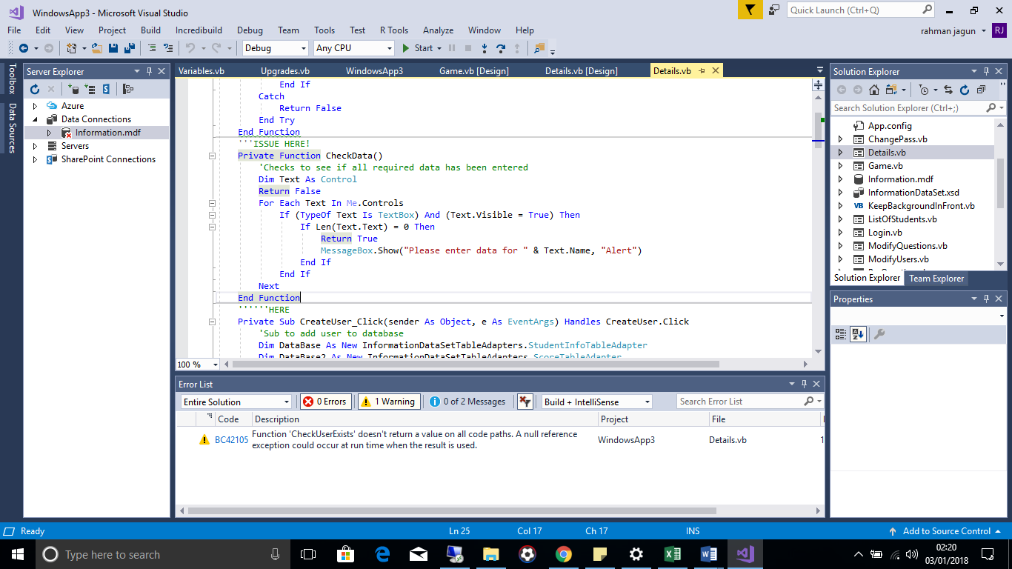The issue was with the RETURN FALSE statement meaning the function exited without checking if data had been entered and the sub that the function returned after being activated thought that everything required was filled in meaning the sub would then proceed to the next steps instead of exiting resulting in the logic errors seen in the three tests. Below are the changes that were to the program to rectify this issue  
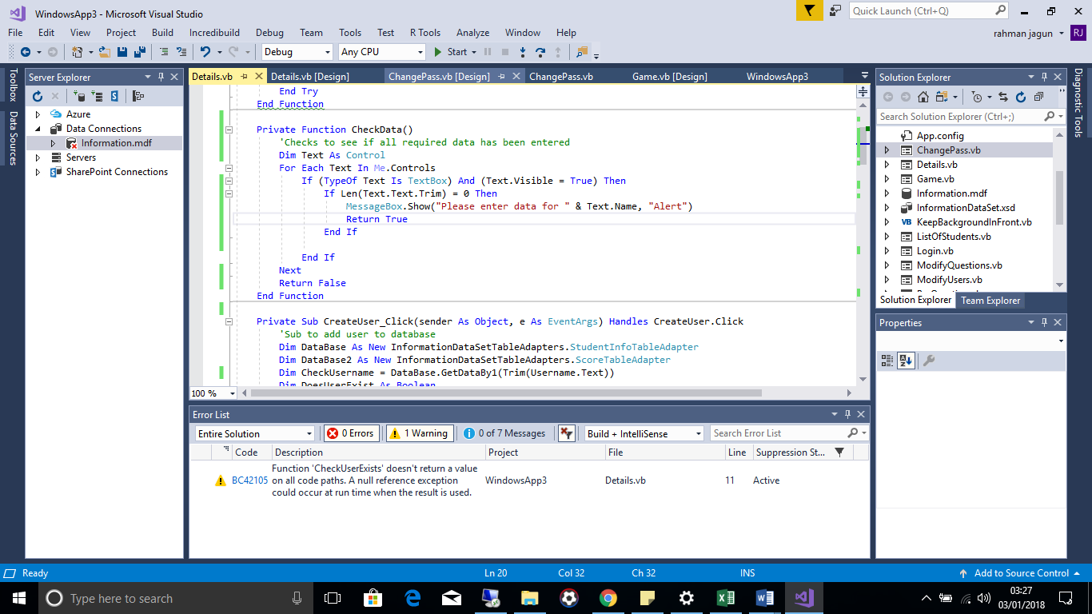

For test number 6 if the teacher tried to add a user with a username with the exact same characters and capitals then it would pass the test however if the teacher created a user with the same username but not the same case in all the letters as a username present on the database then the program would still proceed to attempt to add the user resulting in a error in the database as the username attribute of the StudentInfo table acted as the primary key meaning each username had to be unique no matter if the cases were different, to rectify this problem when checking whether a username was already present when the teacher tried to add a user, the lowercase function was used to convert all the characters to lowercase to compare the username with each one present on the database already. Below are the before and after screenshots of the program.  
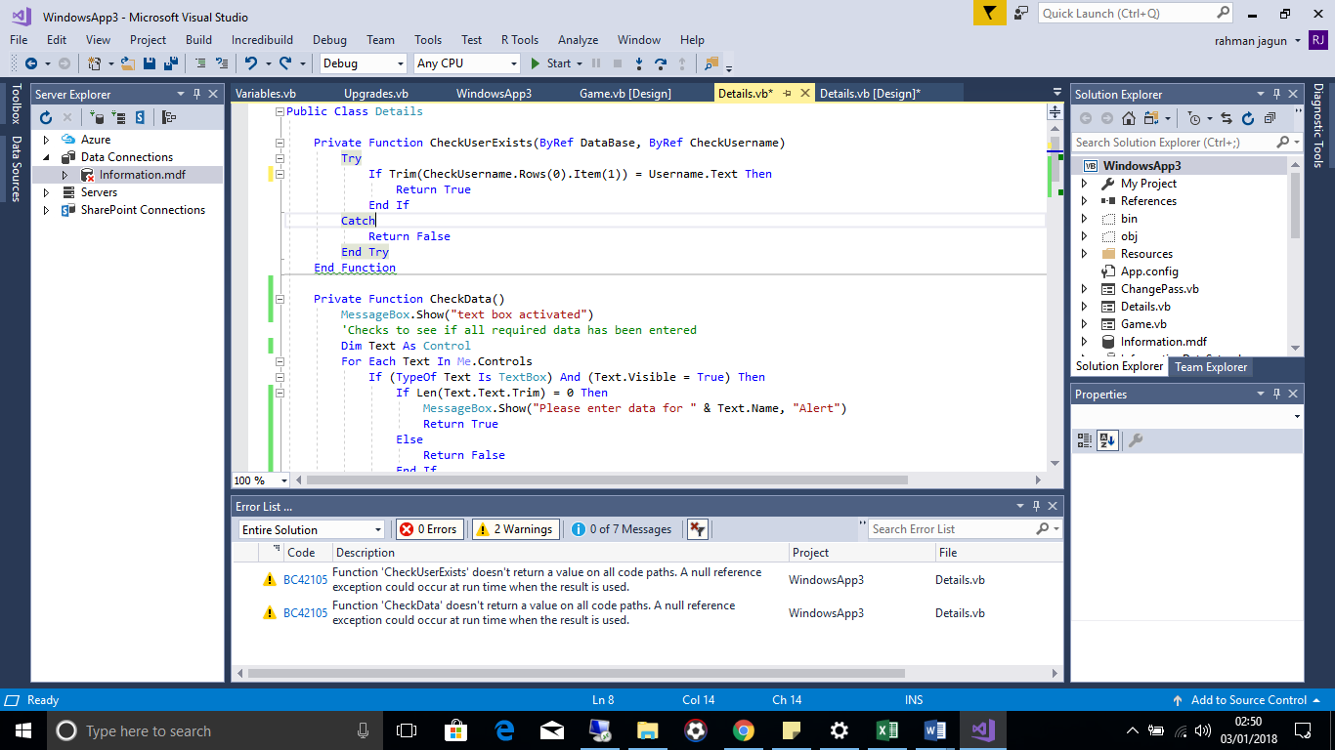   
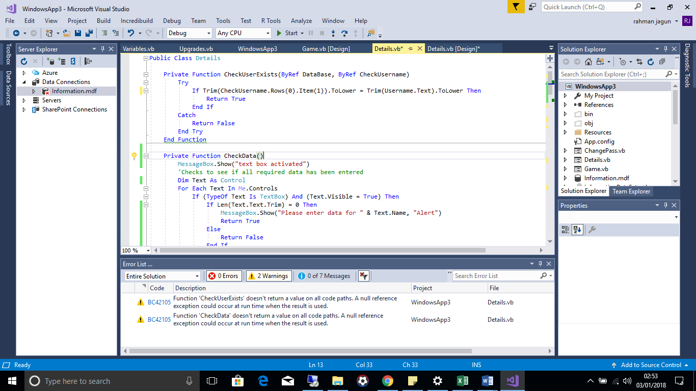

The issue with test number 14 is the function ISNOTHING does not check whether there is data in the PASS.Text variable so instead the Len function was used which counts the amount of characters stored in a variable and returns the value so if nothing is entered into password it would return the value 0 therefore activating the contents within the IF statement

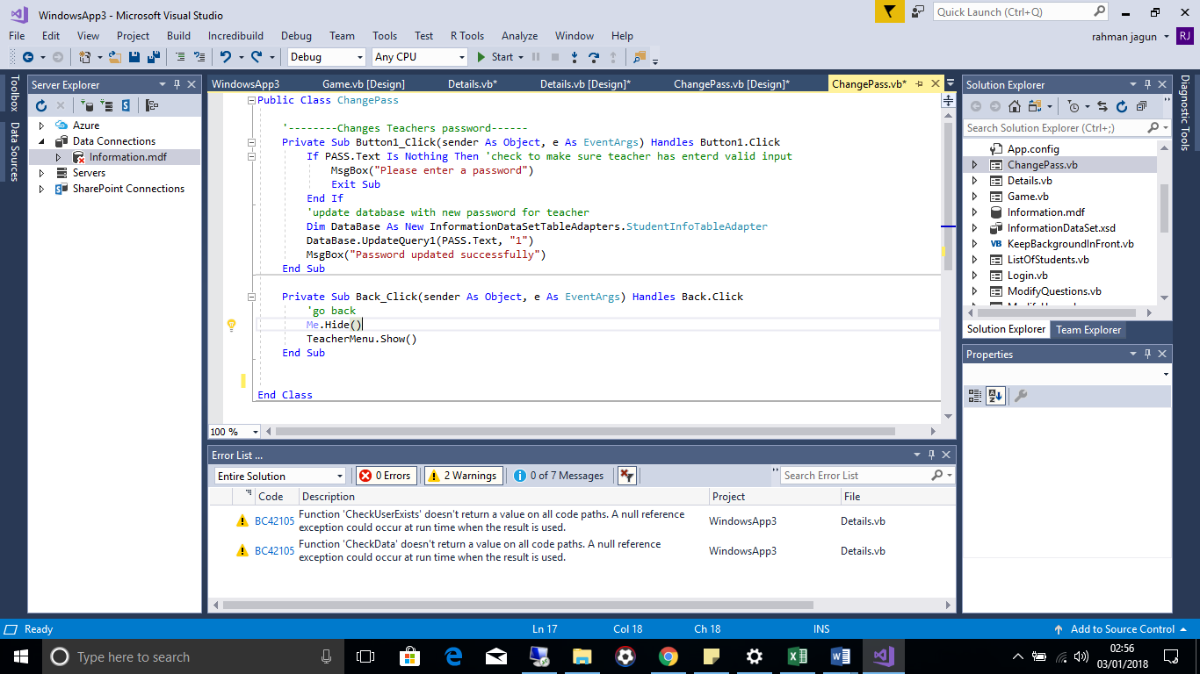

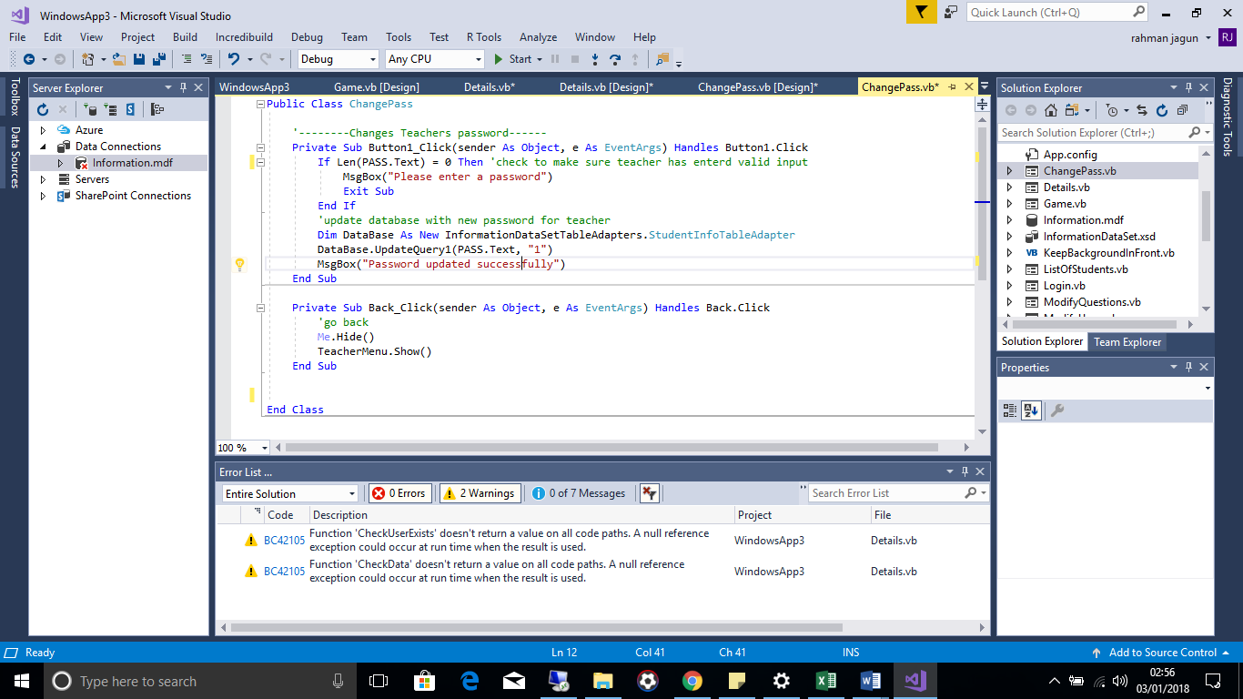

**Retesting results after system modification**

|  |  |  |  |  |  |
| --- | --- | --- | --- | --- | --- |
| 5 | Run through add user form, missing data for each required field at a time to test the program will not attempt to add a user without all the necessary information. | Erroneous | Program should prompt teacher stating they have missed out data. | PASS | Test 5 |
| 6 | Attempt to add user that with same username already present on database | Erroneous | Program should prompt teacher that user already exists |  | Test 6 |
| 9 | Attempt to search without anything entered into user field. This is so teacher cannot a query with nothing as this may cause a fault in the system. | Erroneous | Alert teacher no data is entered and teacher needs to enter data | PASS | Test 9 |
| 10 | Attempt to update user with field(s) missing. This will help to test that a teacher cannot modify information regarding a user without all the required details entered | Erroneous | Alert teacher no data is entered and teacher needs to enter data | PASS | Test 10 |
| 14 | Leave field empty when updating teacher’s password. To test system will not crash due to the teacher attempting to add nothing to a field that cannot be nil in the database. | Erroneous | Alert teacher no data is entered and teacher needs to enter data | PASS | Test 14 |

**Retest 1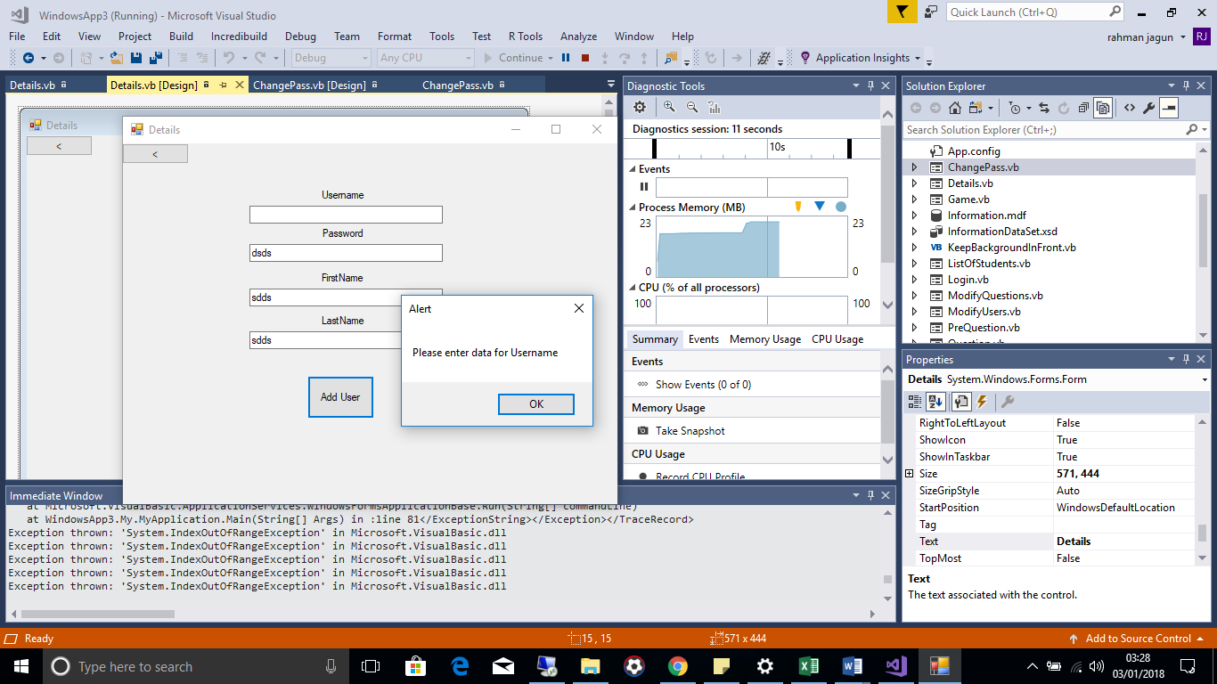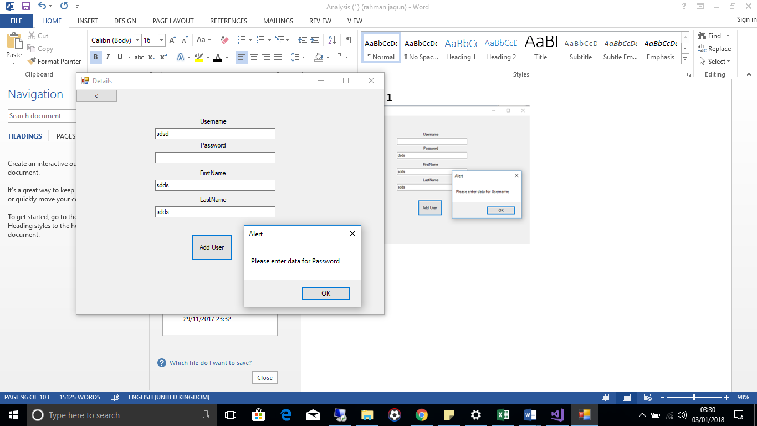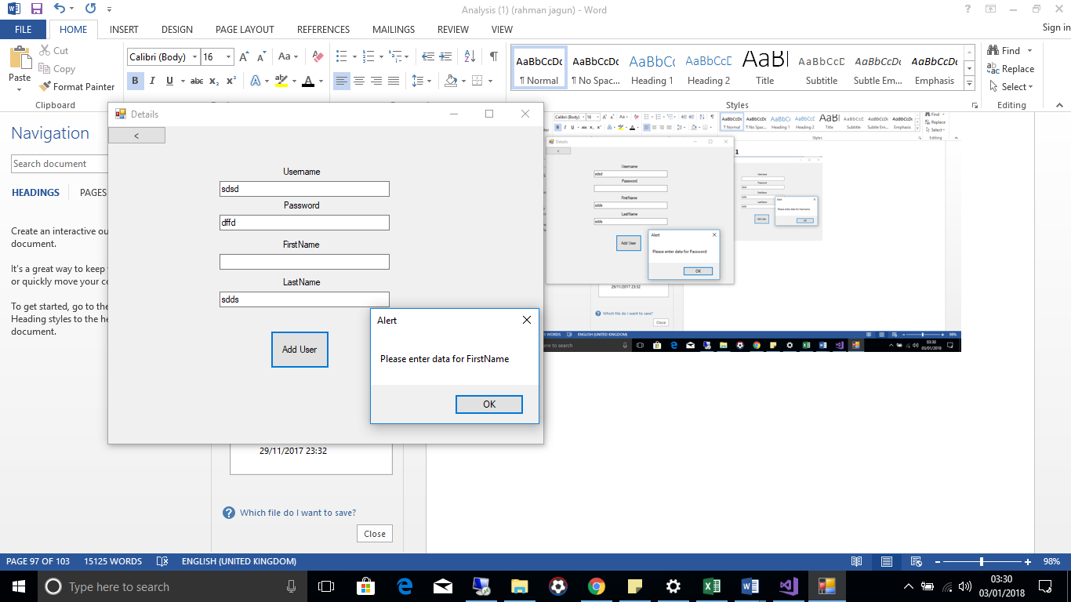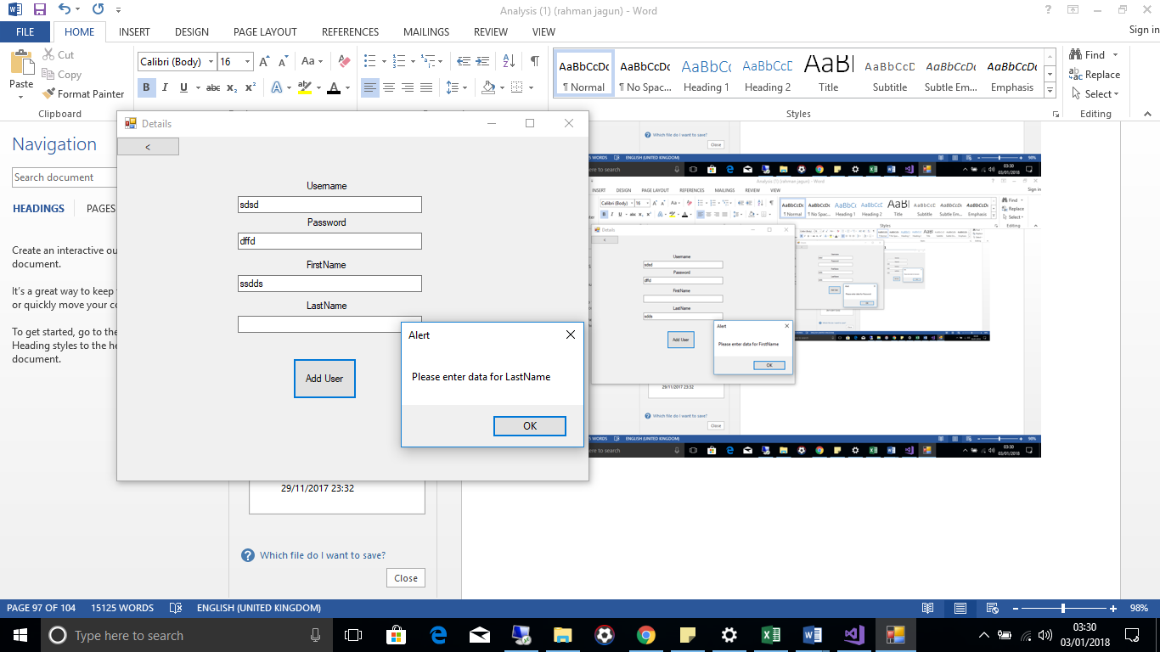 Retest 2**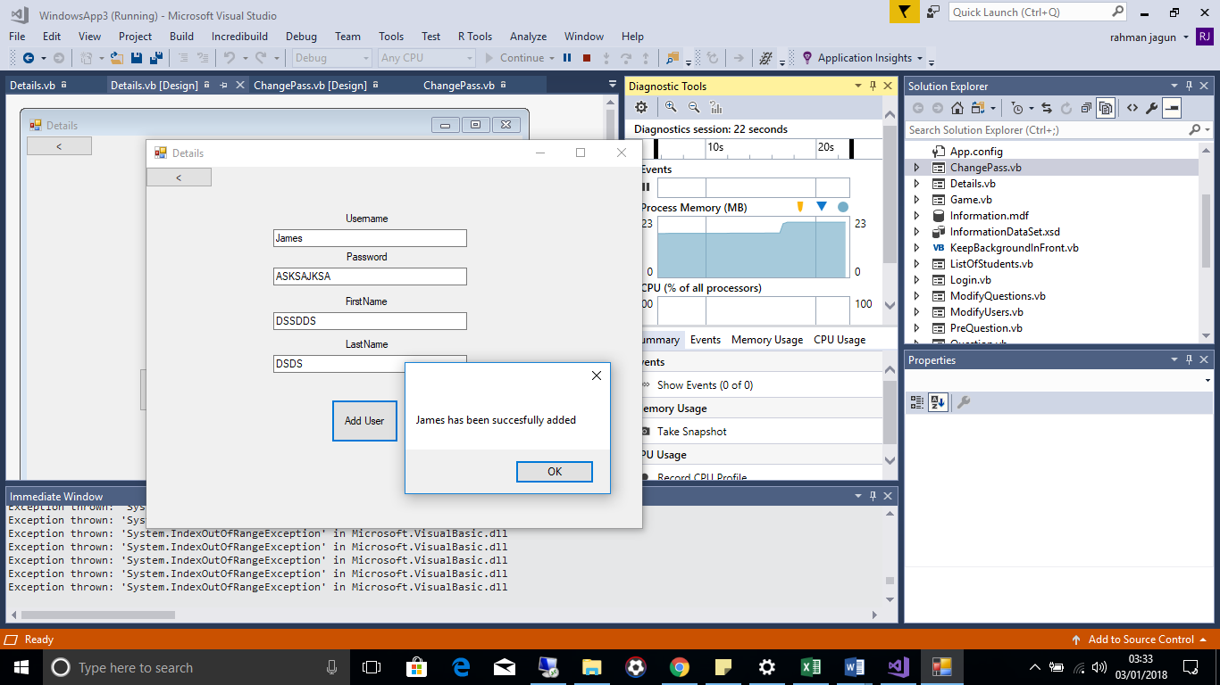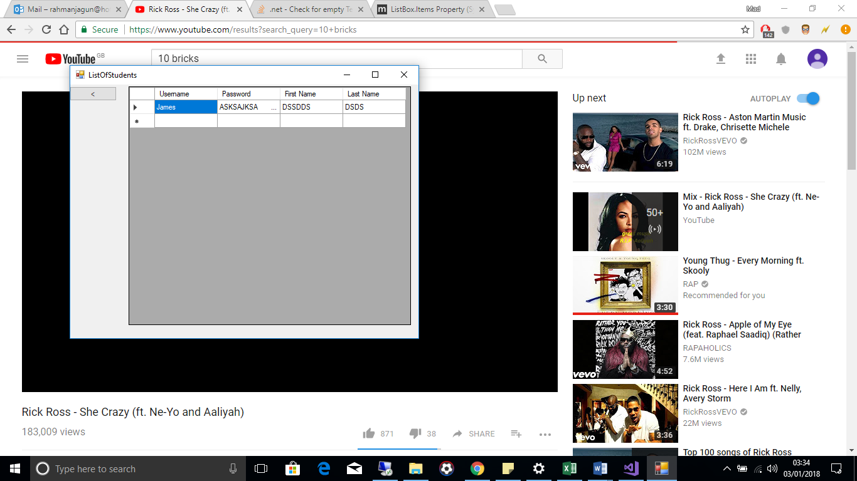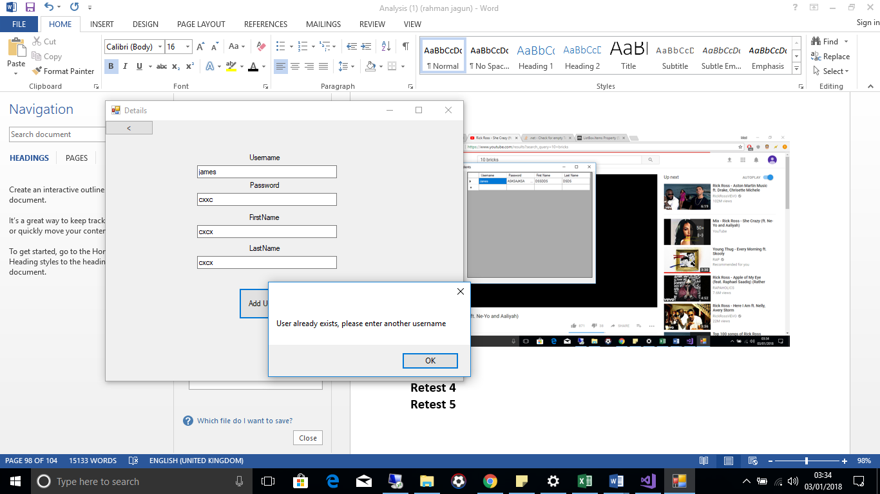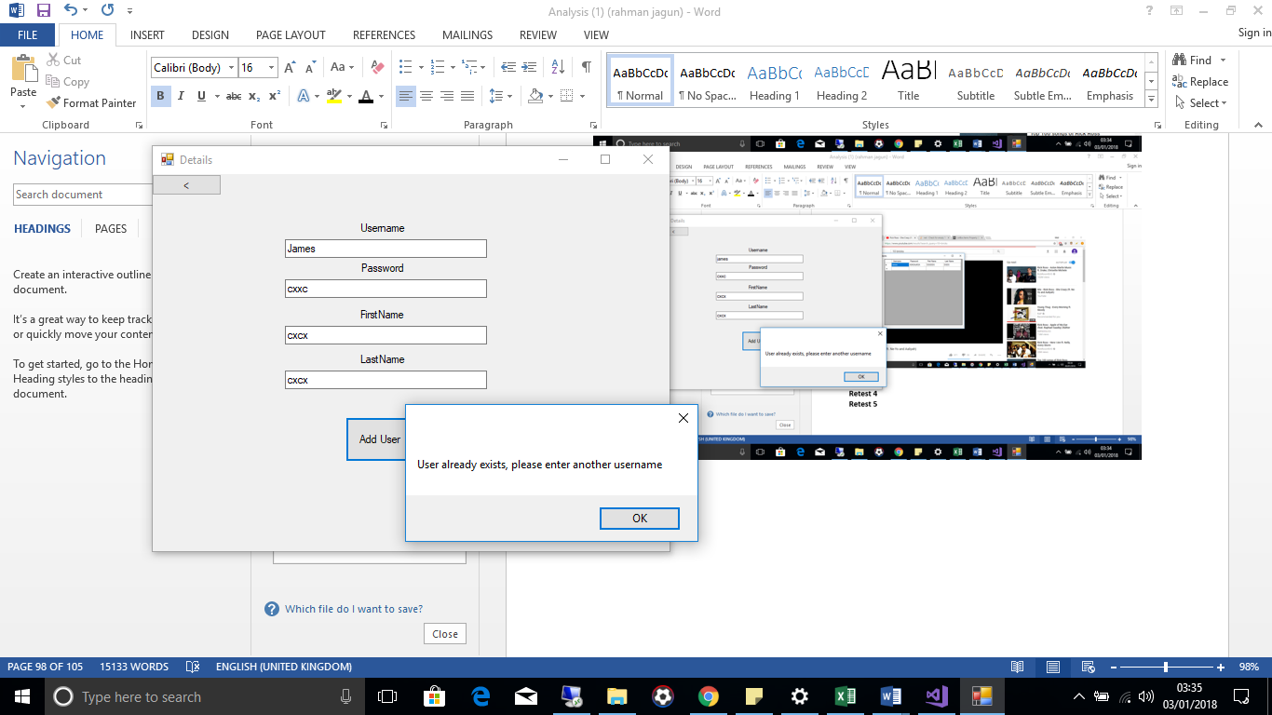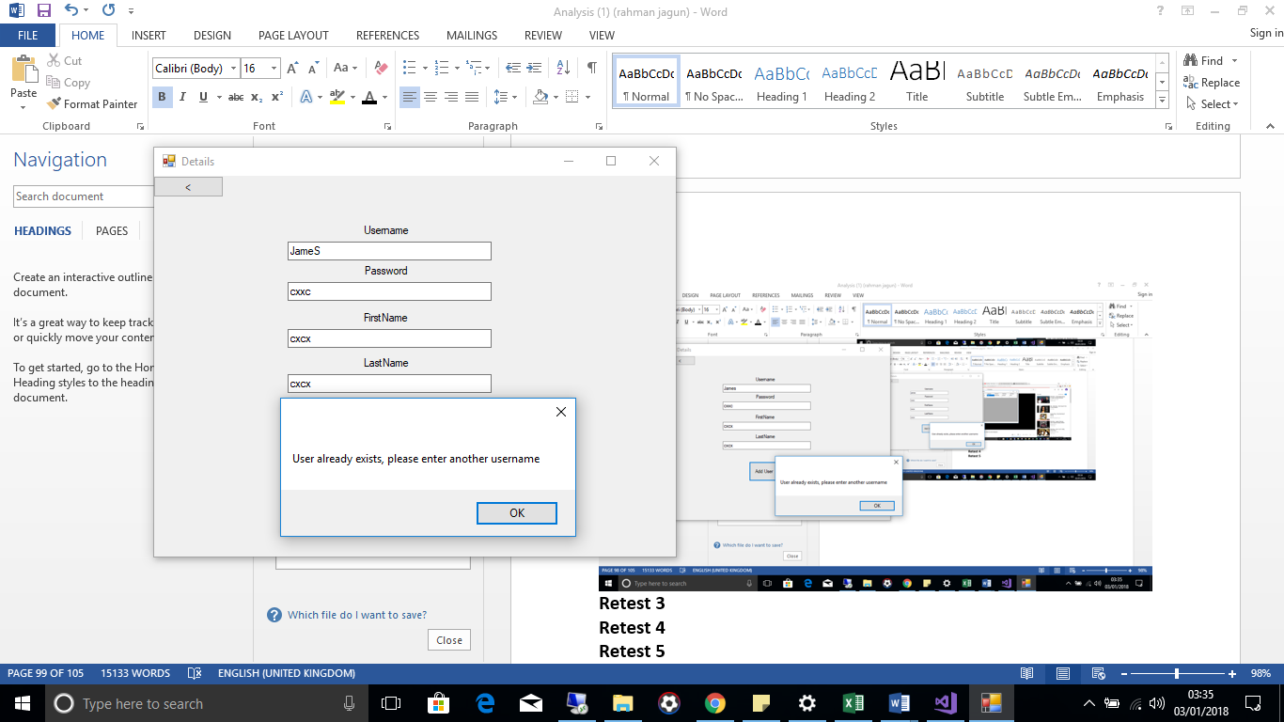

**Retest 3**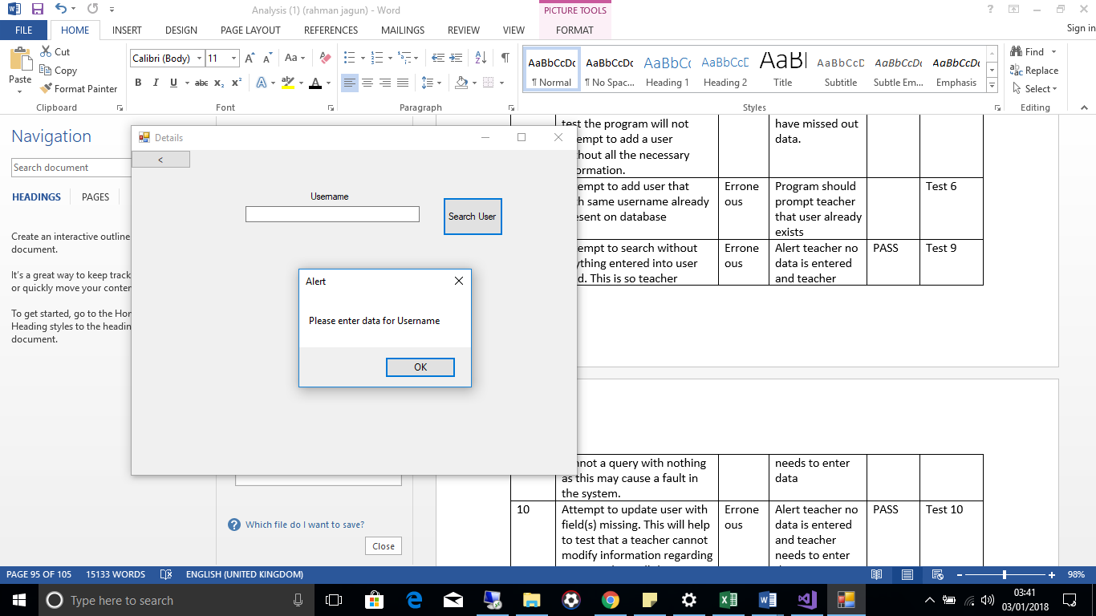

**Retest 4**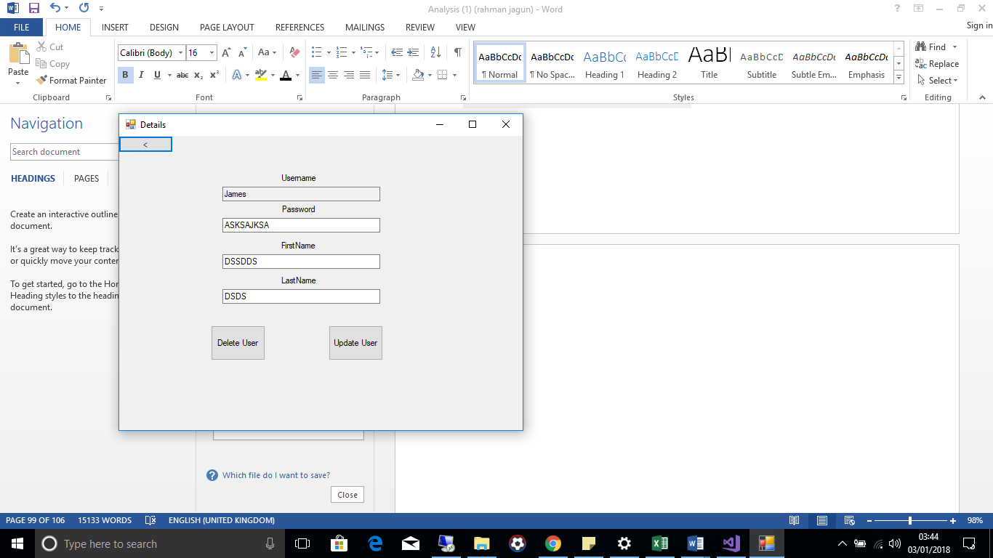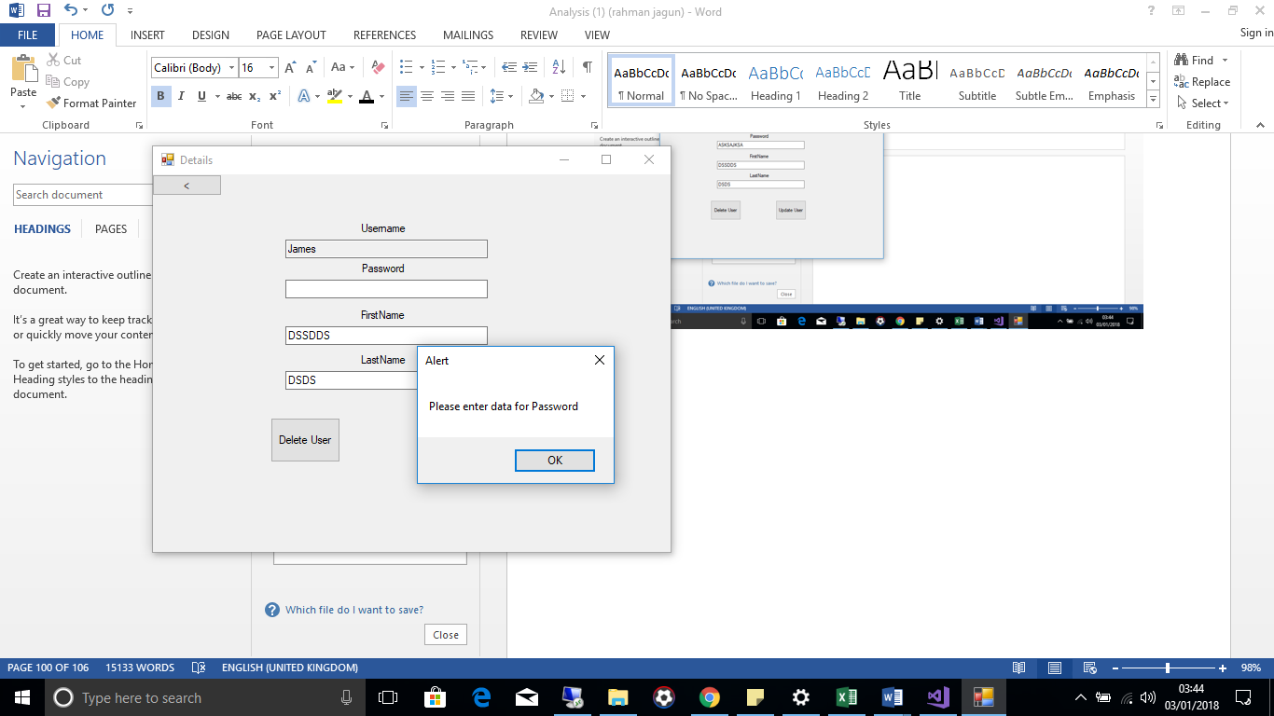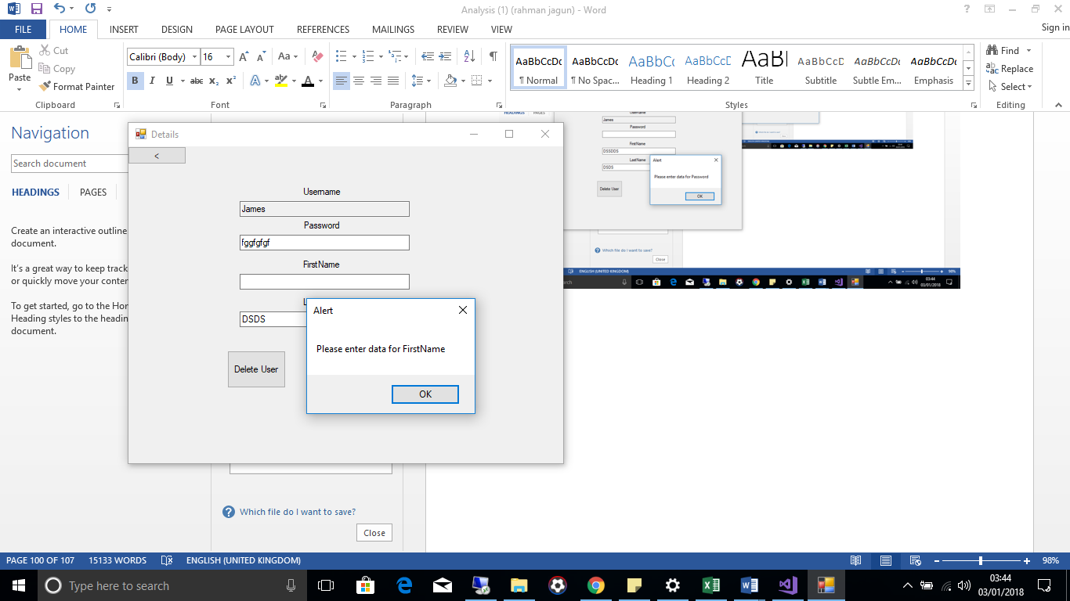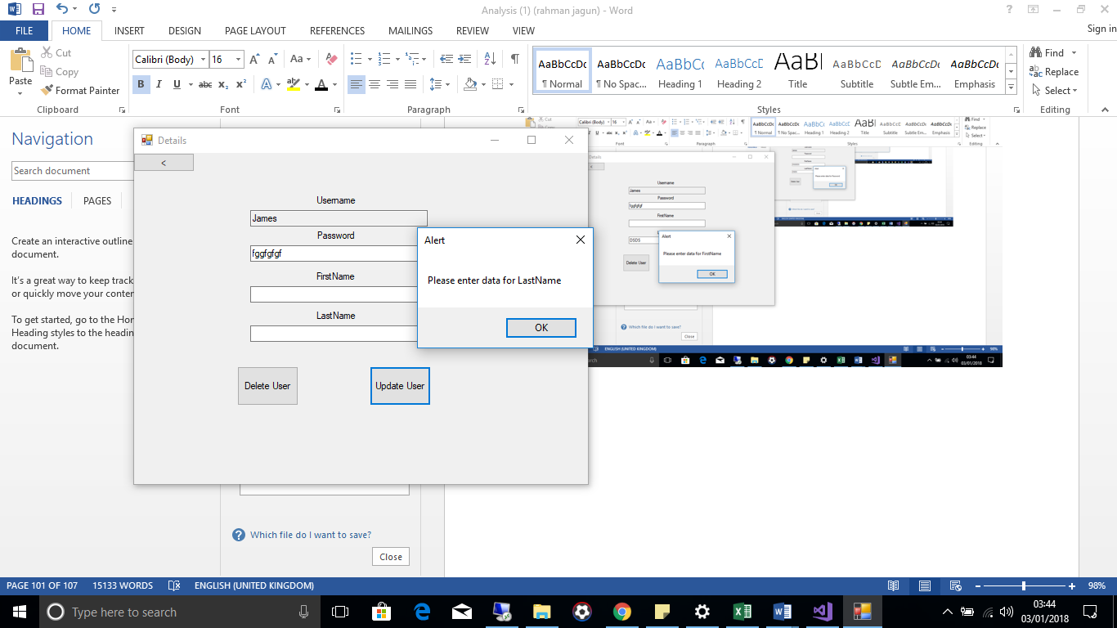

**Retest 5**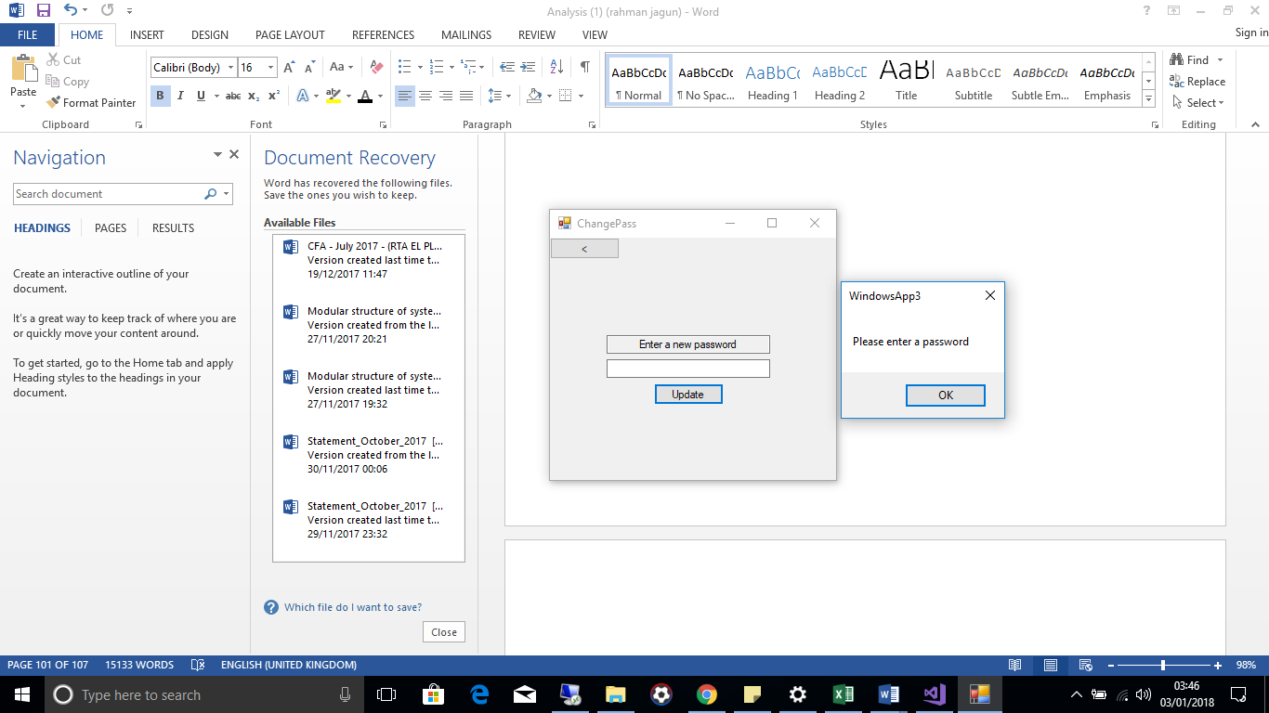

**Appraisal  
CHECK TO MAKE SURE THE SAME**

|  |  |  |  |
| --- | --- | --- | --- |
| Number | Objective | Met? | Comments |
| 1.1 | User can only logon if account exists on database | Yes | When user starts up application they are faced with the login screen in which they can login to an account, if they attempt to login with an account not present on the database they are faced with a message informing them their login details are incorrect. |
| 1.2 | When user logons it will load correct screen corresponding to whether it’s the teacher or student | Yes | Only one account will navigate to the teacher screen the rest will go to the student page, so implementing this feature was relatively simple. |
| 2.1 | Teacher can add new users. | Yes | Programming this feature required extensive research as coding data to be stored on a database was quite difficult |
| 2.2 | The teacher can modify data about an existing user. | Yes | From the modify user’s form the teacher is able to select this feature which will bring them to search for a user |
| 2.3 | The teacher can delete users. | Yes | Similarly to modifying users the teacher will be bought to the search menu to search for the user they would like to delete. |
| 2.4 | The teacher can change their password | Yes | Although the teacher could modify their password by clicking modify user and searching “Administrator”, a separate button for the teacher to change their password is within the teacher menu to make it easier for the teacher. |
| 2.5 | Teacher should be able to view a list of stored username and passwords | Yes | When the teacher clicks the button to view the information the program collects the information from the database ad exports it to a table for viewing. |
| 3.1 | The teacher can set new questions which will display in the student's quiz. | Yes | The teacher is able to do so however, they are limited to three so in the instance they would like to set more or less they will not be able to do so. However the teacher who the system is mainly designed for only uses three questions in order to assess their students. |
| 3.2 | The teacher can view and modify the current set of questions. | Yes | When the teacher click on the modify questions button the program retrieves the information stored on the Questions table and puts the data into the corresponding text box. |
| 3.3 | The teacher can erase the current question and create a new set of question | No | There was no specific button with the option to do so as there wasn’t a need for this feature as the teacher can just delete the information herself and click update or change the questions to a new set of questions. |
| 3.4 | The teacher can erase each student’s mark on the previous set | Yes | When the teacher navigates to the view results page from there they able to erase the results ready for the next set of questions |
| 4.1 | The teacher should be able to view the student’s results on a table. | Yes | The table displays the student’s first name and last name along with their score. |
| 4.2 | The teacher should be able to export these results to a text file. | Yes | At the bottom of the form viewing the results this feature is present, along with the option for the teacher to give the set of results a title so the teacher can keep track of the quiz each setoff results correspond to. The text file is saved/ will be (depending on whether the teacher has already saved a set of results previously) within the same folder as the application under the name statistics. |
| 5.1 | The question should be displayed along with three possible answer choices, which should match that of the ones the teacher assigned. | Yes | After the student is given instructions about regarding the quiz the student is faced with the first question set by the teacher all of the questions are the same as provided by the teacher as they are retrieved from the same table that when they teacher clicks modify questions, the questions and answers are saved on. |
| 5.2 | The student can select the answer which they think is correct and the program should tell them if they got answer wrong or display the upgrade menu if they got it right. | Yes | As shown in the testing if a student gets an answer right they are told so ad if they get it incorrect they are also informed. |
| 5.3 | The program should run through all three questions set by the teacher applying the same process in 5.2 and 5.3 | Yes | After the students answer a question it moves on the next one until it reaches question number 3. |
| 6.1 | The student should be able to select an upgrade and the correct upgrade should be applied to the students in game stats. | Yes | As demonstrated in the test plan by showing popups of the different character stats before and after an upgrade is select, the program meets this objective. |
| 7.1 | When a user presses a character, the program should produce a response based on the character the user pressed. The response should match that of the assigned action the program is meant to do when the user presses the button. For example if the user presses the right arrow key the user’s character should move to the right. | Yes | When the user presses the left arrow key their character moves to the left, when the users press the right arrow key their character moves to right, when the user presses z the character punches and, when the user presses c their character kicks. |
| 7.2 | The CPU should be able to move and interact with the student’s character based on where the user is and where the student’s character is. | Yes | This is demonstrated in several tests in the testing section |
| 7.3 | The game should end when the user or the CPU’S health gets to nothing, and the winner should be displayed. | Yes | When the user’s health is 0 the game ends stating the player lost. When the cpu’s health is 0 the game ends, stating player is winner. When both the CPU’s health and user’s health are 0 the game ends stating the neither won. |

**Feedback**Below are the responses the teacher made regarding the system along with a randomly selected student from the class.

Teacher:  
**How easy the system is to use?**  
  
The system is very easy to use, the layout is quite basic which makes it easy for me to navigate through it, each button clearly states what action will occur when I click it. I was very pleased with how easy you made it to add users as other systems can be quite confusing on this matter. I was able to add questions, view results and most importantly add the results to a document with easy. I’m quite pleased with the system in terms of how quick it takes to get to grip on how to use it. I think this program could be used by anyone trying to assess a group of people on something.

**How does the system meet your objectives?**I am able to add my students to the system. Add the questions and answers which the students then answer and the system marks the work for me where I can then view their results and export it to text document, making it easier for me to assess my students.

**How easy was the system to set up?**The read me file containing my login details to access my part of the system was very useful as I could then proceed to make the changes I needed to. No manual was needed on how to use the use the system as it was so straight forward, setting up the questions and adding the user where all presented in ways that it was clear to me what I needed to do to set up everything ready for use by my students. **What don’t you like about system?**I wish I had the ability to add more questions as in the future I may want to set my students more than 3 questions to assess their knowledge on the topic I have taught to them, also not all questions will have three possible options, for example yes or no questions. I cannot add questions like this to the quiz as the quiz requires a third option and questions like these only have two possible options. Those are the only aspects of the system that are distasteful to me however the rest of the system is perfect to catering to my needs. I can understand why you may have faced issues enabling the user to add a range of questions with a wider range of possible options because as you said at the begging you did not have much prior knowledge about the programming language you made the system and you created the system in quite timely manner. **How would they like system to be improved**?  
First of all, I would like the ability for me to add multiple questions with multiple options to the quiz the students on. I wish the system could store a history of all the questions and results so I can go back to view them in the instance I lose the text file containing the results I have exported of if I clear the results by mistake without exporting them to the text document. Other than these improvements I am happy overall with system you have created. Thirdly instead of me having to pass my hard drive around the class for each student to complete the quiz I would prefer a feature in which all my students can attempt the quiz simultaneously as this would reduce the amount of time spent in the lesson around the quiz.

**Student 1  
How easy the system is to use?**It was quite easy, when I logon I am faced by instructions on what don in the quiz and when I finish the quiz and the game loads up I am told how to play the game however the first time I played the game I accidentally pressed a key to start the game without reading the instructions and there was no way for me to go back and check the controls again so I ended up losing.  
 **How does the system meet their objectives?**The system has made the way our teacher assess us with the game and I would say it has improved my concentration in lesson as I want to get all the answers correct so I can select upgrades and beat the CPU in the final game, The quiz is quick and simple to understand also the design is quite attractive.

**How easy was the system to set up?**Very easy for me, all I had to do was login with details my teacher gave me then run through the questions that was displayed to me.

**What don’t you like about system?**I know you said from the beginning you may struggle to make the game due to lack of expertise however the game was not of very good quality at all. If I went over the computer it would hide the computers character, the game does not last as long as I expected at all, when the players move it looks quite poor however It may be no street fighter video game but I am still happy with it.

**How would they like system to be improved?**It is only the game I would like for there to be improvements on. If possible I would like the following changes, I would like the program to save my stats for next time, I would like for the CPU to get harder each time I beat it, There should be some sort of health regeneration to make the game last longer, There should be more fighting moves and I would like the ability to customize my character, also I would like the character movements to look better. The Quiz itself was perfect, I do not have any improvements I would like made to it.

**Analysis of User Feedback**

The feedback from the teacher is quite positive throughout however the student not as much. Both users found the system relatively easy to use which is a benefit as it could have the system may have the potential for other people to use it. They both found it quite easy to set up the system. All the objectives I was set were met however the teacher and student seemed to want more features implemented into the system in which I did not identify in the analysis stage, if so I would have attempted to add these features into the system.

The methods in which I went about meeting the majority of my objectives were suitable as not a lot of faults were identified in the system, for the most part it met the basic needs of both the student and teacher, the teacher was able to create a quizzes which were automatically marked and the students were motivated somewhat to beat the CPU so they focused more in lesson.

If I were to conduct this project again I would conduct more detailed research into the objectives of each student to ensure I have met the needs of every student to an extent and I would also consult the teacher on multiple occasions on features they may like to see added to the system as they may have thought up of more content that will be helpful to them in meeting their needs. I would also have tested out similar products and looked into features of the product that although was not identified as an objective may have helped to meet the needs of the teacher.

**Possible Extensions**